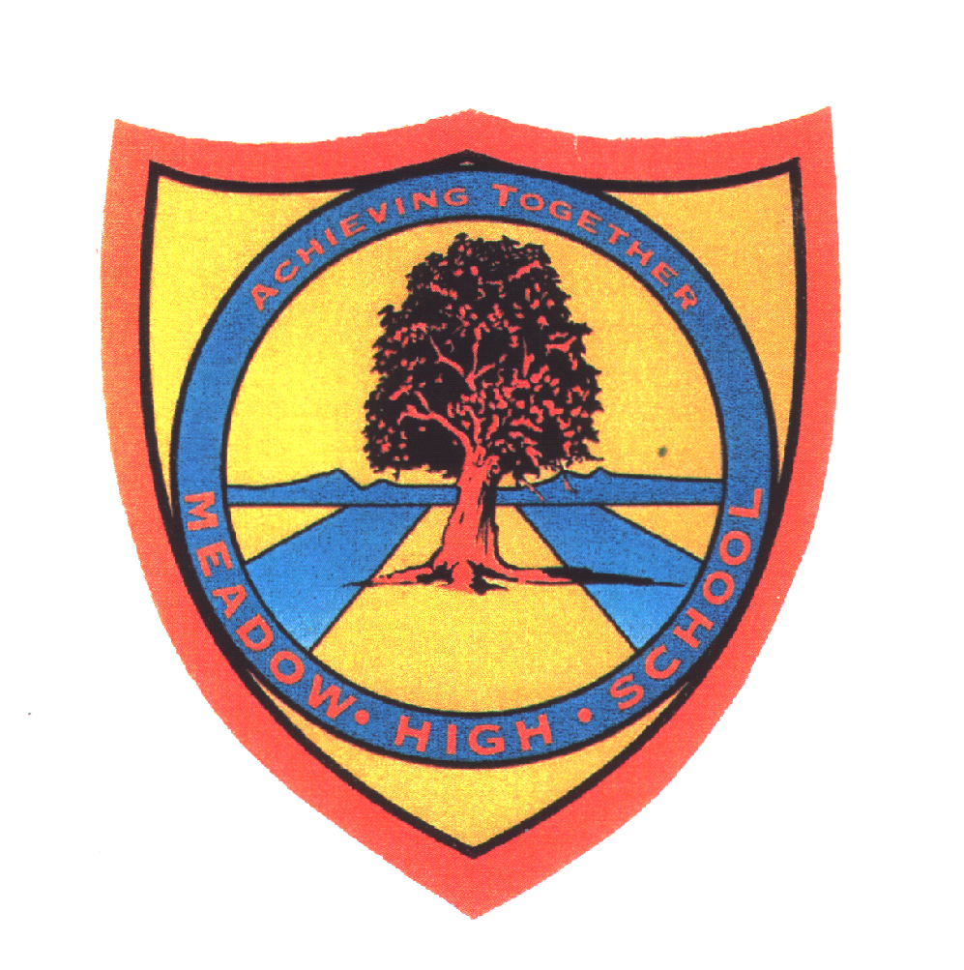 | Pathway 1 | Key Stage 3 Cycle 1 | Summer 2  Topic: Forces and Magnets
Learning Intention: Pupils will learn about forces, friction and magnetic attraction. They will learn about forces in the context of pushing and pulling. Pupils will develop the ability to work scientifically and collaboratively to investigate forces and magnets.
Key knowledge that should be learned during this SoW |  | All | Most | Some
Concept: |  | How magnets create a push or pull force through their opposite poles by attracting and repelling
Knowledge: |  | To explore forces.  To explore how things move on different surfaces | To know that unsupported objects fall towards the Earth because of the force of gravity acting between the Earth and the falling object  To compare how things move on different surfaces | To explore that unsupported objects fall towards the Earth because of the force of gravity. To explore and identify the effects of air resistance, water resistance and friction by identifying forces acting on objects.  Magnetic fields and their strengths
Key Skills: |  | Exploring  Observing  Classifying | Predicting  Comparing | Forming conclusions
Language and/or communication skills: |  | Push  Pull | Twist  Bend | Gravity  Friction  Balanced  Unbalanced

