Meadow High School
Royal Lane, Hillingdon, Middlesex UB8 3QU

Telephone: (01895) 443310
Email: meadow@meadowhighschool.org
Website: www.meadowhighschool.org

Headteacher: Mrs Jenny Rigby
Deputy Headteacher (Royal Lane): Miss Michelle Taylor
Deputy Headteacher (Northwood Road): Miss Amy Willis
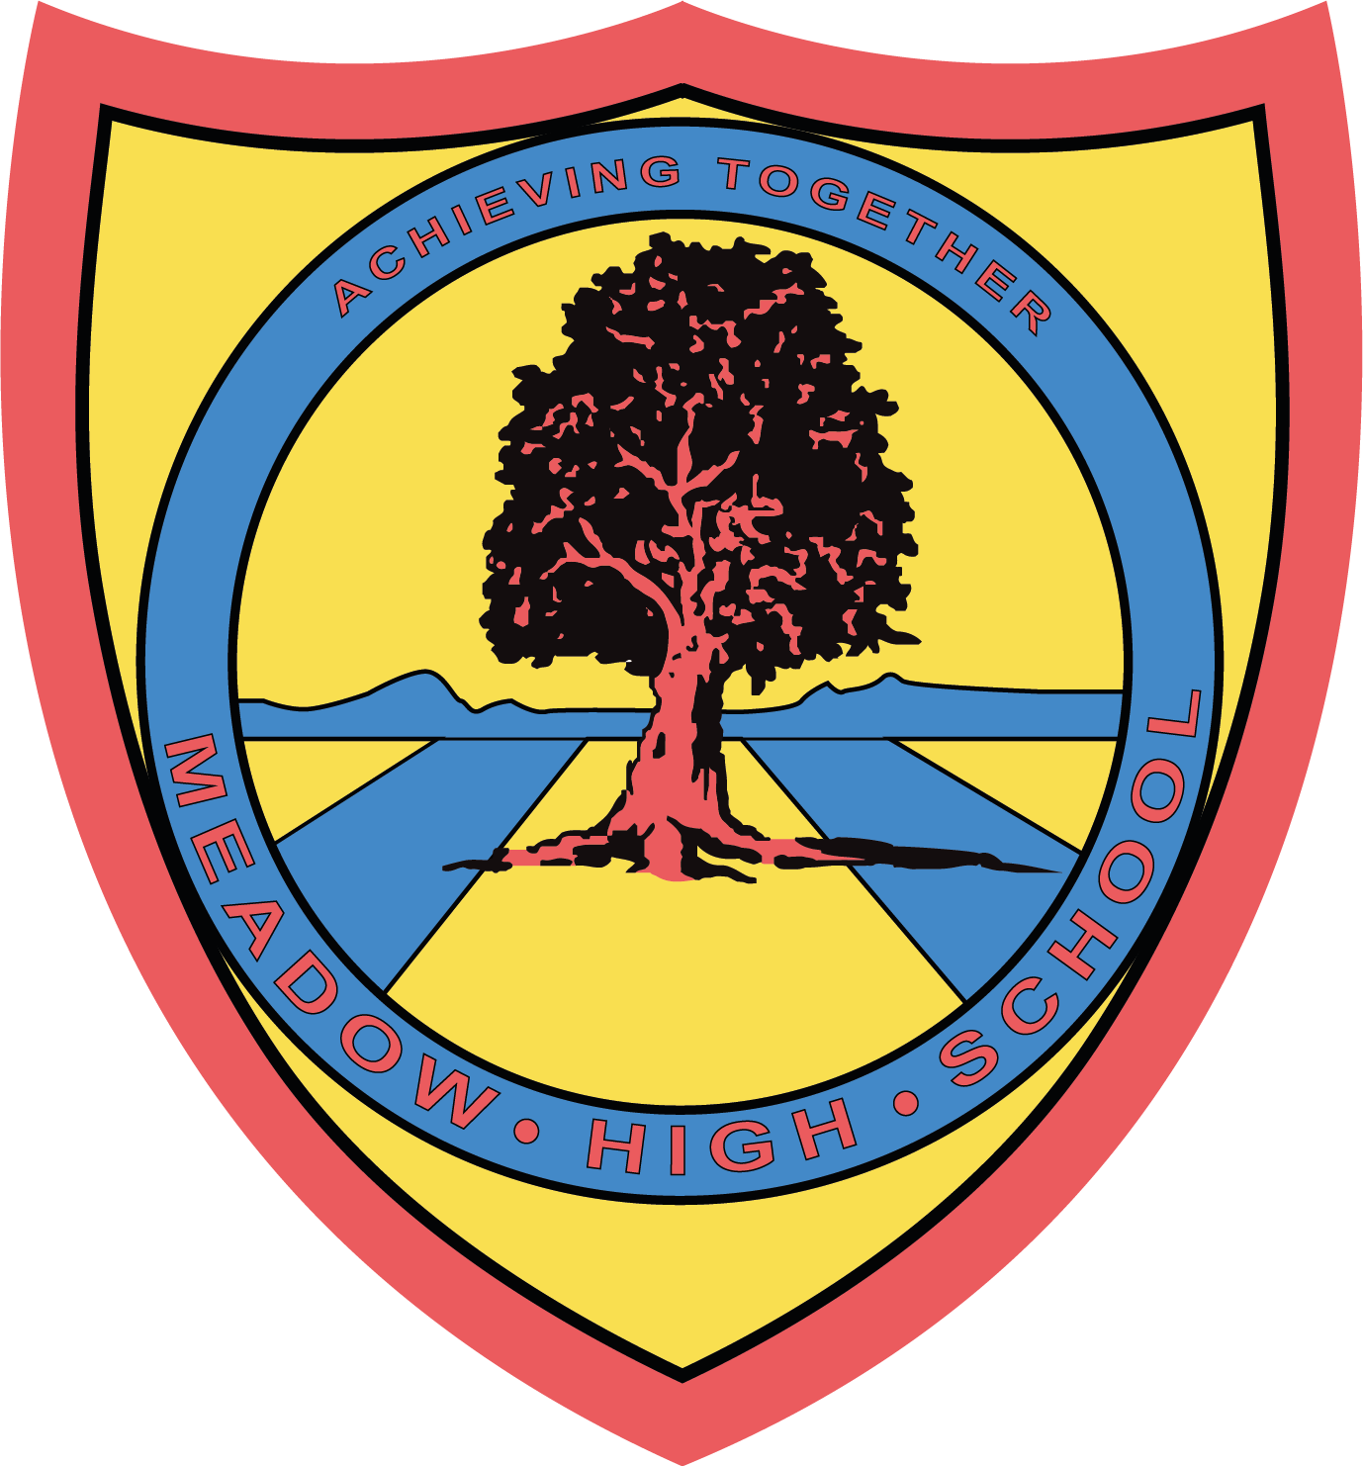

Tuesday 3rd June 2025
Dear Parent/Carer,

Trip to Basil and Crew Mobile Farm – Friday 6th June 2025

To support your child with their learning in PSHCE and Citizenship, we have been given the opportunity to visit a mobile farm near Slough called Basil and Crew.

We will be leaving school after registration at 9:30am and returning to school in time for normal lunchtime arrangements at 12:45pm. Your child will not need anything extra apart from a water bottle and a snack if wanted. A First-Aider will also accompany us.

We have been offered the experience free of charge, this includes a coach that will pick us up from school and bring us back. Therefore, you do not need to contribute anything.

Please could you return the reply slip below ONLY IF your child has an allergy or if there is something you would like to let us know. If not then this letter is just for your information and you do not need to send a reply slip back.

Yours sincerely,

Ms Sojka
Year 7 Form Tutor

Article 23:- 'A child with a disability has the right to live a full and decent life with dignity and independence, and to play an active part in the community.'



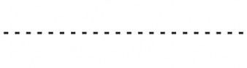
Reply-Slip: Basil and Crew Mobile Farm Trip: Friday 6th June 2025

My child …………………………………………………………….. has the following allergy/requires the following to be taken into consideration: ……………………………………………………………..…………………………………………………………..…………………………………

Signed …………………………………………………………… Date ……………………………………………………………………
(Parent/Carer)

