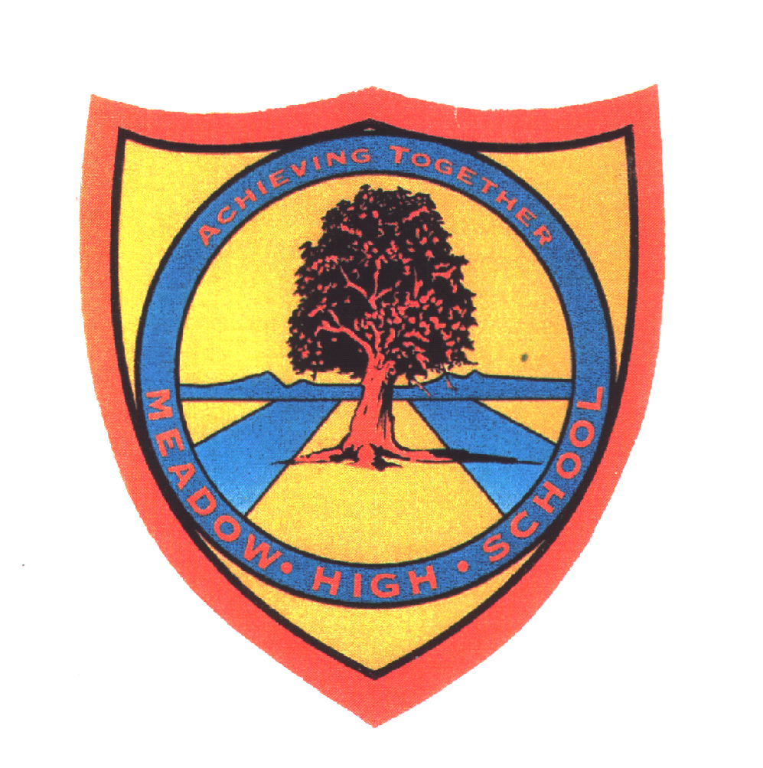 | Pathway 2-3 | Year ‘8’ Art and Design | ARTS- ‘Carousel’ SoW’  3 Term Rotation with Dance, Art & Drama combined
Learning Intention: Title: 8.1 ‘Buildings, Shapes & Architecture’
The intention of this painting and 3D Making Scheme of work is for pupils to develop awareness of the world around them and introduce them to a range of artist’s work and art styles which reflect some defining moments in Architecture and Design. Pupils are encouraged to make links between shapes, colours and styles of art and develop their ability to spot shapes and art styles in buildings around them and their city. More able pupils will start to form links between types of materials used and construction and develop understanding of how art can be used for the purpose of building, design and Architecture. The intention is to develop pupils' imagination and ability to describe the world around them, make comparisons and start to draw conclusions.
Key knowledge that should be learned during this SoW |  | All | Most | Some
Concept: |  | Starting to:  - Develop an interest in exploring shapes and colours of buildings in the surrounding world  - Develop an interest in using paint to express oneself through colour | Improving the ability to:  - Develop a passion for exploring the surrounding world shapes and building and other sources  - Reference some areas of personal experiences and or other sources  - Improve confidence in using paint to express oneself through colour, effects and and 3D material skills | Exploring the ability to:  - Develop a passion for exploring architecture developing an understanding that architects design buildings.  - Share areas of personal experience and or other sources  - Confident use of paint to express oneself through colour, effects and a range of 2D and 3D materials skills
Knowledge: |  | Develop understanding of aspects the following Knowledge:  - Develop knowledge of colour mixing  - Improve ability to spot basic shapes in buildings and Artwork by Mondrian, Kandinsky and the Geometric Art from Ndebele people from South Africa.  - Become familiar with painting styles used by Artists and start to show interest. | Develop a competent understanding of a range of the following Knowledge:  - Develop knowledge -mix Primary colours to get a new colour  - Improve knowledge of a range of lines and shapes in buildings and Artwork , showing interest asking and answering questions  - Develop knowledge of painting styles used by Artists identifying areas of interest. | Develop a confident understanding of a range of the following Knowledge:  - Develop knowledge of colour mixing developing understanding of Secondary colours  - Improve knowledge of a range of lines and shapes and effects in Architecture and Artwork , showing interest starting to explore comparative language discourse  - Confident in knowledge of painting styles used by Artists, showing understanding of styles, materials and tool use.
Key Skills: |  | Develop ability to interact with or use a range of the following skills with support:  - To develop painting effects  - Improve application of shape/line making with some recognisable shapes.  - Try watercolour wash painting skills (inspired by Kandinsky backgrounds) being able to drag the brush across the page  - Refine painting skills through exploring Artist’s shapes (Kandinsky/Mondrian/Ndebele)  - Develop design skills and create a 3D model/relief of a building from recycled materials with some support | Develop a competent ability to use a range of the following skills with some support:  - mixing paints with intent  - Making with recognisable changes to line thickness, direction and 2D shapes  - Experiment with a range of wash and colour mixing effects  - Refine painting skills selecting correct brush size with support  - Develop design skills and create a 3D model/relief of a building from recycled materials with occasional support | Develop a confident ability to use a range of the following skills independently:  - mixing paints with consistent intent in application  - Making with recognisable 2D and some 3D shapes and exploring less familiar shapes  - Explore a range of wash and colour mixing effects independently  - Refine painting skills selecting correct brush size independently  - Develop design skills and create a 3D model/relief of a building from recycled materials with almost no support
Language and/or communication skills: |  | LA-To start to use subject related language with some accuracy:  Art and Design:  - Shapes  - Music  - Primary Colours  - Orange/Green/Purple  - Line-shape  - Outline  - Oil pastel  - Watercolour  - Round brush  - Fireworks  - Recycle  - Design  - Model | MA-To use subject related language with increased regularity and accuracy:  Art and Design:  - Buildings  - Kandinsky  - Primary/Secondary Colours  - Colourwash  - Compare  - Flat brush  - Block-Colour  - Mixed-Colour  - Pattern  - 2D Plan  - 3D Plan | HA-To explore subject related language with confidence and fluency:  Art and Design:  - Architecture/Architect  - Inspired  - Colour-Tone  - Detail  - Abstract  - Mondrian  - Mahlangu  - Ndebele Geometric Design  - Line-Texture or Thickness  - Effects  - Abstract  - Refine  - 3D Relief
Curricular Links |  | Art developing basic painting and 3d making skills  SMSC/PSHCE- Learning about artists from different cultures, developing personal experiences and understanding of the world around them  learning about vocational art such as architecture.  Spiral Learning linking to Year 7 Art and Drama -SoW ‘Getting to know each other’ where pupils learn about expressive painting and basic watercolour skills  Year 8 Art and Drama-‘Puppets, Props & Stunts’ where pupils learn to make 3D spheres/features and recognise shapes  6E Rotation 1 Spring Term-East African Patterns  Computing- Powerpoint and Home learning research  Literacy- Reading, Writing, Speaking and Listening. Numeracy-Proportions  Cross Curricular Links to Science materials and Maths- Geometry, Shapes, Scale, line and Measure

Talking points
Talking Points-Artists, Buildings, Kandinsky, Mondrian, Esther Mahlangu Ndebele and Hundertwasser, Generic familiar buildings- home, School, shops, Churches, Mosques, Shopping Centres.
Relevant Links:

- https://www.artsy.net/artist/esther-mahlangu

- http://www.hundertwasser.com/

- http://www.wassilykandinsky.net/

Wider talking points to develop cultural capital and depth of language and linking of ideas:
Discussing famous buildings and landmarks e.g. Eiffel Tower, Statue of Liberty, Buckingham palace, Windsor Castle.
Discussing how different people can live and work together in large and small communities
Opportunities for Wider vocabulary:

Towers, sky scrapers, Cottages, bungalows, places of worship, Communities, Famous Female Architects

Implementation
Main Focus History of Art: Introduction to opposing Architecture/Art styles developing wider knowledge in Art, Design and Architecture.
- Expressive wash and line effects painting-Kandinsky
- Block Colour Geometric lines - Mondrian & Esther Mahlangu Ndebele
- Firework painting -mixed colours, loose line, Texture
Learning Through Comparisons and Design Exploration:. Opportunities-visual comparison discourse
- Pupils’ responses to Artist’s work should be personal yet linked to observed tool/colour/line effects
- The first part of the unit focuses on understanding exploring and recognising lines, shapes and colours in Architecture and Artists styles making comparisons and drawing visual conclusions
- The second half focuses on developing the planning and design skills understanding how Architects plan and make 3D models.
- Work is scaffolded to support pupils ability to work more independently and extension work provided by th eTeacher
Assessment:
Comparative Assessment comparing main styles of application they have worked with to improve pupils analytical skills
- Assessment -Improve ability to discuss Art styles, comparing paintings of loose Fireworks with Mondrian’s tight line style
Impact
Core Outcomes
- 1.Research in pairs using ICT skills, selecting images to create an Architecture Moodboard
- 2. Develop drawing skills using line and shape responding to set music
- 3. Take inspiration from Kandinsky to explore Watercolour and poster paint effects and developing application knowledge
- 4. Assessment -Improve ability to discuss Art styles, comparing paintings of loose Fireworks with Mondrian and Ndebele Art tight line style
- 5.Develop 2D and3D planning skills, creating a recycled cardboard building relief/Model, inspired by Artists and Architecture
Wider Impact
- A drawing, painting and 3D making project.
- Career Links-Pupils will be inspired by other artist’s building designs, Architects and Painters use of shape and paint effects.
- Career Links-Learn to express themselves through painting to music and creating their own buildings developing design skills and related knowledge for world of work-Design related employment
- Life skills-Developing the ability to analyse, compare and form opinions on visual information, improve ability to recognise buildings and places around them
- Broadening descriptive vocabulary and visual Maths understanding.

