Meadow High School
Royal Lane, Hillingdon, Middlesex UB8 3QU

Telephone: (01895) 443310
Email: meadow@meadowhighschool.org
Website: www.meadowhighschool.org

Headteacher: Mrs Jenny Rigby
Deputy Headteacher: Ms Claire Caddell
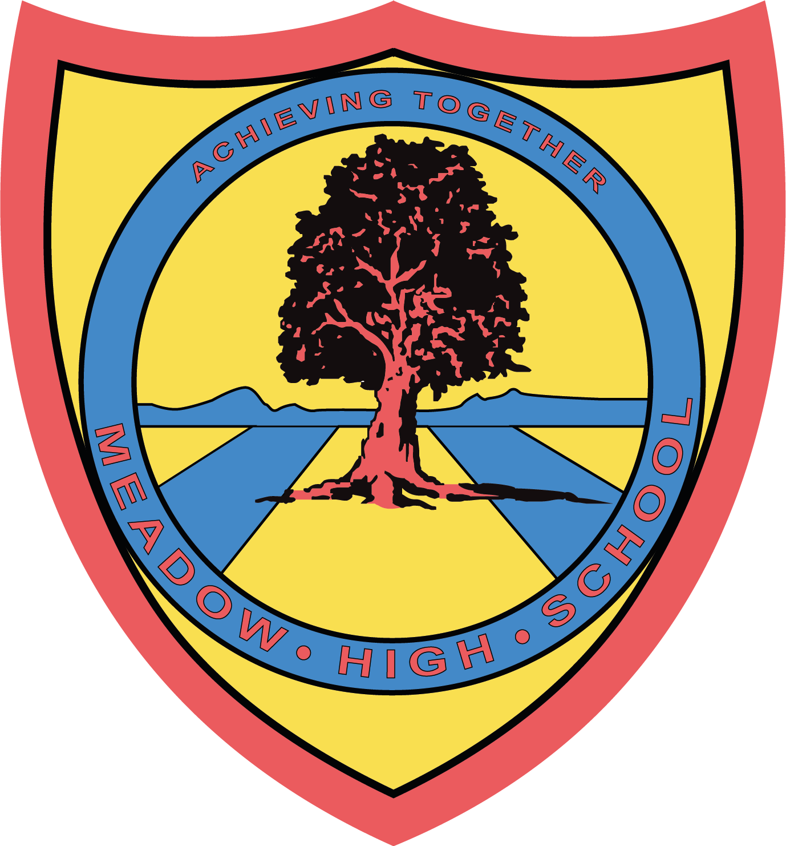


March 2023

World Down Syndrome Day
Lots of Socks Campaign
Tuesday 21st March 2023

Dear Parents/Carers,
We will be celebrating ‘World Down Syndrome Day’ on Tuesday 21st March 2023 by taking part in the Lots of Socks Campaign.
All you need to do is choose some socks that are going to be noticed - they might be mismatched or your craziest and most colourful socks!
This is NOT a non-uniform day, so please send your child in their full school uniform, showing off their fun socks!
https://lotsofsocks.worlddownsyndromeday.org/
Please follow the link above if you would like to learn more about this campaign raising awareness for Down Syndrome.
Yours sincerely,

Mrs Mistry
AHT Workforce Development

