Meadow High School
Royal Lane, Hillingdon, Middlesex UB8 3QU

Telephone: (01895) 443310
Email: meadow@meadowhighschool.org
Website: www.meadowhighschool.org

Headteacher: Mrs Jenny Rigby
Deputy Headteacher: Ms Claire Caddell

Dear Parents/Carers, 1st March 2023

Re: Celebrating Our Diverse Community: One World – The LEX the Dragon Project

At Meadow High School we have a rich and diverse community of staff and students. As you know, we have recently invested in a wide range of new books for our library to ensure this is fully represented. One World – The LEX Project is an update on a project we ran a few years ago. Our aim is build a school community based on respect and appreciation of the opportunity to learn from each other, enabling our students to ‘achieve together’ and become productive and positive members of society.

So, the story of LEX* the dragon…
Lex the Dragon has flown into the grounds of Meadow High School and needs our help. LEX loves to travel and has flown all around the world, learning about how people live in different countries, trying different food, listening to different sounds and languages. LEX has enjoyed travelling so much it has changed their ideas about the world and the markings on their scales. LEX is now covered in flags from all around the world but needs our MHS students to add the correct colours to the flags.
[*LEX – short for Lexicon – means the vocabulary of language, ours at MHS is made up of many languages, about 21 at the moment, and of course signing too!]

If you would like your child to have the opportunity to help paint Lex, complete the attached slip or email asugden@meadowhighschool.org. Please let us know if you have someone in your family who has a connection with another country. It might be they
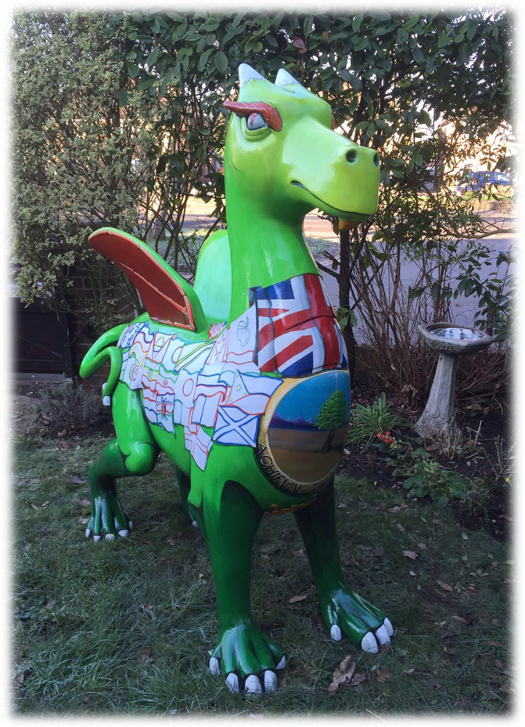
- moved to live in another country
- lived in another country for a while,
- go on holiday to this country regularly/or a special holiday
- moved from another country to live here.

It will be lovely to gain a picture of just what a global community
we are. Last time we had connections with 44 countries – let’s see
if we can beat that this time! We’re going to log all the places on a
map of the world and display it in school. We will make sure
all students who reply have the opportunity to help paint Lex,
where possible, the flag of the country they have a link to.
Finally, LEX will take their place at the front of our school.

If you have any questions please feel free to contact us.

Yours faithfully,

Mrs. Sugden, Ms Sojka
English & Communication Faculty Leader EAL & Reading Intervention Manager

One World: The Lex the Dragon Project
[Completed slips to be handed to Mrs Sugden in room 26.]

I give my permission for my child ________________________________________ Form ____________
to take part in the above project.

( ) The country we have a connection with is

Please add further information if you wish about this connection e.g. has an auntie who moved to California U.S.A. 5 years ago. (You can explain in more detail if you wish.)

_______

_____________

_______

__________ _

Signed: _________________________________________

PRINT NAME: ____________________________________

