Meadow High School
Royal Lane, Hillingdon, Middlesex UB8 3QU

Telephone: (01895) 443310
Email: meadow@meadowhighschool.org
Website: www.meadowhighschool.org

Headteacher: Mrs Jenny Rigby
Deputy Headteacher: Ms Claire Caddell
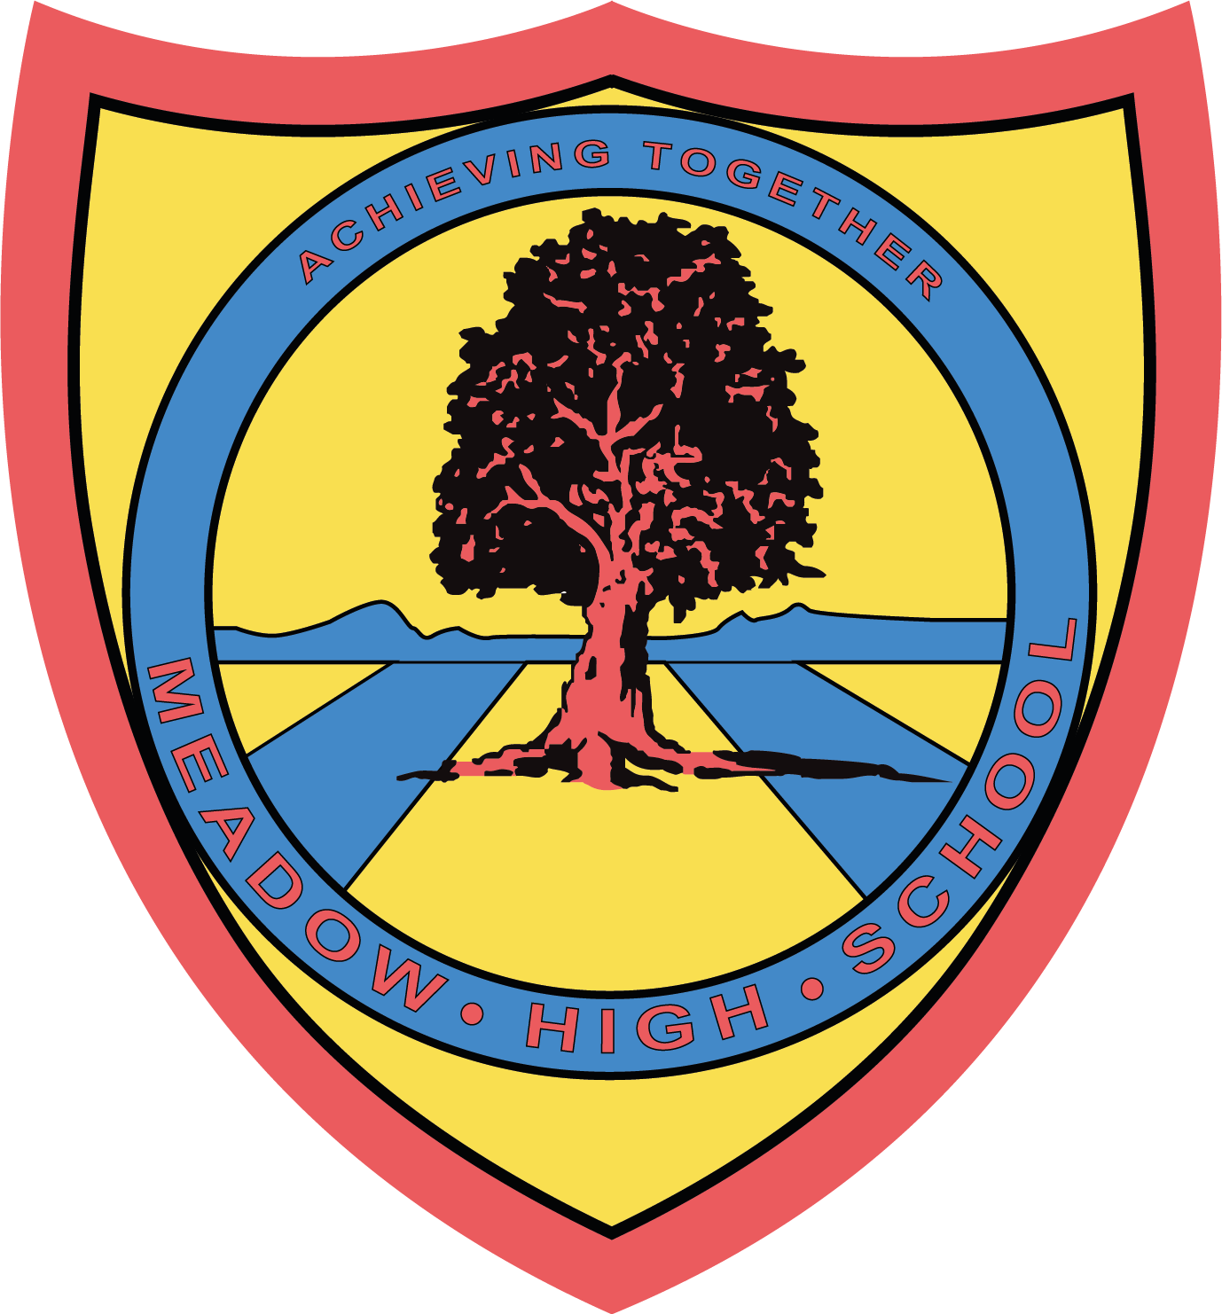

2nd October 2023

Dear Parents/Carers,

As part of Work Experience, Class AP are working at a care home each Monday. They will be undertaking a range of jobs including window cleaning, gardening, washing up, chatting to residents and general tidying and cleaning. Pupils will be working outside, so need to wear old clothes and have a coat with them. Please ensure pupils are dressed suitably on Mondays for outdoor working.
Yours sincerely,


Faye Bonnar
Assistant Head Teacher Pathway 1

Article 23:- 'A child with a disability has the right to live a full and decent life with dignity and independence, and to play an active part in the community.'


