Meadow High School
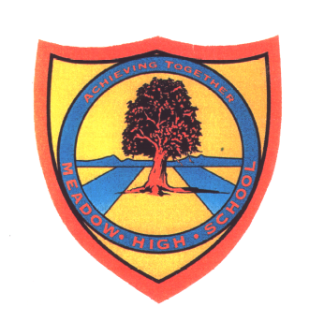
Royal Lane, Hillingdon, Middlesex UB8 3QU

Telephone: (01895) 443310
Email: meadow@meadowhighschool.org
Website: www.meadowhighschool.org

Headteacher: Mrs Jenny Rigby
Deputy Headteacher: Ms Claire Caddell

5th September 2022

Dear Parents/ Carers,

Girls Only Middlesex FA Tournament

Your child has been selected to attend the Girls Only Football Event on Wednesday 12th October. The event will be taking place between 09:50 – 12:40, so no extra travel arrangements need to be made. Pupils will also be back for normal lunch arrangements. On the day, your child should come into school in their PE kit with shin pads.

If you have any questions just let me know.

Kind regards,

Mr. Anstee
PE Teacher
@MeadowPE

