Meadow High School
Royal Lane, Hillingdon, Middlesex UB8 3QU

Telephone: (01895) 443310
Email: meadow@meadowhighschool.org
Website: www.meadowhighschool.org

Headteacher: Mrs Jenny Rigby
Deputy Headteacher (Royal Lane): Miss Michelle Taylor
Deputy Headteacher (Northwood Road): Miss Amy Willis
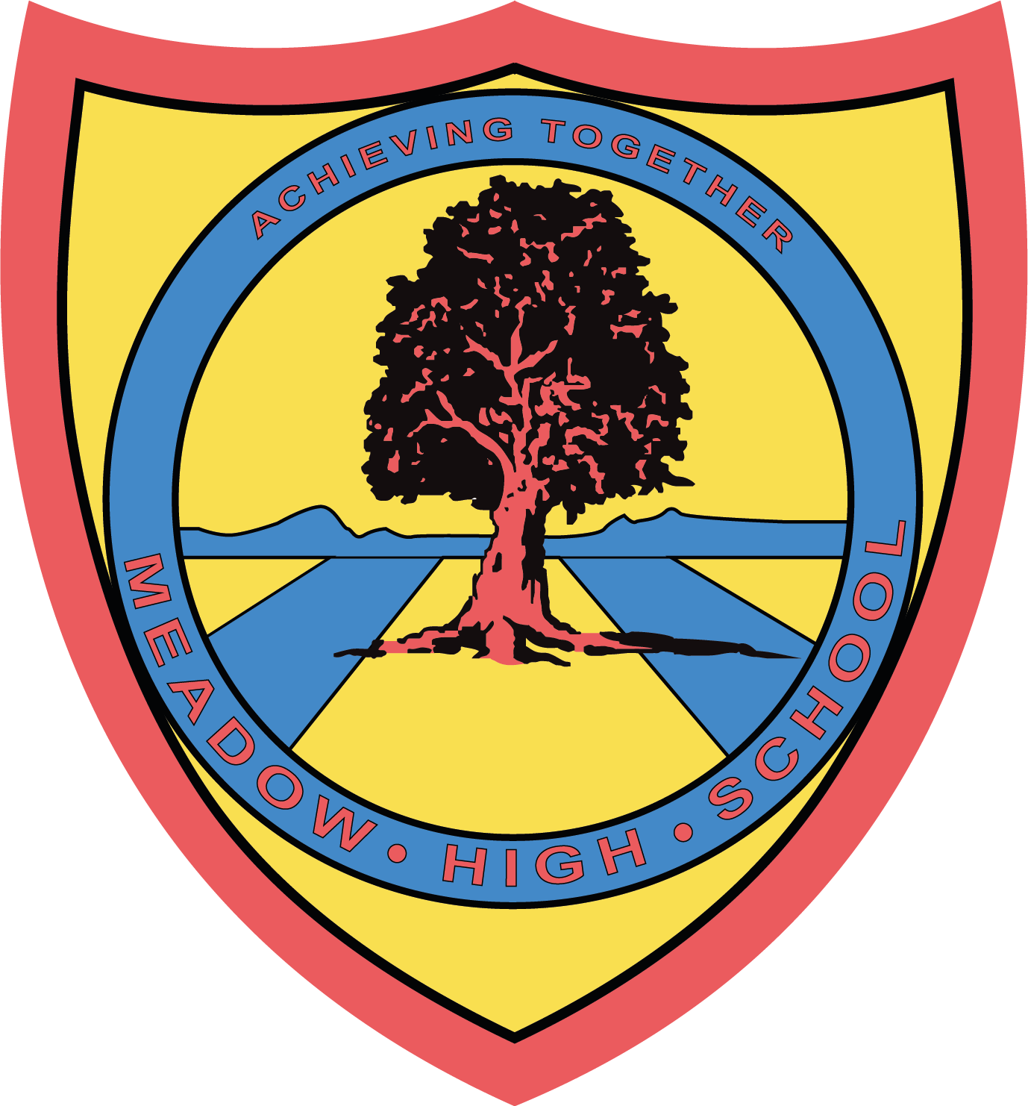

9th June 2025
Dear Parents/Carers,

I am writing to inform you that your child will be visiting the Higgins construction projects in Hayes town centre on 13/06/2025 as part of the Career’s visit to a local employer.

The sites address are -
- 3 Wellings House, 236 Avondale Drive, Hayes UB3 3PN
- Avondale Drive Estate, Phase 1a Avondale Drive, Hayes UB3 3PP

Students and school staff members will leave school around 10.00 am on the school minibus and will be returning to school by 12:30 pm. During the visit, students will have an opportunity to learn about the company, build knowledge of various job roles within the construction sector, meet with professionals/skilled labour and tour the construction sites. Students will not carry out any practical tasks due to the nature of the business and risk involved. This trip is free of charge and doesn’t require any contribution.

Please note: this visit can be cancelled or postponed at any time due to unforeseen circumstances.

Should you have any questions, please do not hesitate to email me on: skabhoo@meadowschool.co.uk or call school on 01895 443310 ext. 244
Yours Sincerely,

Mrs Kabhoo
Trip Organiser

Article 23:- 'A child with a disability has the right to live a full and decent life with dignity and independence, and to play an active part in the community.'


____________________________________________________________________________________
Brompton Photo Permission Slip - Please sign and return this slip if you give permission for the photo to be taken by the hosting organisation for their internal and external publication purposes.

Child name - _____________________ Form - ____________

Parent name - ____________________

Signature of parent - __________________ Date - ______________

