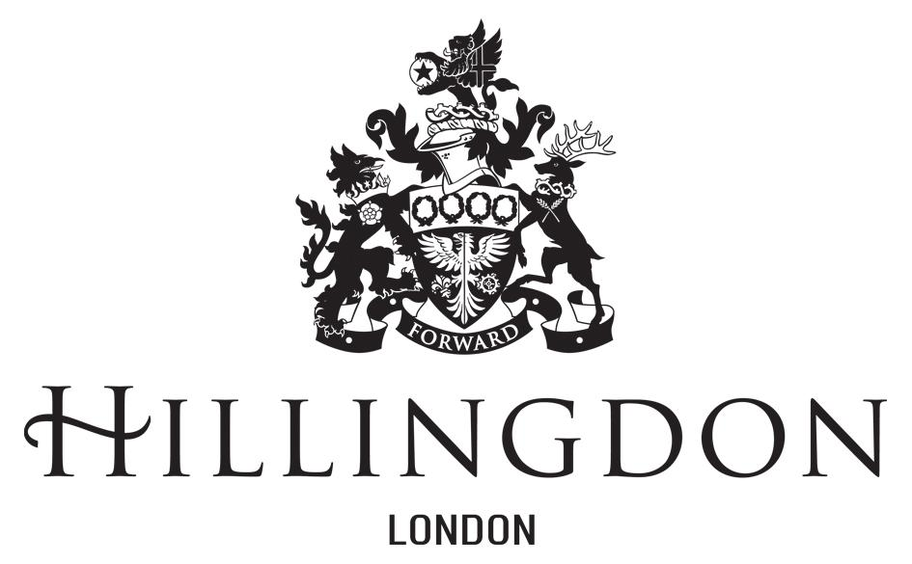

YEAR 6 2022-23 Bikeability Level 1&2 -Meadow High School (AM Only), Course 1

Dear Parent/Guardian

On behalf of your child’s school, I am writing to invite your child to a safer cycling course, which will enable them to complete Levels 1 and 2 combined.

The training is scheduled to take place on our Cycle Track at Pield Heath House School with additional staff from Meadow High School escorting and accompanying the children.

Course Information:
The course will run for 4 days for 2 hours each session.

Monday 13th March 2023 (c1) | Level 1 | 9:30 – 11:30
Tuesday 14th March 2023 (c1) | Level 2 | 9:30 – 11:30
Wednesday 15th March 2023 (c1) | Level 2 | 9:30 – 11:30
Thursday 16th March 2023 (c1) | Level 2 | 9:30 – 11:30

You can apply for your child to attend this course by completing the online booking form via the link below

Online Bikeability Booking Form

Applicants will be registered on a first come first serve basis.

Yours sincerely,
Ian Ramsay

Ian Ramsay
Borough Cycle Support Officer

To find out more about Bikeability visit https://bikeability.org.uk/

