Meadow High School
Royal Lane, Hillingdon, Middlesex UB8 3QU

Telephone: (01895) 443310
Email: meadow@meadowhighschool.org
Website: www.meadowhighschool.org

Headteacher: Mrs Jenny Rigby
Deputy Headteacher: Ms Claire Caddell
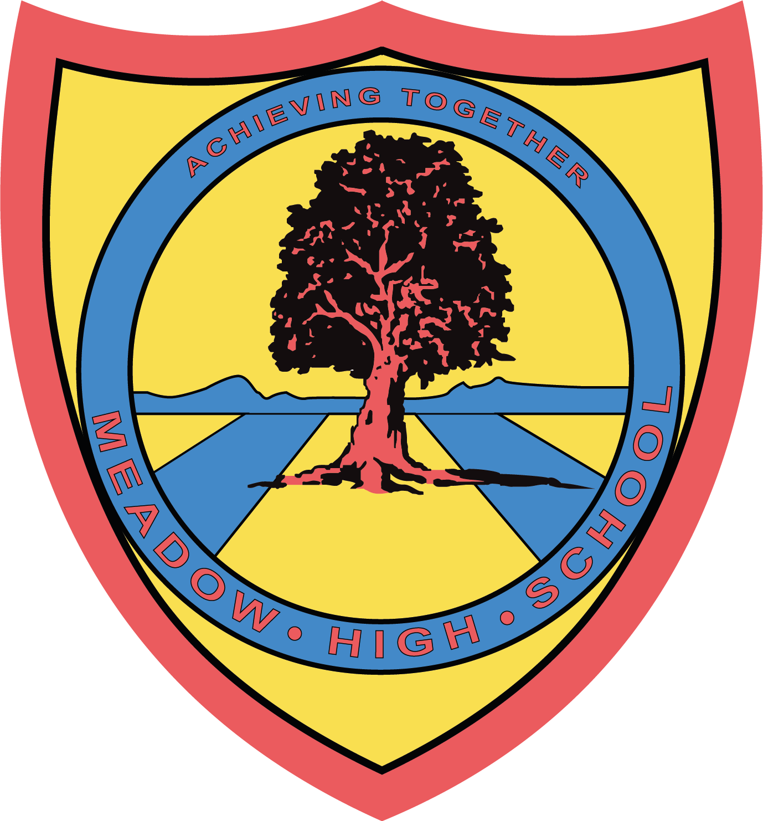

Dear Parents/Carers,
Residential Trip to Centre Parcs 2024

I am writing to inform you following this year's successful residential trip to Centre Parcs, Woburn Forest in Bedford, we are pleased to be proposing, subject to uptake, the following opportunities. As this has become an annual event and highly successful we are proposing two trips next year of differing level of challenge. Students can only the maximum of one of the trips.

We are currently liaising with the Duke of Edinburgh scheme to see if this trip can meet some of the residential requirements for the students undertaking the ‘gold’ level. There will be additional Duke of Edinburgh trips for specific students, these families will have received letters about these opportunities from Miss Bonnar. Students are welcome to attend both the Duke of Edinburgh residential and the Center Parcs Residential in the same academic year.

Option 1
Center Parcs Woburn Forest, Bedfordshire

We have provisionally booked for Monday 20th May - Friday 24th May 2024. We have booked a range of accommodation, including provision for those who require additional accessibility. This trip is open to all students in Year 10-14 inclusive in the 2023-2024 academic year.

The offer of places will be completed in the following priority order:
- To ensure single sex accommodation groupings.
- Key Stage 5 students who have not previously been.
- Key Stage 4 students who have not previously been.
- Students who can only access this trip, regardless of age due to a physical or medical need.
- Key Stage 5 students who have previously attended.
- Key Stage 4 students who have previously attended.

Option 2
Center Parcs Park de Haan, Belgium

We have set provisional dates of Monday 25th April - Friday 29th April 2024.

This option is open to students who have previously successfully attended a school residential to Woburn Forest and are seeking a new level of Challenge. We will access this trip via the Euro Tunnel and the total driving time is approximately 4 hours. Students will require a valid passport and a UK Global Health Insurance Card (GHIC), which is free to order online.

We regret this option would not be accessible to those who use a wheelchair or those who require specialist carer support, i.e. nursing care. For these students we ask for those to attend Option 1.

- To ensure single sex accommodation groupings.
- Key Stage 5 students who have previously attended.
- Key Stage 4 students who have previously attended.

Both trips will give pupils the opportunity to take part in life skills, cooking, team building and outdoor activities; such as swimming, walking, cycling and accessing an indoor climbing wall. There are comprehensive facilities available on site including a medical center, shops, restaurants and cafes. This is a great opportunity for the young people to improve their confidence and independence and create some great memories.

The cost of both trips is estimated and likely to be in the region of £350 per student. This cost includes all transportation, accommodation, food, staffing and access to daily activities. We are able to subsidise this trip for those eligible for pupil premium (free school meals) at a cost of £100. If you are not sure of your young person's status please contact the class team or school office who will be happy to confirm.

Once expressions of interest have been received, we will contact those interested with an offer of a place or an indication of their position on the waiting list if applicable. At this point a 10% non-refundable deposit is required. Payment plans can be arranged to help spread the cost over the period leading up to the trip.

If you have any questions regarding this trip please do not hesitate to contact me on awillis@meadowhighschool.org or on 01895443310. Most parents have some anxieties but we have worked previously to overcome personal care, food difficulties and students with very specific medical needs to ensure this trip can be inclusive to all. If you have any concerns, please do not hesitate to explore these barriers with us, so we can put appropriate in place to maintain the inclusive nature of our residential offer.

If you are interested please complete the slip by Monday 3rd July.

Best wishes to you all,

Miss Amy Willis
Assistant Headteacher- Pathway 1

Article 23:- 'A child with a disability has the right to live a full and decent life with dignity and independence, and to play an active part in the community.'



Reply Slip - Residential trip to Center Parcs:

I would like my child ____________________________________ (name) in class _________
to be considered for a place on the Centre Parcs residential trip.

I would like to be considered for the following trip/s: (please circle which trip you are interested in).

Option 1: Center Parcs Woburn Forest
Monday 20th May -Friday 24th May 2024

-or-

Option 2: Center Parcs Park de Haan, Belgium
Monday 25th April- Friday 29th April 2024.

Signed________________________________

Please return to Miss Willis no later than Monday 3rd July.

