Key Stage 4 ICT Cycle 2 Autumn
Technology through time

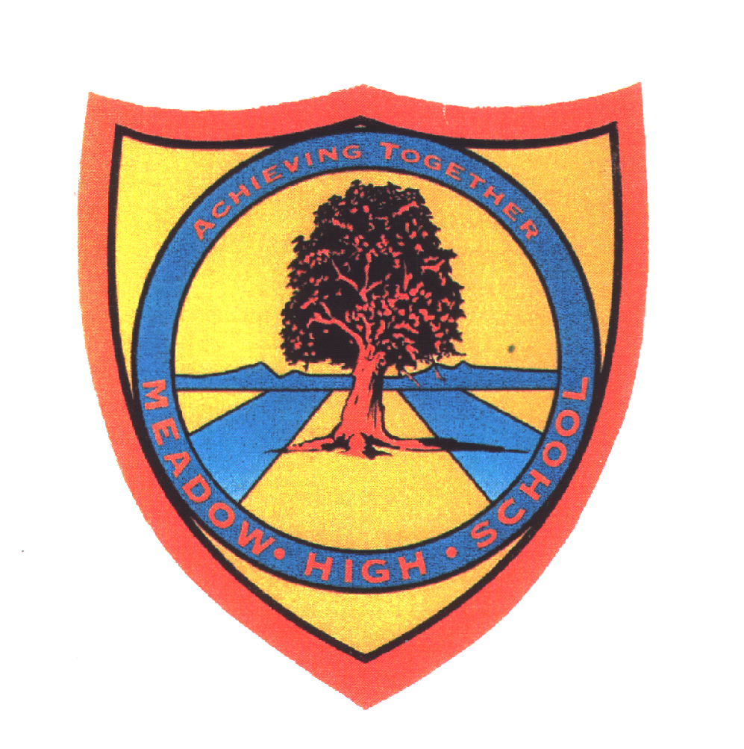 | Pathway 1 | Cycle 2  KS 4 (Pathways 1) | Term Autumn
Learning Intention: This SOW aims to teach the changes in technology through time, the concepts of past and present, the differences between devices in the past and present and their uses. In the end, some pupils will be able to imagine what future devices may look like.
Key knowledge that should be learned during this SoW |  | All | Most | Some
Concept: |  | The pupils will understand the concept of present. | The pupils will understand the concepts of past and present. | In addition to the previous, the pupils will understand the concept of different.
Knowledge: |  | The pupils will understand that technology changes through time. | The pupils will understand the exact changes in technology through time. | The pupils will understand the differences between different devices in the past and present.
Key Skills: |  | The pupils will be able to name and sort devices that are used in the present. | The pupils will be able to sort devices in the past and present. | The pupils will be able to sort devices in the past and present and explain the differences between them.
Language and/or communication skills: |  | The pupils will be able to name various devices and talk about what they look like in the present. The pupils will gain descriptive language skills that they can use in the future. The pupils will learn the following keywords: Past, present, technology, change, Ipad, Internet, devices. | The pupils will be able to talk about various devices in the past and present. They will also be able to explain their uses. The pupils will learn the following keywords: Past, present, technology, change, Ipad, Internet, device, storage device, difference. | In addition to the previous, the pupils will be able to explain the exact differences between devices in the past and present. They will also be able to think and try to explain what the devices may look like in the future. The pupils will learn the following keywords: Past, present, technology, change, Ipad, Internet, devices, interview, society, employees, storage device, difference.
Curricular Links |  | Links to other learning within the subject and spiral learning links: Use of devices, sorting of devices, use of the Internet, use of the Ipads.  Cross-curriculum links: History (past and present), PSHCE, English: speaking and listening

