KS4 Cycle 1 Autumn 1 Food tech/Healthy living Exploring Food

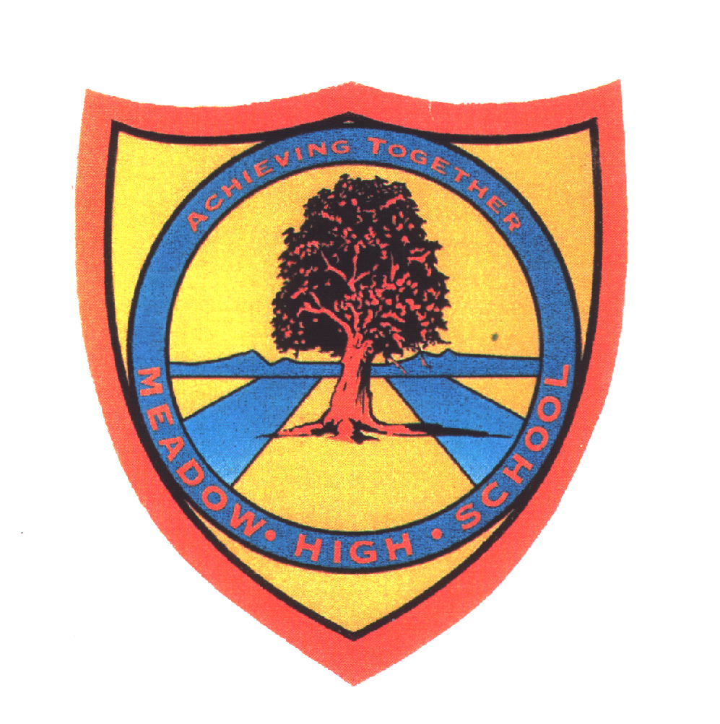 | Pathway 1 | Food Tech  KS4  Cycle 1 | Autumn 1  Exploring Food
Learning Intention: Pupils will explore food through taste, texture, smell, and sight. Pupils will be encouraged to try new foods and expand what foods they are familiar with. Pupils will learn about how ingredients make up our favourite foods and learn some simple processes of how food is made and manufactured.
Key knowledge that should be learned during this SoW |  | All | Most | Some
Concept: |  | That we all need food to survive.  The importance of food. | The importance of having a variety of foods which we choose to eat. | Explore foods including how different foods are made at home and how some are produced in factories.
Knowledge: |  | Where some foods come from.  Sort foods into categories. | That some foods come from plants and some animals..  Know some ingredients in basic food and where they are found/come from. | How different foods and made at home and how some are produced in factories.
Key Skills: |  | Be exposed to new foods.  Explore new foods positivity. . | Expand their food choices.  Try new foods. | Make informed choices about the food they eat.  Sort foods into types.
Language and/or communication skills: |  | Pupils will learn words which can be used to sort foods - words related to size, colour, texture. | Pupils will learn and be able to use words to detail where foods come from and what they contain - hot, cold, plant, animal, ingredients.  Pupils will also be able to describe foods by sight, smell and taste using designing words such as big, bigger, small, smaller, round, long, lots, many. | Pupils will be able to sequence simply how some foods are produced/made. Pupils will use language such as first, second, then, last.
Curricular Links |  | PSHCE  S+L

