Meadow High School
Royal Lane, Hillingdon, Middlesex UB8 3QU

Telephone: (01895) 443310
Email: meadow@meadowhighschool.org
Website: www.meadowhighschool.org

Headteacher: Mrs Jenny Rigby
Deputy Headteacher PW2/3: Ms Claire Caddell
Deputy Headteacher PW1: Miss Amy Willis
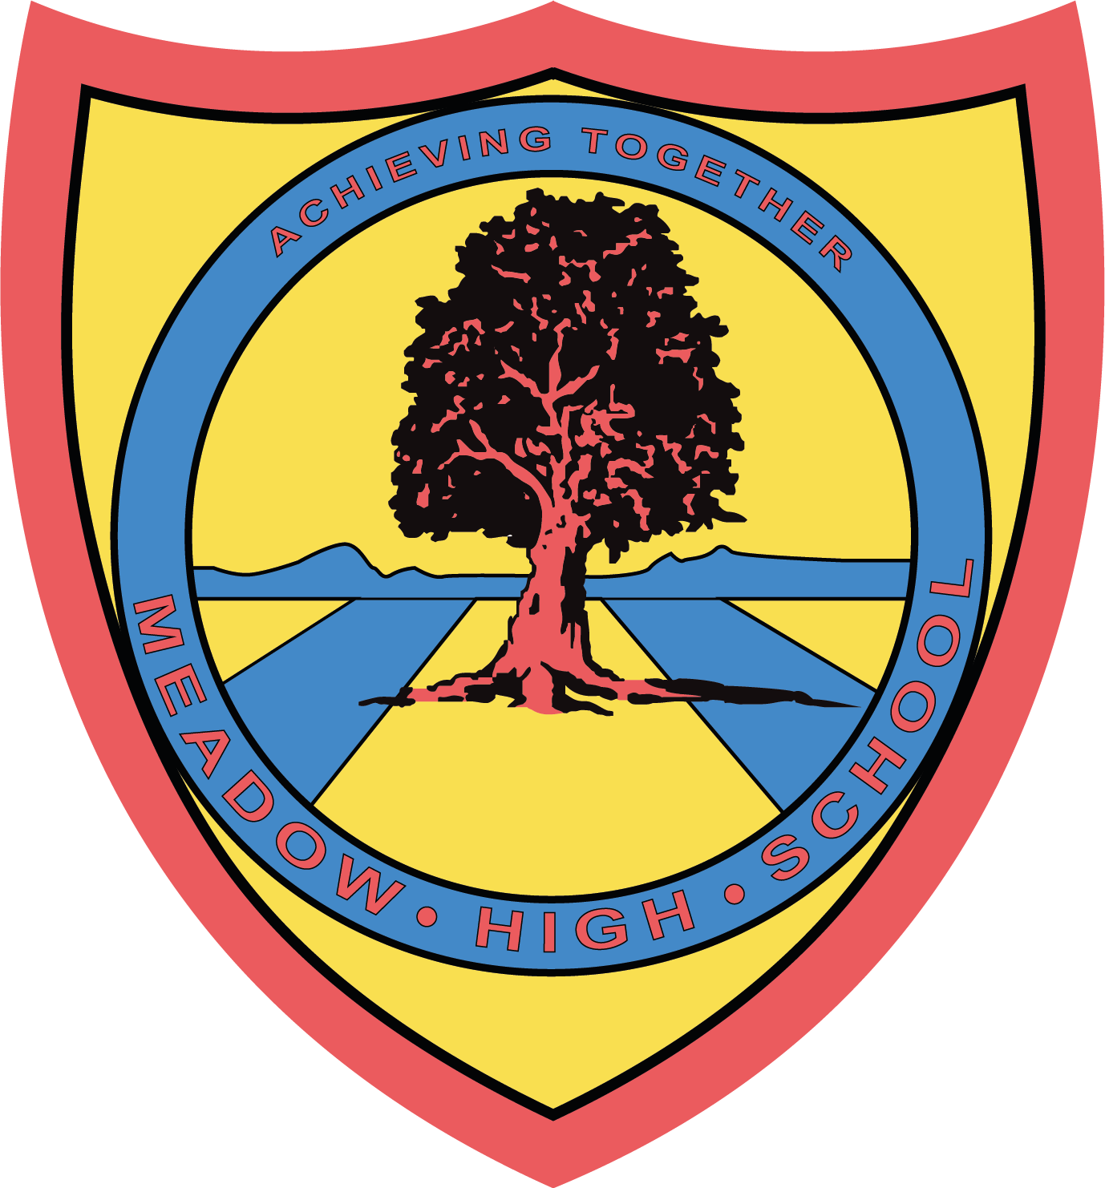

Thursday 23rd November 2023

Dear Parent/Carer,

Part of our Library refurbishment has given us the opportunity to acquire lots of amazing new books for our students to read. This is really exciting and has ensured we are working towards our school aim of being a safe, welcoming environment which celebrates diversity.

Books can be borrowed for two weeks, after which they will need to be returned to the Library. If your child wishes to borrow their book(s) for longer than two weeks, they must speak to the Librarian.

As you will appreciate, new books are expensive, and the Librarian keeps track to ensure books are being returned on time. If book(s) are not returned, are lost or damaged beyond repair, a letter will be sent home asking for payment towards a replacement.

Unfortunately, there is no alternative but to implement this course of action. Pupils who fail to return or lose their Library books will be able to continue to enjoy books in the library but not be able to borrow Library books until payment has been made. Please note that the Librarian will take any extenuating circumstances into consideration before issuing payment requests for replacements, and will discuss this with your child’s form tutor.

If your child has any school Library books at home, please return them to school as soon as possible.

If you have any questions, please contact the Librarian, Miss S Gaafar, at sgaafar@meadowhighschool.org.

Kind Regards,

Miss S Gaafar - Librarian
Mrs A Sugden - English & Communication Faculty Leader

Article 23:- 'A child with a disability has the right to live a full and decent life with dignity and independence, and to play an active part in the community.'


