Meadow High School
Royal Lane, Hillingdon, Middlesex UB8 3QU

Telephone: (01895) 443310
Email: meadow@meadowhighschool.org
Website: www.meadowhighschool.org

Headteacher: Mrs Jenny Rigby
Deputy Headteacher (Royal Lane): Miss Michelle Taylor
Deputy Headteacher (Northwood Road): Miss Amy Willis
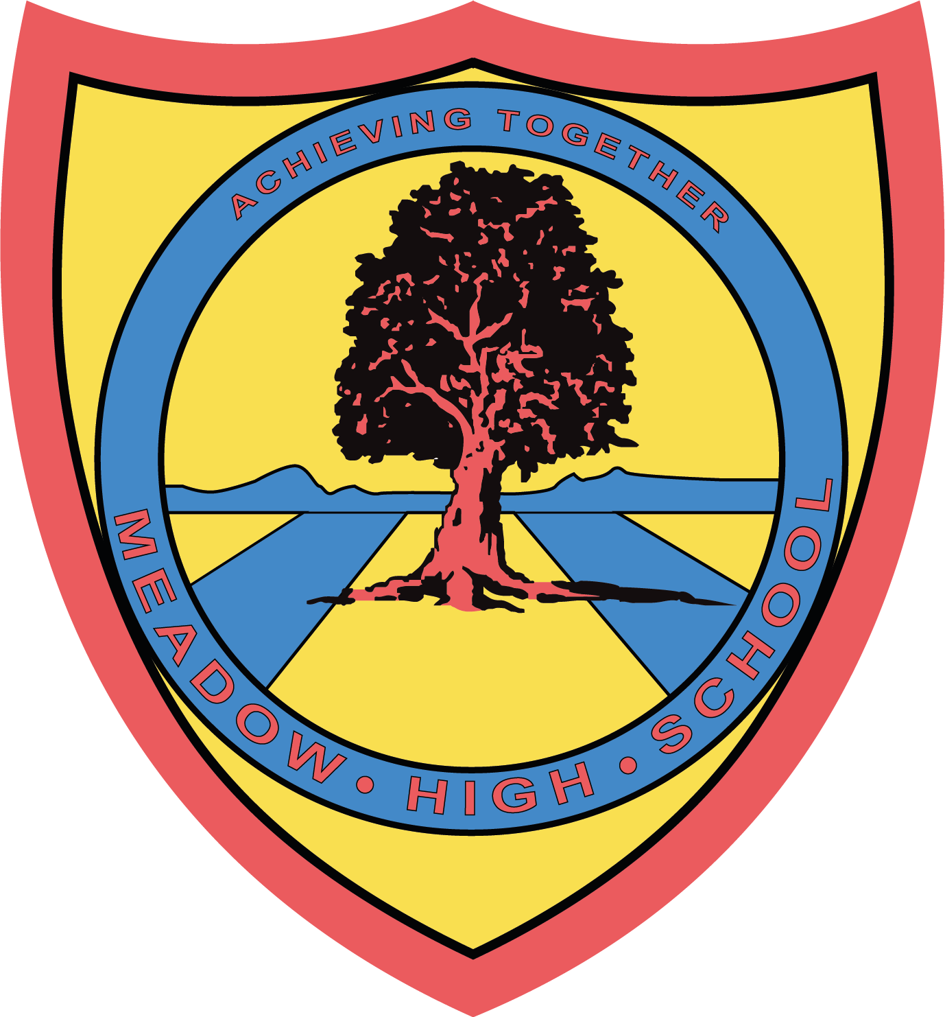

12th June 2025
Dear Parents/Carers,

I am writing to inform you that your child will be visiting the bicycle factory in Greenford on 17/06/2025 as part of the Career’s visit to a local employer.

The site address is -
Brompton workshop
Unit 1 Greenford park
Ockham Drive
Greenford UB6 0FD

Students and school staff members will leave school around 9:15 am on the school minibus and will be returning to school by 12:45pm. During the visit, students will have an opportunity to learn about the background of the company, tour the site, build knowledge of various job roles, meet with professionals and see the assembly line. Students might get an opportunity to ride their bicycles. This trip is free of charge and doesn’t require any contribution.

Please note- This visit can be cancelled or postponed at any time due to unforeseen circumstances.

Should you have any questions, please do not hesitate to email me on: skabhoo@meadowschool.co.uk or call school on 01895 443310 ext. 244

Yours Sincerely,

Mrs Kabhoo
Trip organiser

Article 23:- 'A child with a disability has the right to live a full and decent life with dignity and independence, and to play an active part in the community.'


____________________________________________________________________________________
Brompton Photo Permission Slip
Please sign and return this slip if you give permission for the photo to be taken by the hosting organisation for their internal and external publication purposes.

Child name: _____________________________________________ Form: ____________

Parent name: _________________________________

Signature of parent: ______________________________________ Date: ______________

