KS3 Cycle 3 Art Summer 1 All about Bears

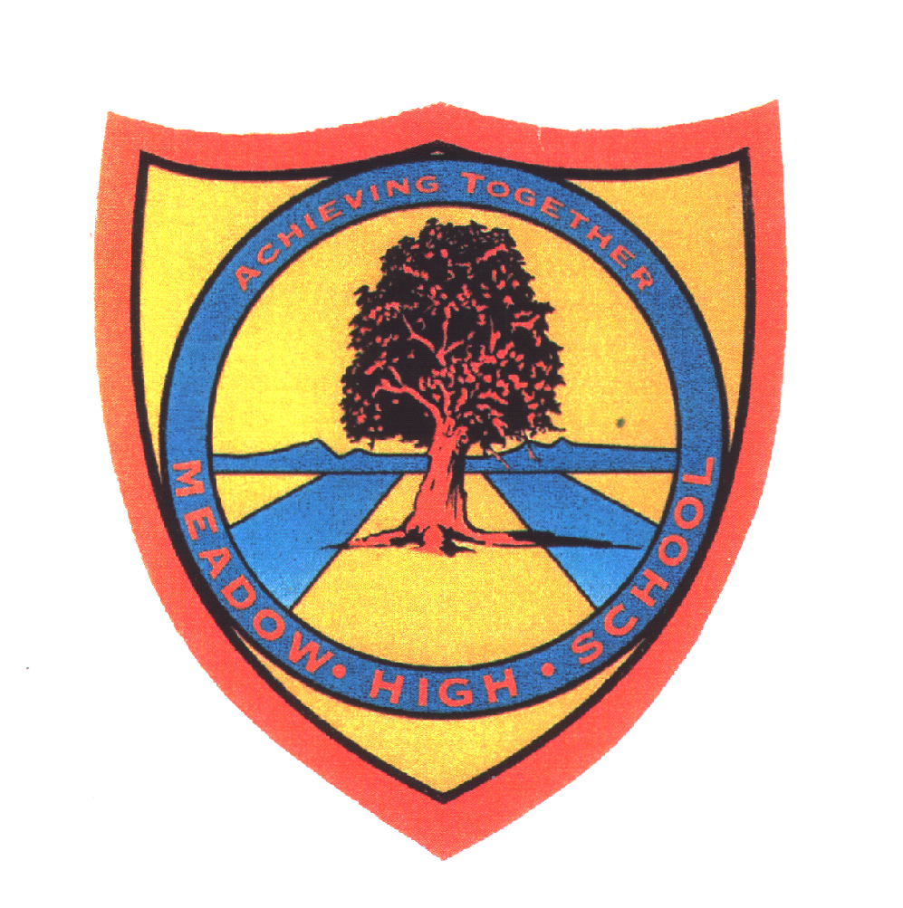 | Pathway 1 | KS3  Art  Cycle 3 | Term Summer 1  Bears
Learning Intention: A focus on bears providing students with skills for expressing their artistic creativity using resources in an artistic way. Students will learn that they can explore their creativity and expressive nature through colour and materials. They will develop their fine motor skills through using and manipulating materials whilst creating images, colour and texture. They will be able to explore the mindfulness and comfort that art can provide.
Key knowledge that should be learned during this SoW |  | All | Most | Some
Concept: |  | All students will have had some experiences in expressing their artistic skills using some variety of materials and mediums for recreating bears. | Most students will be able to experience using a range of materials and mediums for expressing their creativity for the recreating bears. | Some students will be flexible and explore all materials and mediums and be able to successfully use them to express their creativity for the concept of recreating bears.
Knowledge: |  | All students will know that artistic resources are used to make art work. | Most students will know that there is a choice of resources that can be used to make art work. | Some students will be able to know that they can use different materials for creating images. They will be able to use this knowledge in a cross curricular way in other lessons where they can be creative.
Key Skills: |  | All students will use and apply materials and mediums in a way that is most suited to their needs - developing their fine motor skills and recognition for creative mediums. They will use paint brushes, fabrics, and tissue paper. | Most students will be able to use their fine motor skills to apply creative mediums for creating a desired effect. | Some students will be able to effectively use and apply creative mediums in a range of activities. They will be able to use their fine motor skills
Language and/or communication skills: |  | All students will have experience in signing and saying key words:  Bear  sketch  small  medium  big  oil pastels  blend  soft  fluffy  collage  brown  cut  fabric  water colours  paint  happy  sad  Clay  model  paddington bear  choose | Most students will be able to use the key words in the context of the art lessons and remember them for the following lessons. | Some students will be able to use and apply the key words in alternative lessons.
Curricular Links |  | Links to other learning within the subject and spiral learning links, cross curriculum links and over learning opportunities  English - vocabulary development  Signalong - key words through sign  Maths - vocabulary linked with size

