Meadow High School
Royal Lane, Hillingdon, Middlesex UB8 3QU

Telephone: (01895) 443310
Email: meadow@meadowhighschool.org
Website: www.meadowhighschool.org

Headteacher: Mrs Jenny Rigby
Deputy Headteacher: Ms Claire Caddell
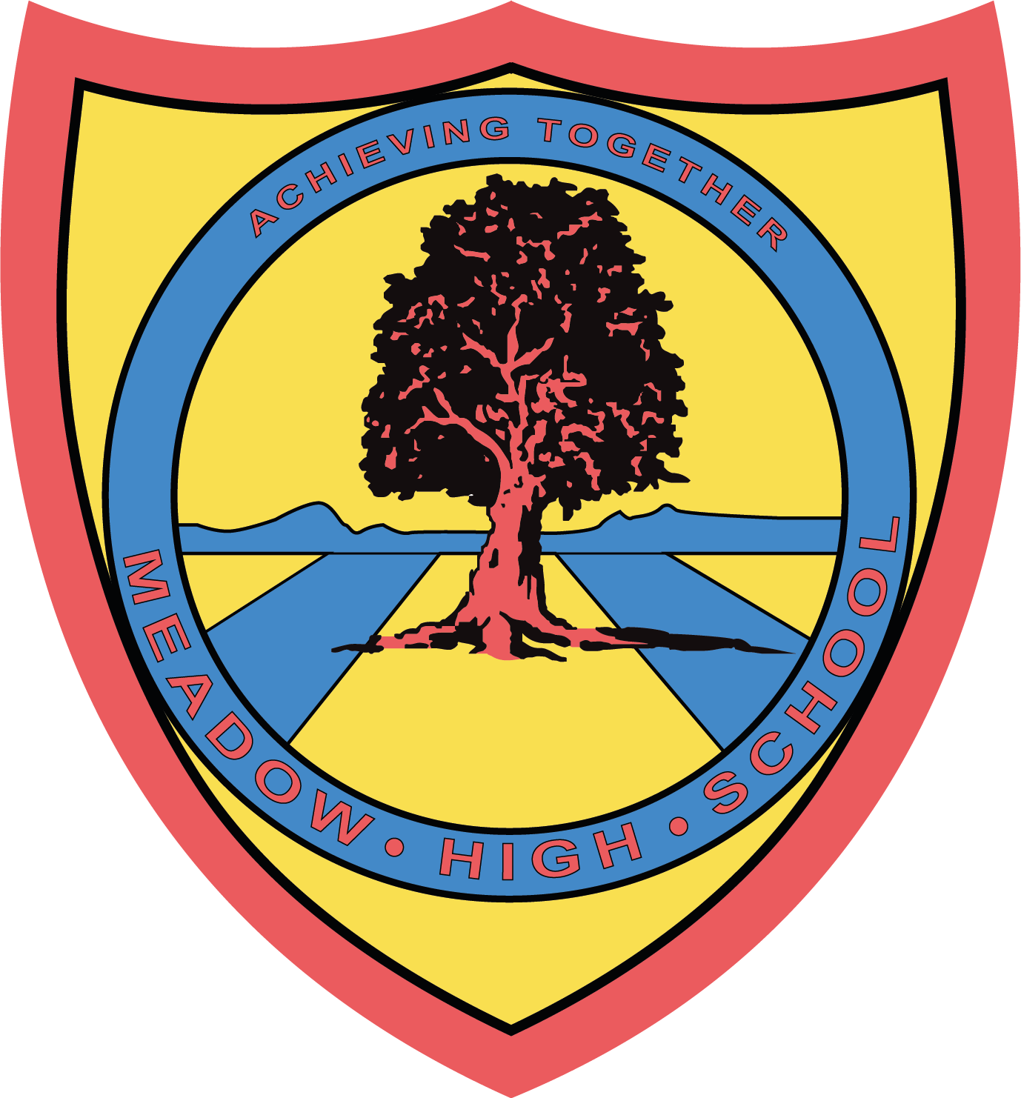

Dear Parents / Carers

re: Mamma Mia Theatre Trip REMINDER

This is a reminder that your child will be attending the theatre show Mamma Mia which will be performed in central London this Thursday 23rd February 2023.

We will leave school at midday and travel to Uxbridge where we will have McDonalds for lunch. Students will need to bring £10 spending money for this. We will then travel into central London via tube and watch the show as a group. Tickets have been provided for this through two charities; Jack Petchy and Mousetrap.

The show finishes at 5.35pm and after a toilet stop, we will travel back to school. We aim to be back at Meadow between 7pm - 7.15pm where you will be responsible for collecting your child. If your child uses a taxi, you will need to make arrangements for this alternative timing and provide a contact number.

Students are welcome to bring their own snacks and drinks as they won’t be eating from lunchtime until we return back to school.

We will have a school mobile with us which we will turn on at 6.45pm - 07842 309870

Kind Regards,

Maxine Newman & Michelle Taylor

School Council Leads
KS4 Team Leader
KS5 Assistant Headteacher

Article 23:- 'A child with a disability has the right to live a full and decent life with dignity and independence, and to play an active part in the community.'



