Meadow High School
Royal Lane, Hillingdon, Middlesex UB8 3QU

Telephone: (01895) 443310
Email: meadow@meadowhighschool.org
Website: www.meadowhighschool.org

Headteacher: Mrs Jenny Rigby
Deputy Headteacher: Ms Claire Caddell
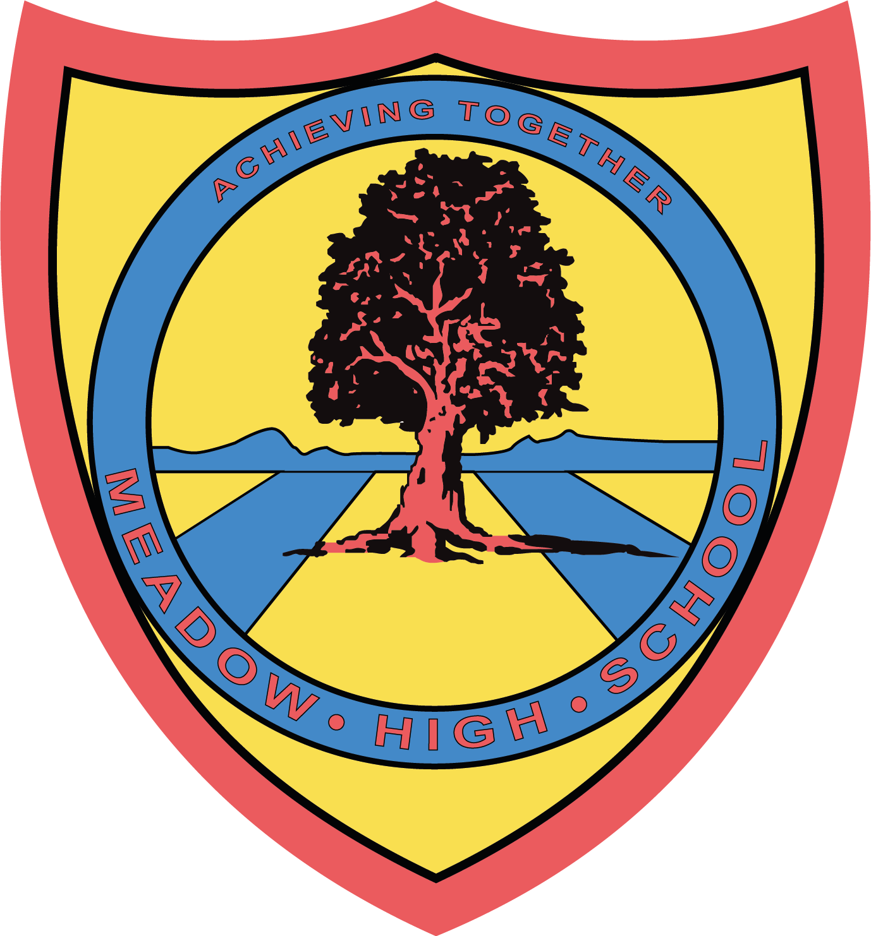

6th June 2023
Dear Parents/Carers,
Year 11 English Trip to the Chiltern Open Air Museum – Thursday 22nd June 2023
On Thursday 22nd June, some of the Year 11 English classes will be going to the Chiltern Open Air Museum for the day. They will spend the day consolidating what they have learnt so far in their English lessons for Myths and Legends. We will be leaving school straight after registration and returning to school at 2:45pm in time for normal transport home.
We will travel by Minibus and first aiders will accompany us on the visit. To cover the cost of the trip, can we please ask for a voluntary contribution of £6.00. Please make your payment via ParentPay.
Students will need to bring their own healthy packed lunch. If your child is entitled to a Free School Meal, a lunch can be provided, please indicate below. Students will also be allowed to bring some spending money to spend in the gift shop, a maximum of £10 for which they will be responsible for.
The trip is non-uniform, so please encourage your child to dress appropriately for the weather and wear sensible footwear as there will be a lot of walking outside.
We hope that your child will be able to take part in this trip, as it is designed to support the learning that takes place in the classroom. Please complete the attached slip and return it as soon as possible.
Yours faithfully,
Mrs A. Sugden & Mrs J. Tudor
Year 11 English Teachers

Article 23:- 'A child with a disability has the right to live a full and decent life with dignity and independence, and to play an active part in the community.'

✂---------------------------------------------------------------------------------------------------------------------------------------
Reply-Slip: Trip to Chiltern Open Air Museum - Thursday 22nd June 2023 – please return to Mrs Tudor or Mrs Sugden.
I am aware that my child……………………………………………………………….has a trip to the Chiltern Open Air Museum on the above date.
( ) I will pay £6 via ParentPay
( ) I will be providing my child with a healthy packed lunch
( ) My child is entitled to a free school meal and would like a lunch provided.
Please specify sandwich filling: Egg mayonnaise ( ) Tuna mayonnaise ( ) Cheese ( )
Signed (Parent/Carer): ………………………………………… Date: ………………

