Meadow High School
Royal Lane, Hillingdon, Middlesex UB8 3QU

Telephone: (01895) 443310
Email: meadow@meadowhighschool.org
Website: www.meadowhighschool.org

Headteacher: Mrs Jenny Rigby
Deputy Headteacher: Ms Claire Caddell
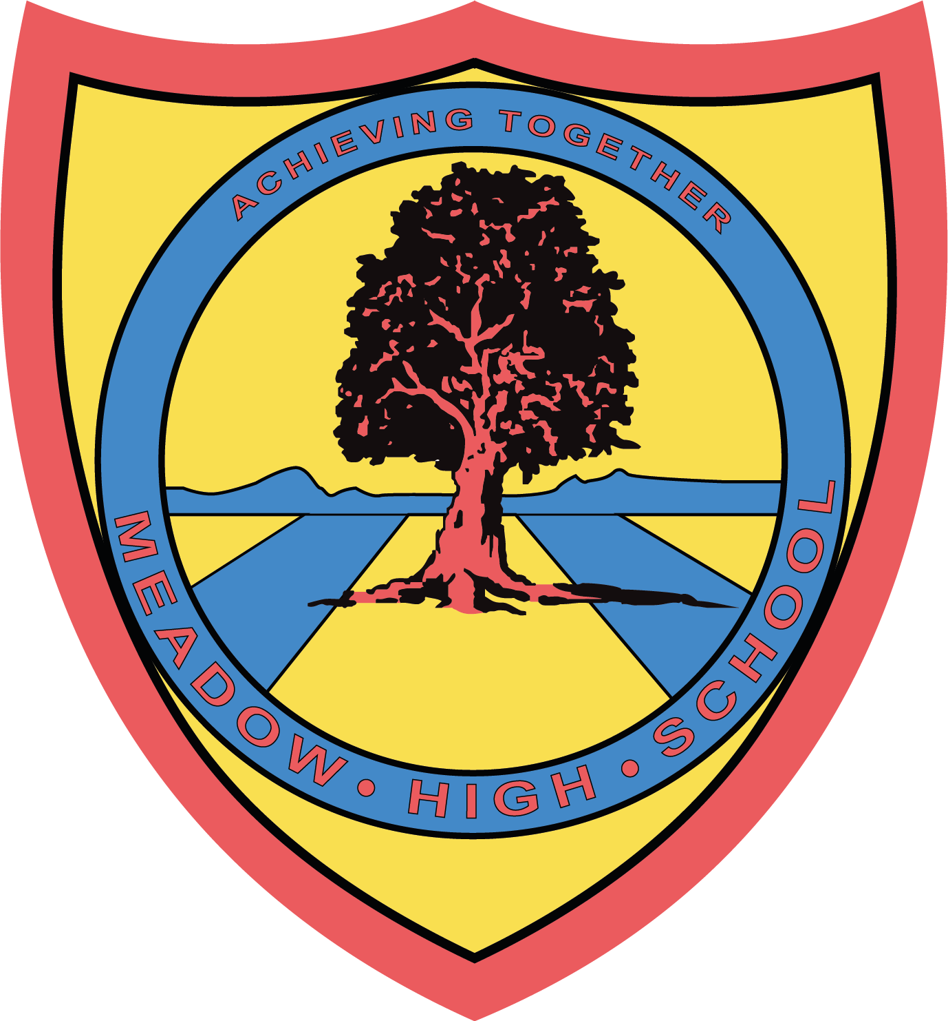

6th November 2023

Dear Parents/Carers,

As part of PE lessons, pupils in Class YA will be having swimming lessons starting on 30th November 2023. Pupils will travel via minibus to Windsor Leisure Centre and be taught by qualified swim instructors. Members of the staff from the class team will also be in the water to support. Swimming will occur each Thursday. Pupils will require a suitable swimming costume/shorts, a towel and any other personal preferences when swimming such as googles. I also suggest sending in an extra snack and drink as swimming can make you hungry. Pupils last swimming lesson will be on 8th February 2024.
Yours sincerely,


Faye Bonnar
Assistant Head Teacher Pathway 1
Article 23:- 'A child with a disability has the right to live a full and decent life with dignity and independence, and to play an active part in the community.'



