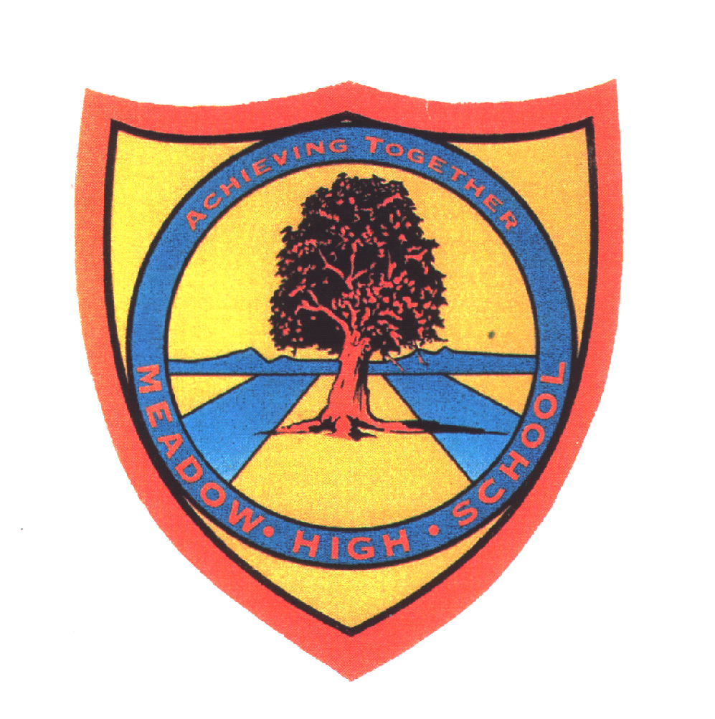 | Pathway 1 | KS3 Cycle 1 | Spring Term 1  Topic: Food Drink and Exercise
Learning Intention: Pupils will learn about why we need food, drink and exercise.
Key knowledge that should be learned during this SoW |  | All | Most | Some
Concept: |  | Pupils will learn what their body needs to be healthy and how their actions can help keep it healthy.
Knowledge: |  | To know that humans needs a variety of food to sustain a healthy body. | What the human body needs to thrive.  To know what experiences they can do to keep fit and healthy.  The main food groups. | What can be harmful to the human body.  How they can proactively look after themselves.  What the different food groups help our body to do.
Key Skills: |  | Name and identify | Label | Sort and explain.  Classifying
Language and/or communication skills: |  | Healthy  Unhealthy | Fit  Healthy  Harmful | - Carbohydrates  - Protein  - Dairy  Fruit and vegetables Fats and sugars
Curricular Links |  | PSHCE

