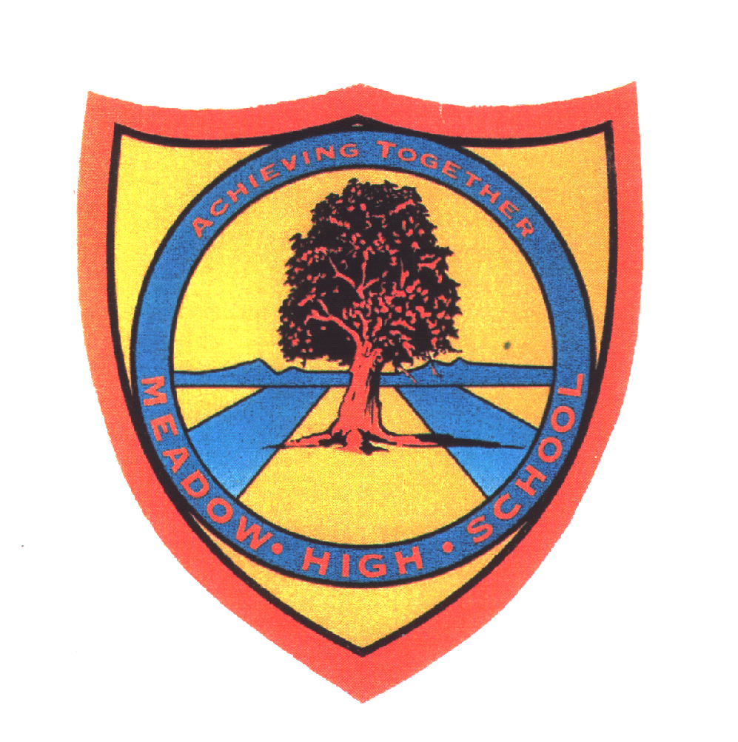 | Pathway 1 | Key Stage 3 Cycle 3 Earth and Space | Summer 1  Topic: Earth and Space
Learning Intention: This unit builds on work on the Solar System and looks at the Earth and its place in our Solar System including the seasons and the Earth’s magnetic field and gravity. It also looks at the Solar System and what is beyond the Solar System.
Key knowledge that should be learned during this SoW |  | All | Most | Some
Concept: |  | Scientific methods and ideas on experiments, observation, hypotheses and theories are discussed, leading to an understanding of the impact of natural and human activity on the environment and exploring the Solar system
Knowledge: |  | To label basic elements of the solar system.  Know the term spherical and use it label Earth and moon. | To know the names and order of planets from the Sun.  Know the Earth rotates around the sun.  Know the moon rotates around the earth.  Know the Earth spins on its axis. | To understand how day and night occur on Earth.  To recall the natural causes and mankind can affect climate change.  To identify the harm plastic waste poses to life in the oceans  Describe some features of the planets.  Place the planets in the solar system in the correct order.  Understand how night and day occur.
Key Skills: |  | Observational and explorative.  Identifying. | Ordering  Labelling  Investigate | Questioning  Predict
Language and/or communication skills: |  | Sun  Moon  Earth | Planets  Solar system
Curricular Links |  | Maths, Geography

