Meadow High School
Royal Lane, Hillingdon, Middlesex UB8 3QU

Telephone: (01895) 443310
Email: meadow@meadowhighschool.org
Website: www.meadowhighschool.org

Headteacher: Mrs Jenny Rigby
Deputy Headteacher PW2/3: Ms Claire Caddell
Deputy Headteacher PW1: Miss Amy Willis
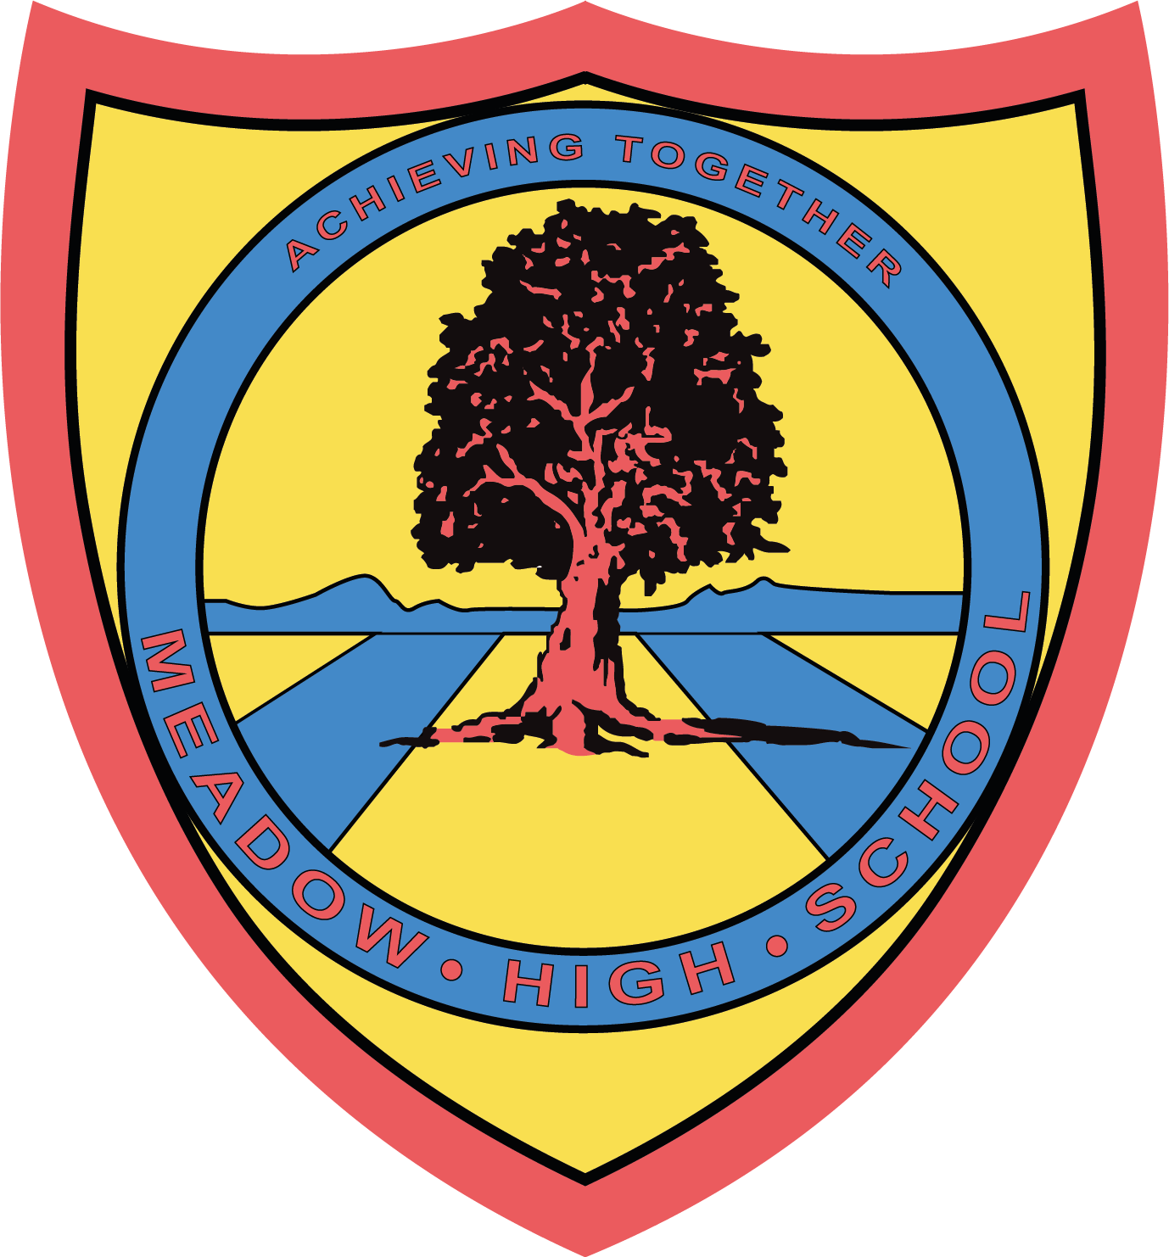

25th June 2024

Dear Parents/ Carers,

Many apologies for the late response,

I am pleased to inform you that your child has been selected to participate in the school multi-sports session after school each Wednesday between 26th June and 17th July. The sessions run from 3.15pm to 4.15pm.

If your child is an independent traveler they can leave on their own straight after the session, but should your child require pick up, then you must collect them no later than 4.30pm. If for any reason you will be late, please contact us as soon as possible. Email dmcalernon@meadowhighschool.org for a quick and easy response.

For your child to participate, they must bring a set of trainers to the session. No studs/football boots are allowed.

There are zero tolerances in negative behavior linking to the school policy. If any child does not follow the session expectations, they will be withdrawn from the session.

If you have any questions or any issues, please do not hesitate to contact me.

Kind regards,

Mr McAlernon
Teacher of Physical Education and Year 11 Form Tutor

Article 23:- 'A child with a disability has the right to live a full and decent life with dignity and independence, and to play an active part in the community.'


