Meadow High School
Royal Lane, Hillingdon, Middlesex UB8 3QU

Telephone: (01895) 443310
Email: meadow@meadowhighschool.org
Website: www.meadowhighschool.org

Headteacher: Mrs Jenny Rigby
Deputy Headteacher: Ms Claire Caddell


Dear Parent / Carer,

The whole school roll out for The Evidence for Learning Families App will be happening soon!

To ensure the process is smooth we need to ensure that all parents have downloaded the app on their mobile or tablet device.

To download the app you either need.



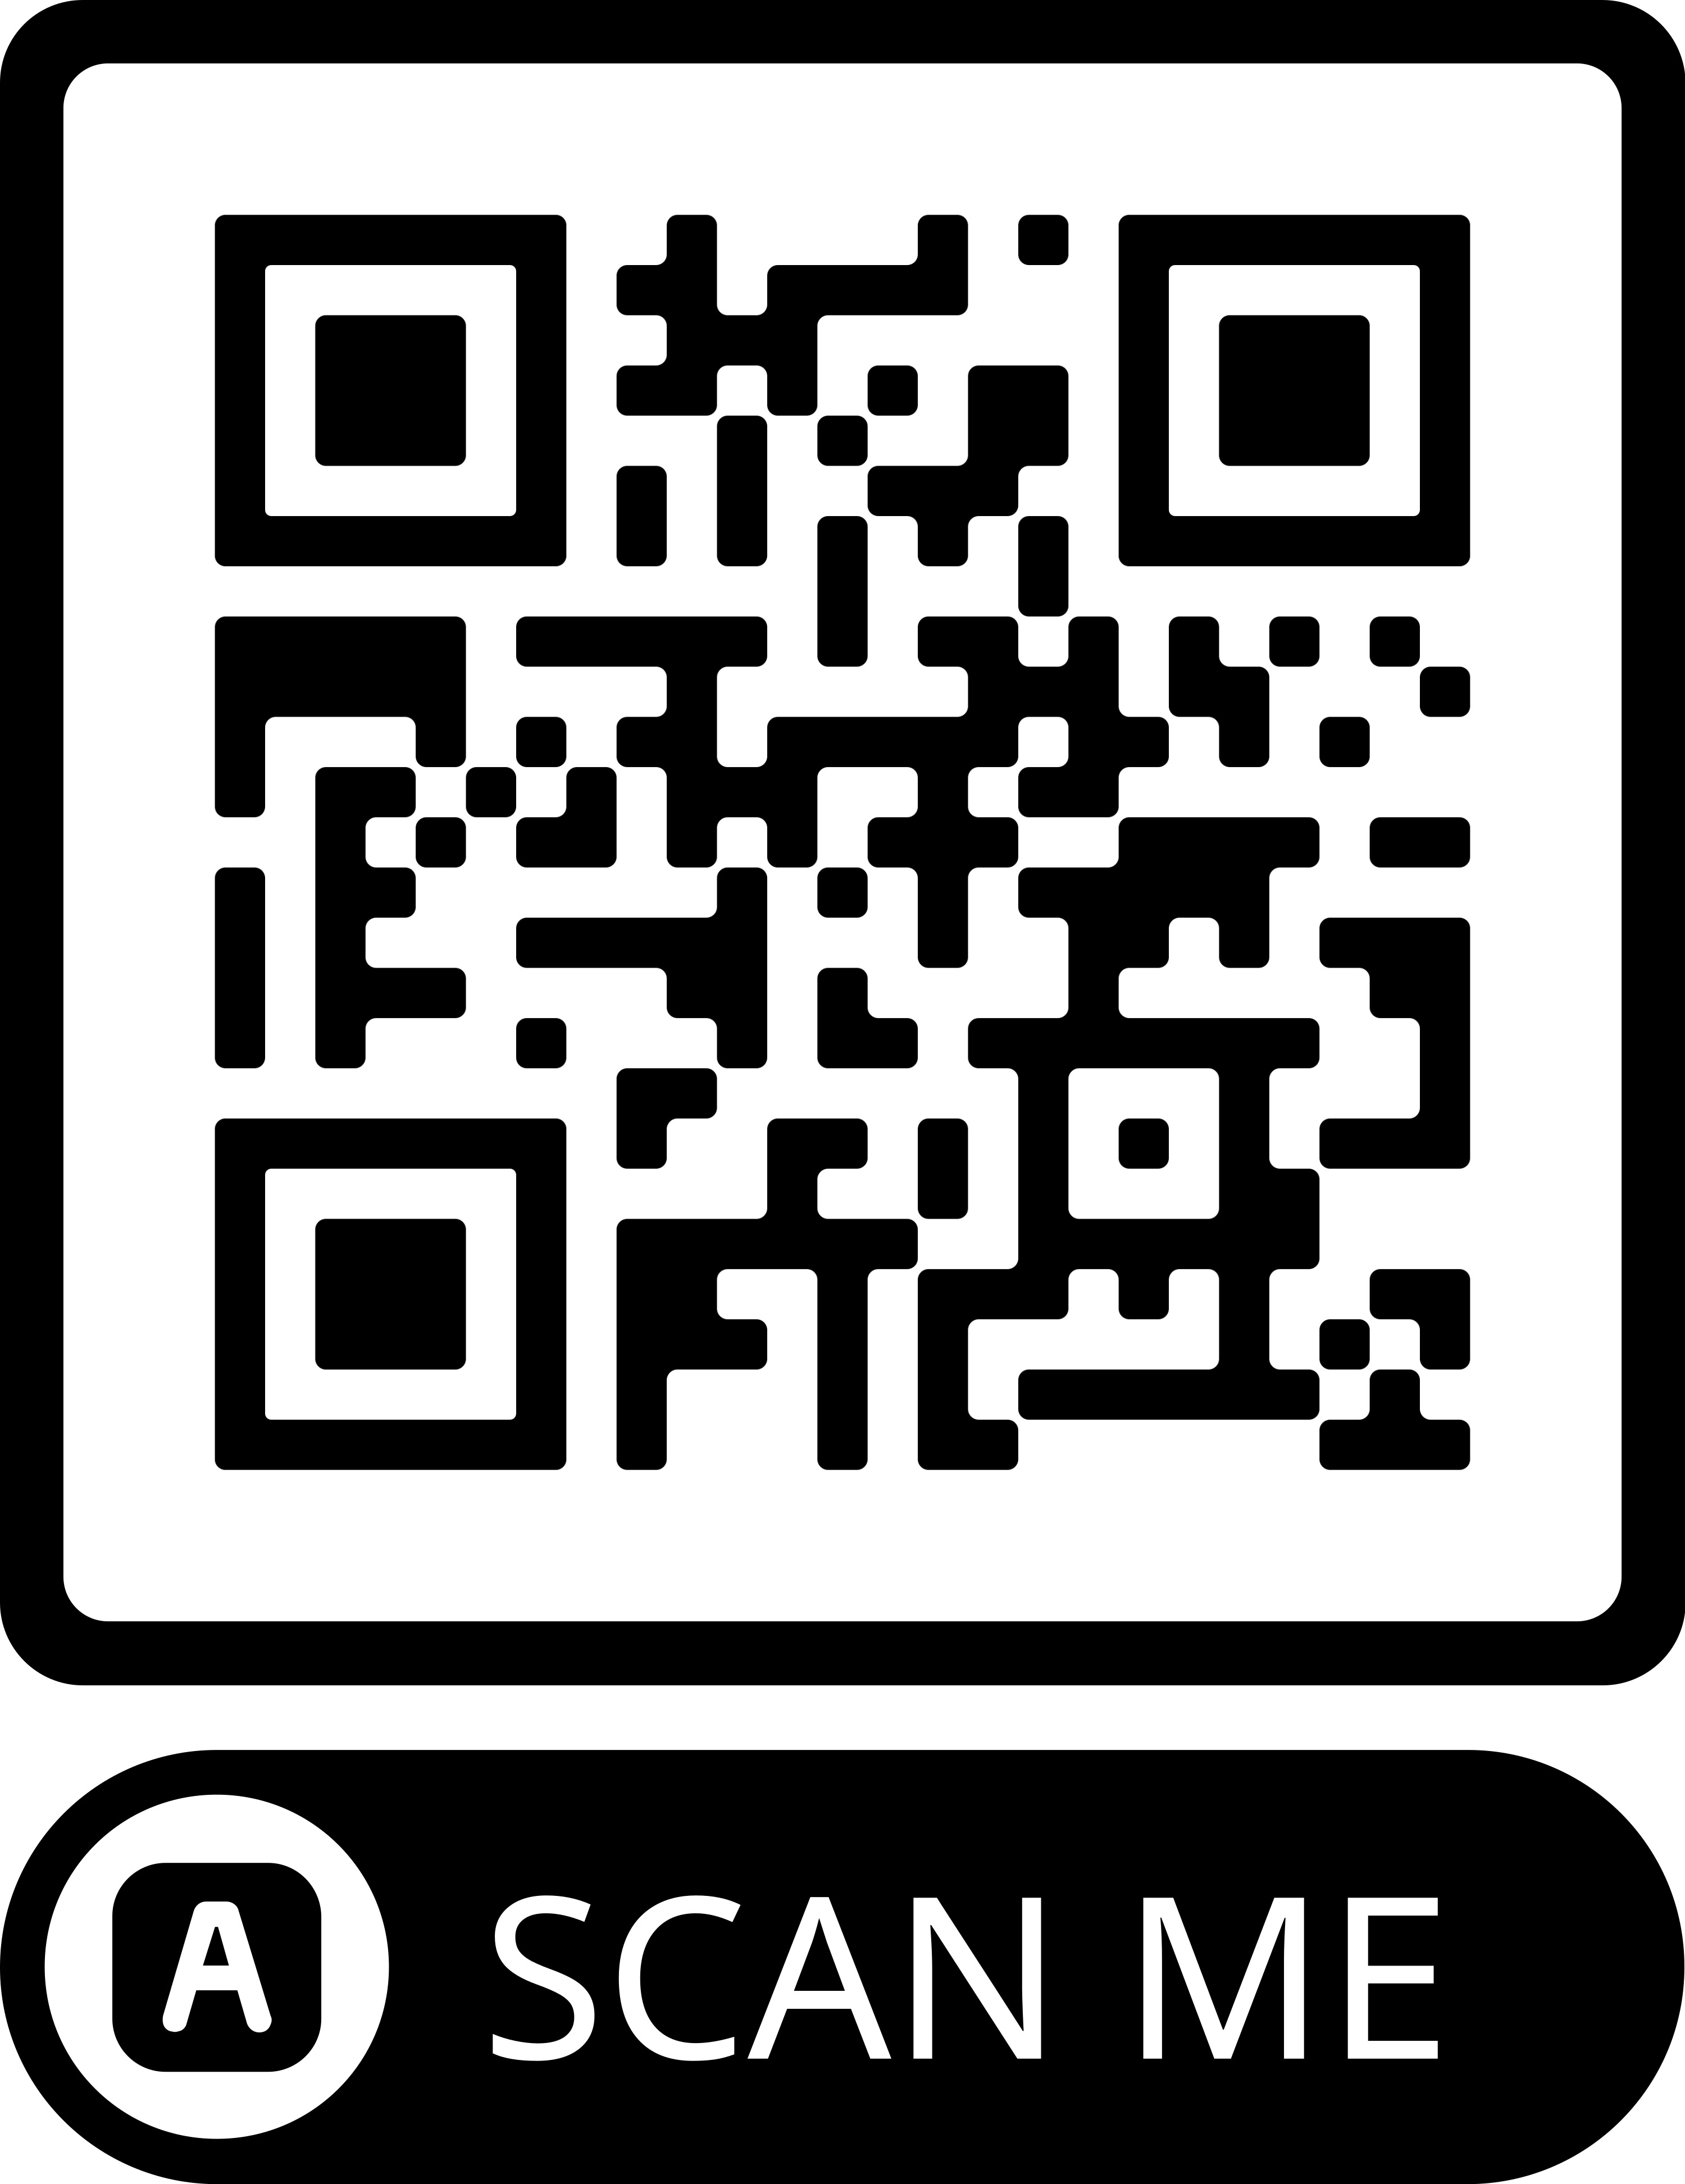
Google play store or Apple app store

Alternately, you can scan this QR code to take you to the download page.

There are many apps for Evidence for learning please ensure you download this app.
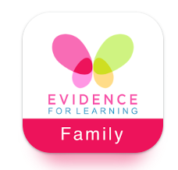
Yours sincerely,

Further information such as your log ins and parents meetings (face to face and virtual) will be arranged and sent out soon.

Mr G Millard
EfL Parent/Family Engagement Coordinator

