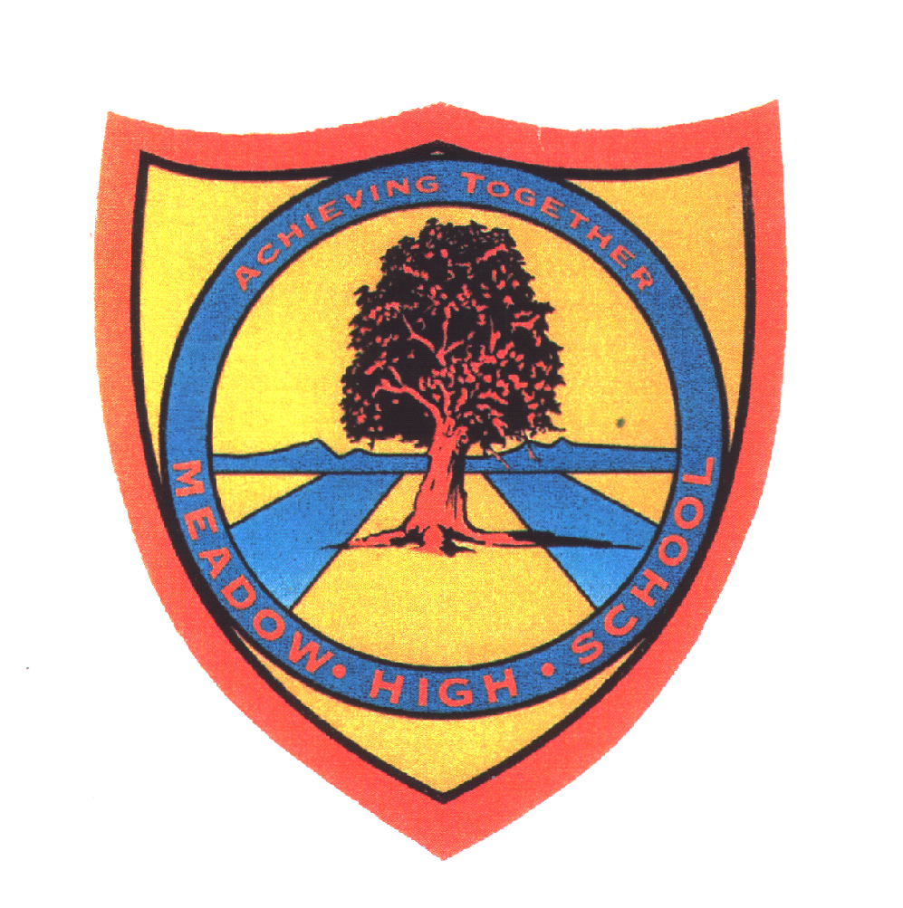 | Pathway 1 | KS4 Cycle 1 | Spring Term  Topic: A Healthy Human Body
Learning Intention: Pupils will further explore the human body and what it requires to work effectively.
Key knowledge that should be learned during this SoW |  | All | Most | Some
Concept: |  | Pupils will learn what their body needs to be healthy and how they can take ownership, as they get older to ensure they are healthy as can be.
Knowledge: |  | To know that different animals require different foods to be healthy.  To know that humans needs a variety of food to sustain a healthy body. | To understand that animals (including humans) can be grouped according to what they eat.  What the human body needs to thrive.  To know what experiences they can do to keep fit and healthy. | To group and sort what can make its own nutrition.  What can be harmful to the human body.  How they can proactively look after themselves.
Key Skills: |  | Name and identify | Label | Sort and explain.  Classifying
Language and/or communication skills: |  | Healthy  Unhealthy | Carnivore,  Herbivore,  Omnivore | - Carbohydrates  - Protein  - Dairy  Fruit and vegetables Fats and sugars
Curricular Links |  | PSHCE

