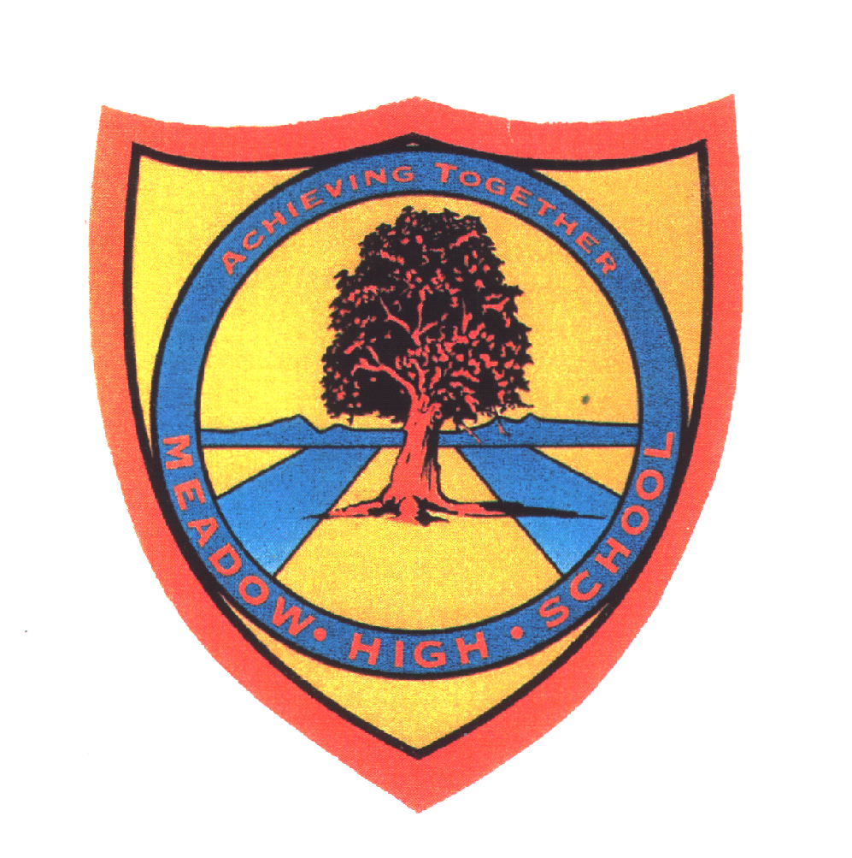 | Pathway 1 | KS4 Cycle 1 | Summer  Topic: Earth and Space
Learning Intention: By the end pupils will gain a deeper awareness of space and space travel. Pupils will work on skills such as comparing, comparing and observing.
Key knowledge that should be learned during this SoW |  | All | Most | Some
Concept: |  | That the Earth is one of eight planets in our Solar System. That we are able to live on Earth because it has the things we need as humans to survive.
Knowledge: |  | Links between the Earth, moon and sun. | The Solar System and what makes the Earth right for people. | Key information and dates regarding the history of space travel.
Key Skills: |  | Observational and explorative.  Identifying. | Ordering  Labelling  Investigate | Questioning  Predict
Language and/or communication skills: |  | Sun  Moon  Earth | Planets  Solar system | Gravity  Survive  Solar system
Curricular Links |  | Geography, PSHCE,

