Meadow High School
Royal Lane, Hillingdon, Middlesex UB8 3QU

Telephone: (01895) 443310
Email: meadow@meadowhighschool.org
Website: www.meadowhighschool.org

Headteacher: Mrs Jenny Rigby
Deputy Headteacher: Ms Claire Caddell
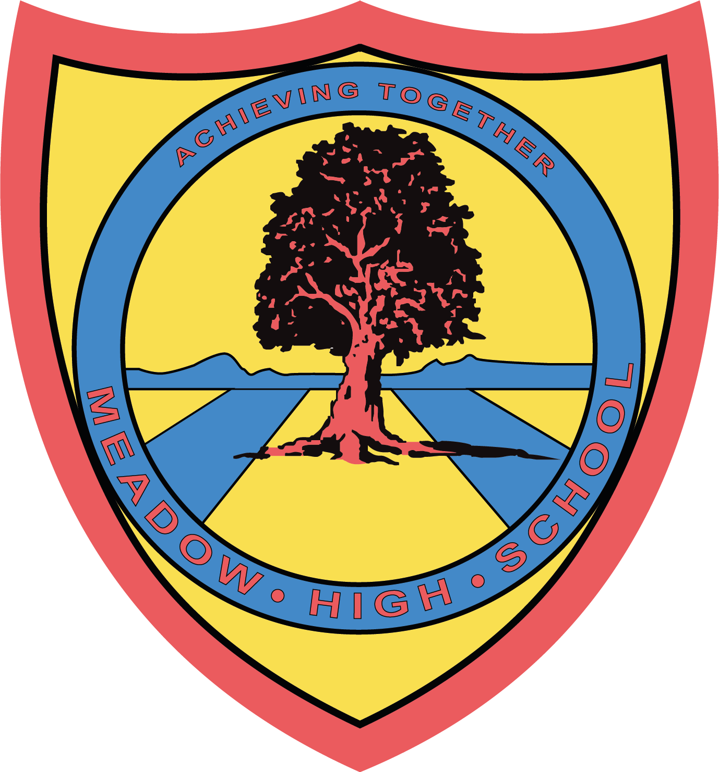

9th June 2023

Dear Parents/Carers,

Trip to Pizza Hut, Hayes

As you may know, this Academic year, your child has successfully taken part in vocational pathways.
As a reward for their hard work during the Catering VP (Crunchy Munchy), we are taking the students to Pizza Hut, Hayes. We will be having a lunch buffet on Tuesday, 27th June 2023.

This will also support our work with accessing our local community and its facilities.

We will be leaving school at 11.10am and returning to school after lunch in time for normal transport home. We will be travelling by TFL busses (travel covered by school) and first aiders will accompany us.

If you have any enquiries, please feel free to contact me lbrown@meadowhighschool.org

Yours sincerely,

Miss L Brown
Lead VP Catering

Article 23:- 'A child with a disability has the right to live a full and decent life with dignity and independence, and to play an active part in the community.'



