Meadow High School
Royal Lane, Hillingdon, Middlesex UB8 3QU

Telephone: (01895) 443310
Email: meadow@meadowhighschool.org
Website: www.meadowhighschool.org

Headteacher: Mrs Jenny Rigby
Deputy Headteacher: Ms Claire Caddell
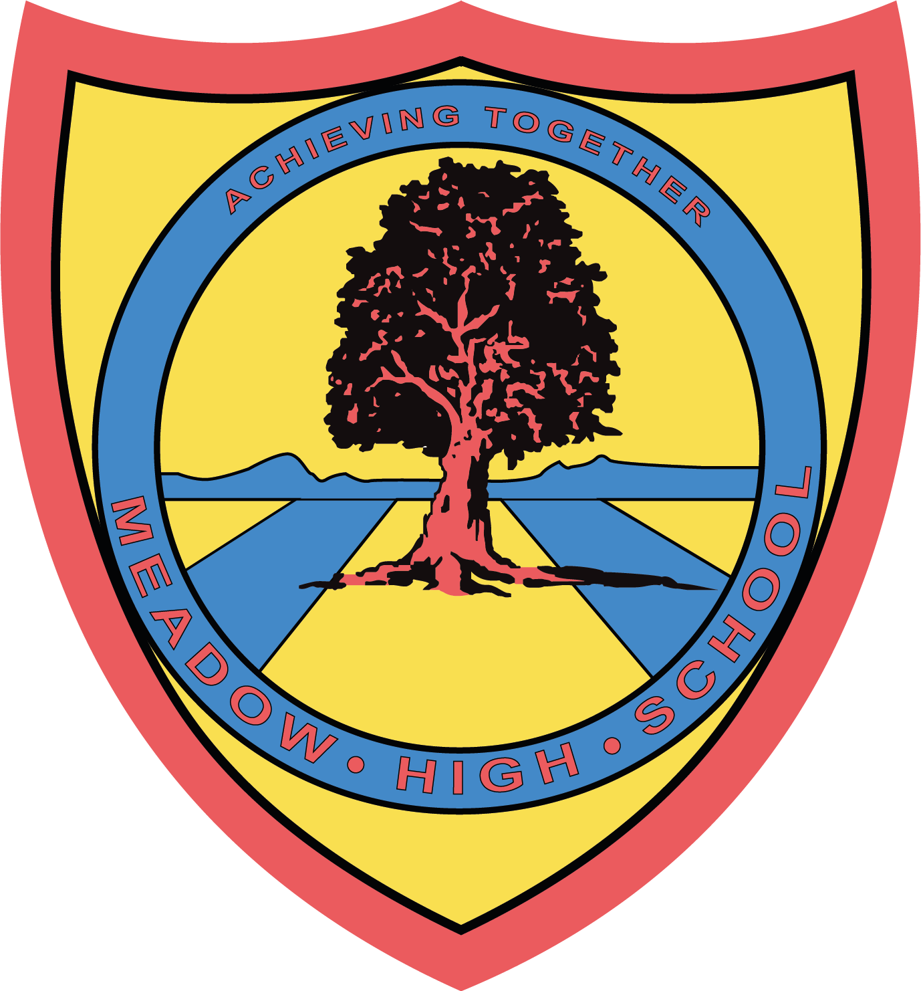

3rd November 2023

Dear Parents

13JS have been taking part in a topic called Parenting Awareness. Next week the students will be making their own flour babies as part of an activity to make students aware of the responsibilities of being a parent.
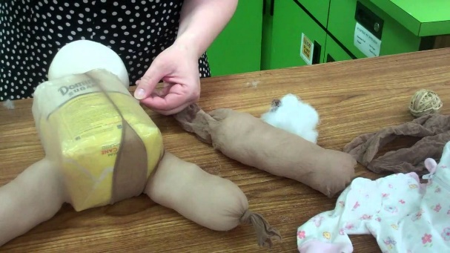

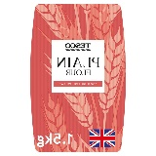
For this activity, students will need:
A packet of flour

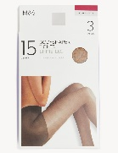

Two pairs of flesh coloured tights

£4 for the Styrofoam sphere for the baby’s head and we will be visiting the local charity shop where students can buy four baby clothing items for £1
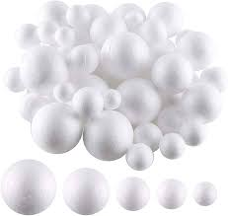
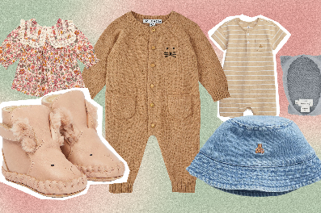

Could the following items and the sum of £4 be brought to school by Monday 6th November 2023.

Miss St John
13JS Form Tutor

Student’s Name …………………………………………………. Class 13 JS

I am happy for my child to take part and enclose the sum of £4 to cover the coast of the Styrofoam and baby clothes. ◻

I do not wish my child to take part ◻

Parent/Carer Signature …………………………………………. Dated ………………………….

