Meadow High School
Royal Lane, Hillingdon, Middlesex UB8 3QU

Telephone: (01895) 443310
Email: meadow@meadowhighschool.org
Website: www.meadowhighschool.org

Headteacher: Mrs Jenny Rigby
Deputy Headteacher: Ms Claire Caddell
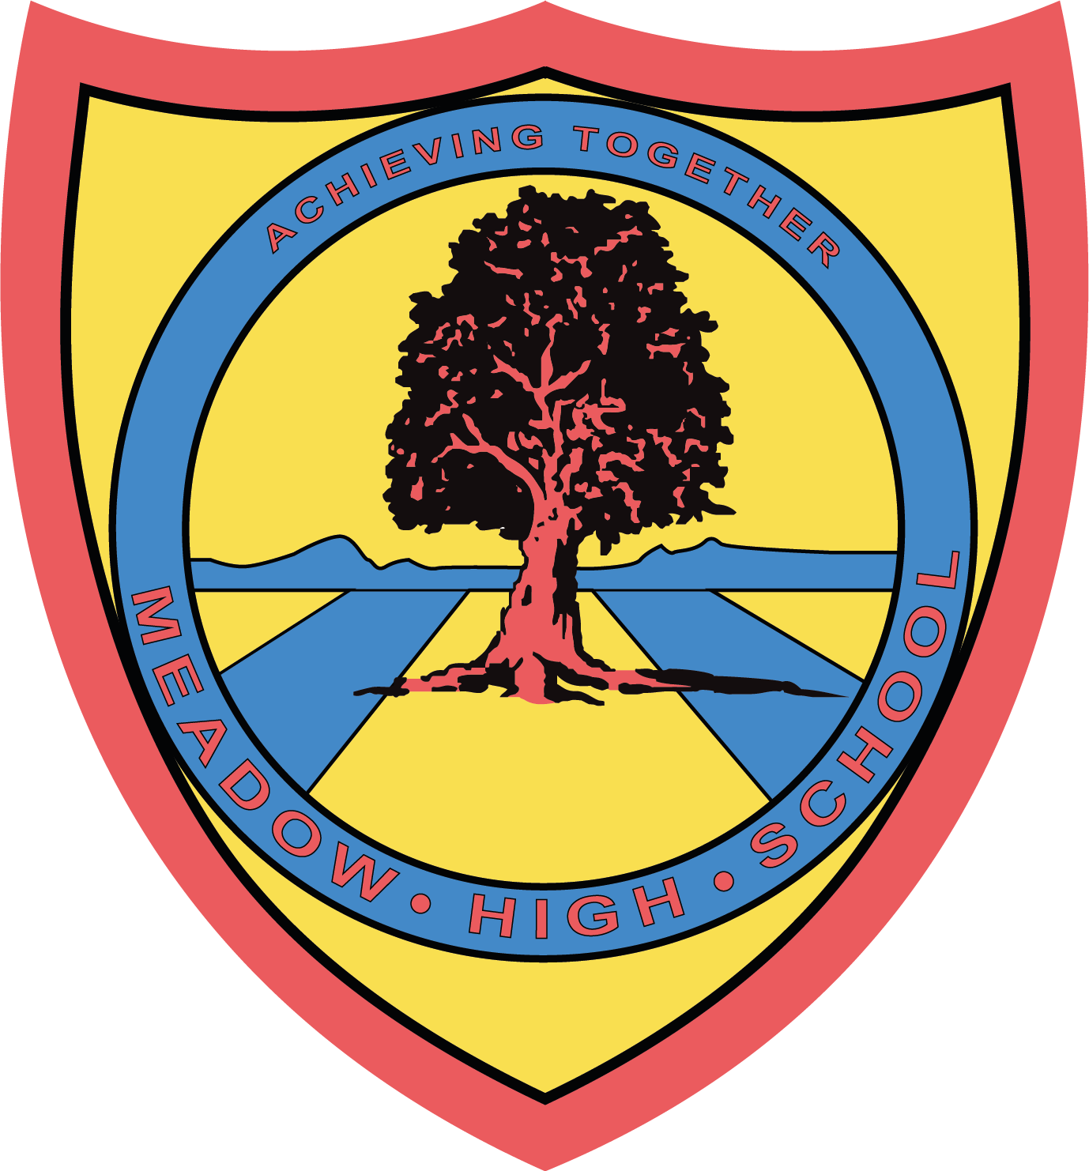

3 May 2023
Dear Parents/Carers,
Year 14 – Trip to Thorpe Park
Year 14 are planning on going to Thorpe Park on Wednesday 24th May. It is an opportunity for the students to build on teamwork skills, social interaction and enjoy their last term at Meadow High School.
Please could you confirm if your son or daughter is able to make this trip by completing the permission slip as soon as possible. The cost will be £16.00 or less per student, dependent on the number of students that are able to attend. This will need to be paid via ParentPay, which will be uploaded as soon as we receive permission slips confirming student’s attendance.
We will be leaving after registration and travel by school mini bus. Students should bring a packed lunch. If your child is entitled to a free school lunch, please indicate below and we will make sure they have a lunch to bring along from school.
Yours sincerely,

Mrs Lazarevic and Miss Lennon
6th Form Tutors

Article 23:- 'A child with a disability has the right to live a full and decent life with dignity and independence, and to play an active part in the community.'


----------------------------------------------------------------------------------------------------------------------------------------------------------------------------------------------
Reply-Slip - Year 14 Thorpe Park – Please return to Mrs Lazarevic and Miss Lennon

Name: ……………………………………………………………..

Is able to attend Thorpe Park Trip

Is entitled to a free school lunch Sandwich Choice: ( ) cheese ( ) tuna mayo ( ) egg mayo

Will bring in a packed lunch

Will pay for entry ticket via ParentPay

Parent/Carer Signature: …………………………………………………… Date: …………………..

