***Meadow High School***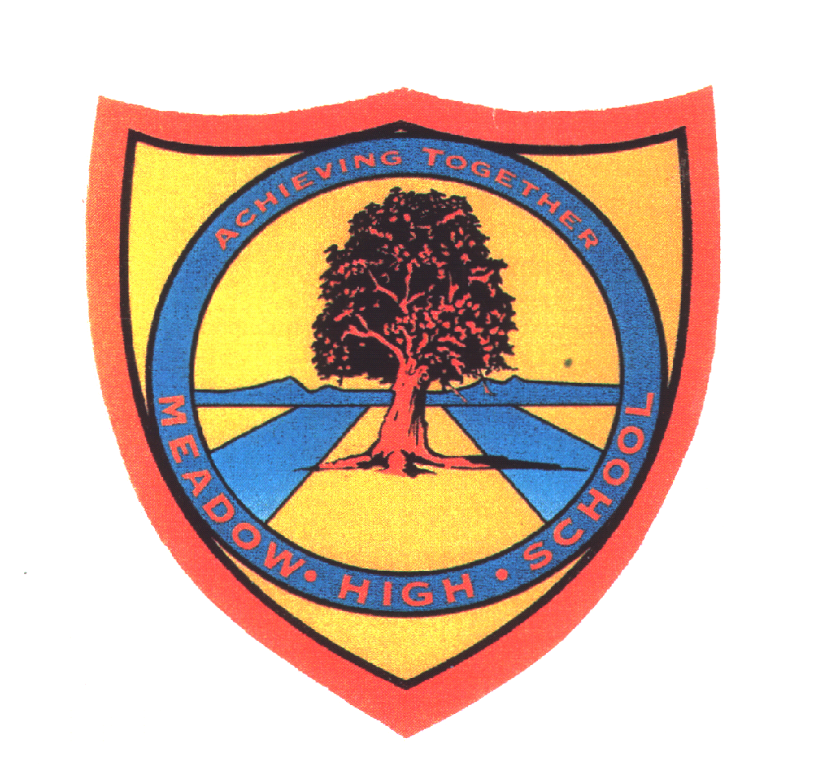

*Royal Lane, Hillingdon, Middlesex UB8 3QU*

*Telephone: (01895) 443310*

*Email: meadow@meadowhighschool.org*

*Website: www.meadowhighschool.org*

***Headteacher: Mrs Jenny Rigby***

***Deputy Headteacher: Ms Claire Caddell***

Thursday 8th July 2021

**Re: Sports Day**

Dear Parents / Carers,

KS5 (6th Form) Sports Day will be taking place on **Thursday 15th July**.

On this day please make sure you send your child in with their PE kit and a top to represent their house colour.

The pupils will be outside for large periods of the day, please make sure your child has plenty of water and sun cream with them.

Unfortunately, due to current Covid regulations, we are sorry to announce that Parents & Carers will not be able to join us for the afternoon track events.

­­

Kind regards,

Mr. Morgan

Head of PE

[CMorgan@MeadowHighSchool.org](mailto:CMorgan@MeadowHighSchool.org)

@MeadowPE