Meadow High School
Royal Lane, Hillingdon, Middlesex UB8 3QU

Telephone: (01895) 443310
Email: meadow@meadowhighschool.org
Website: www.meadowhighschool.org

Headteacher: Mrs Jenny Rigby
Deputy Headteacher PW2/3: Ms Claire Caddell
Deputy Headteacher PW1: Miss Amy Willis
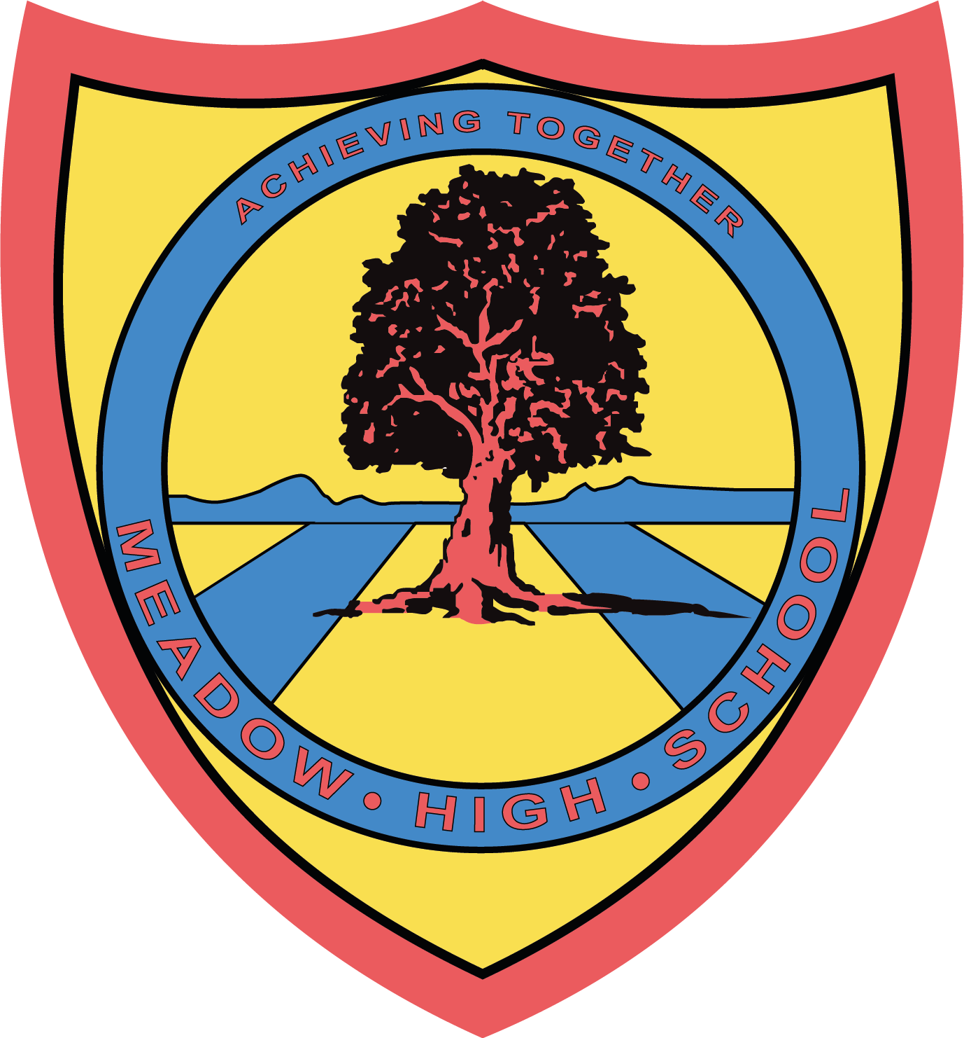

November 2023

Dear Parents/Carers,

Trip to Pizza Hut, Hayes

As part of our learning in Food Technology, we are taking part in an eating out experience at Pizza Hut on Tuesday 5th December 2023. This experience will support with the learning where we have been exploring different types of pizza. Pupils have been researching, planning and making their own pizzas.

This will also support our work within PSHE looking at developing our social skills.

We will be leaving school at 11.00am and returning to school after lunch in time for normal transport home. We will be travelling by school minibus and first aiders will accompany us.

We are asking for £10 towards an all you can eat buffet and the purchase of a drink. Please pay via parent pay.

Please complete the attached slip and money be sent into school by Tuesday 28th November 2023.
If you have any enquiries, please feel free to contact me gmillard@meadowhighschool.org.

Yours sincerely,

Mr G Millard and Miss C LePage
Food Technology Teachers

Article 23:- 'A child with a disability has the right to live a full and decent life with dignity and independence, and to play an active part in the community.'

…….……………………………………………………………………………………………………………….
Reply-Slip – Food Tech trip to Pizza Hut.

I give my permission for ………………………………………….…to take part in the above trip.

Dietary requirements: ………………………………………………………………………………………

I have paid £10 on parent pay.

Signed (Parent/Carer): …………………………………………………….. Date ……………….

Emergency contact number: ………………………………………………………

