KS4 Food Tech Autumn 2 Food tech/Healthy living Fruit and vegetables

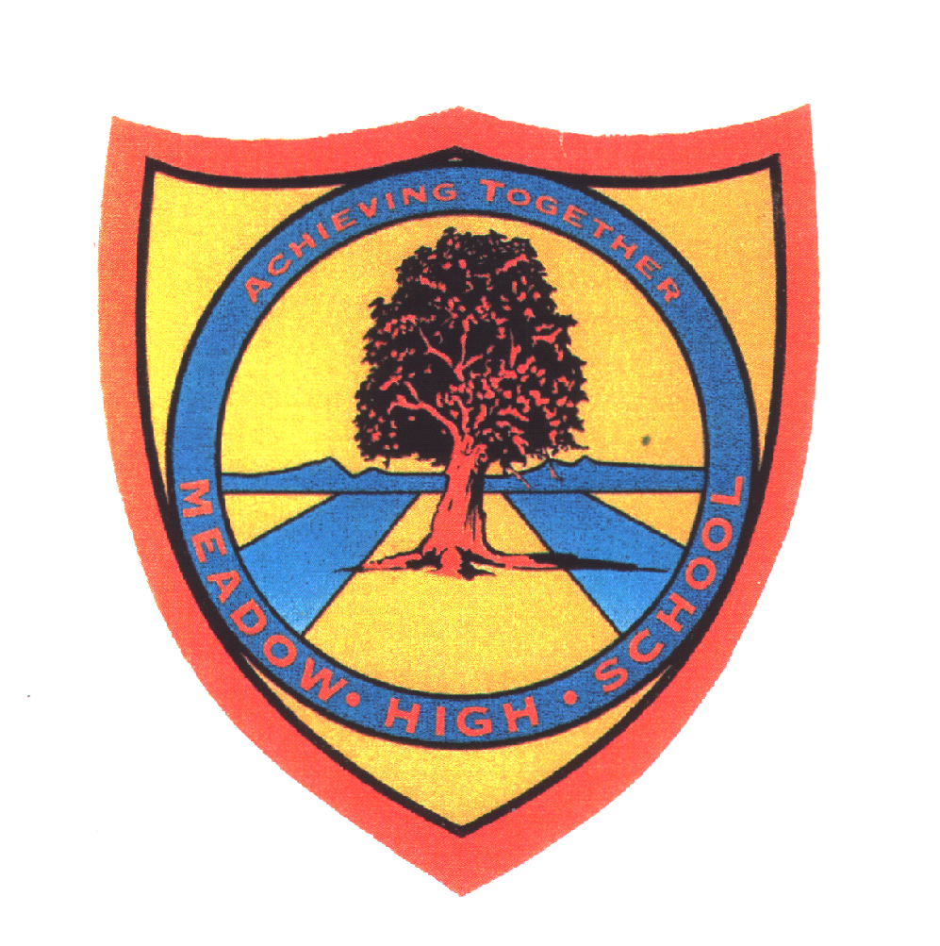 | Pathway 1 | Food Tech  KS4 | Autumn 2  Fruit and Vegetables
Learning Intention: Pupils will learn where we get fruits and vegetables from. Pupils will learn about which part of the plant we eat and why they are important for our diet. Pupils will learn where in the world different fruits and vegetables grow and pupils will learn how they can be prepared for us to eat.
Key knowledge that should be learned during this SoW |  | All | Most | Some
Concept: |  | For pupils to become more failure with fruits and vegetables. | For pupils to be able to try new foods and begin to understand the importance of healthy foods in their diet. | To want to prepare own healthy foods as part of a balanced meal/diet. Pupils to be able to safely peel and chop vegetables.
Knowledge: |  | To identify and sort fruits and vegetables. To taste unfamiliar fruits and vegetables. | To know how fruits and vegetables grow and how they grow differently from each other. | To know that we eat different parts of different fruits and vegetables - roots, flowers, stem, leaves.  To prepare a salad.
Key Skills: |  | Tasting a wide variety of fruits and vegetables.  Selecting the correct fruit and vegetable from the description given.. | Washing fruits and veg prior to cooking/eating.  Peeling carrots.  Chopping soft fruits and vegetables. | Make salad by peeling and chopping fruits and vegetables.
Language and/or communication skills: |  | Pupils will recognise key word symbols and use with speech/ and or signs. Pupils will be able to communicate their likes, dislikes and wishes though speech, signs and or symbols. | Pupils will be able to communicate how different fruits and vegetables need to be prepared. Pupils will also communicate which utensils they need in order to fulfill the task. | Pupils will be able to sequence what they need to do and what they have done. Pupils will use language to recall what they have observed.
Curricular Links |  | Science, Geography, S+L

