Meadow High School
Royal Lane, Hillingdon, Middlesex UB8 3QU

Telephone: (01895) 443310
Email: meadow@meadowhighschool.org
Website: www.meadowhighschool.org

Headteacher: Mr Graham Cunningham
Deputy Headteacher (Royal Lane): Miss Michelle Taylor
Deputy Headteacher (Northwood Road): Miss Amy Willis


8 October 2025

Dear Parent/Carer,

I am writing to inform you that your child has been enrolled in Tag Rugby as an enrichment option for the Autumn term. Every Friday, your child is required to bring their PE kit and, if feasible, Astros or plastic moulded studs. No metal studs at all. This is necessary because we are involved in the field to prevent any child from slipping. Trainers may be acceptable. I will show pictures below this image with different types of football/rugby boots. Students who are engaged in sports enrichment must bring a PE kit to participate.

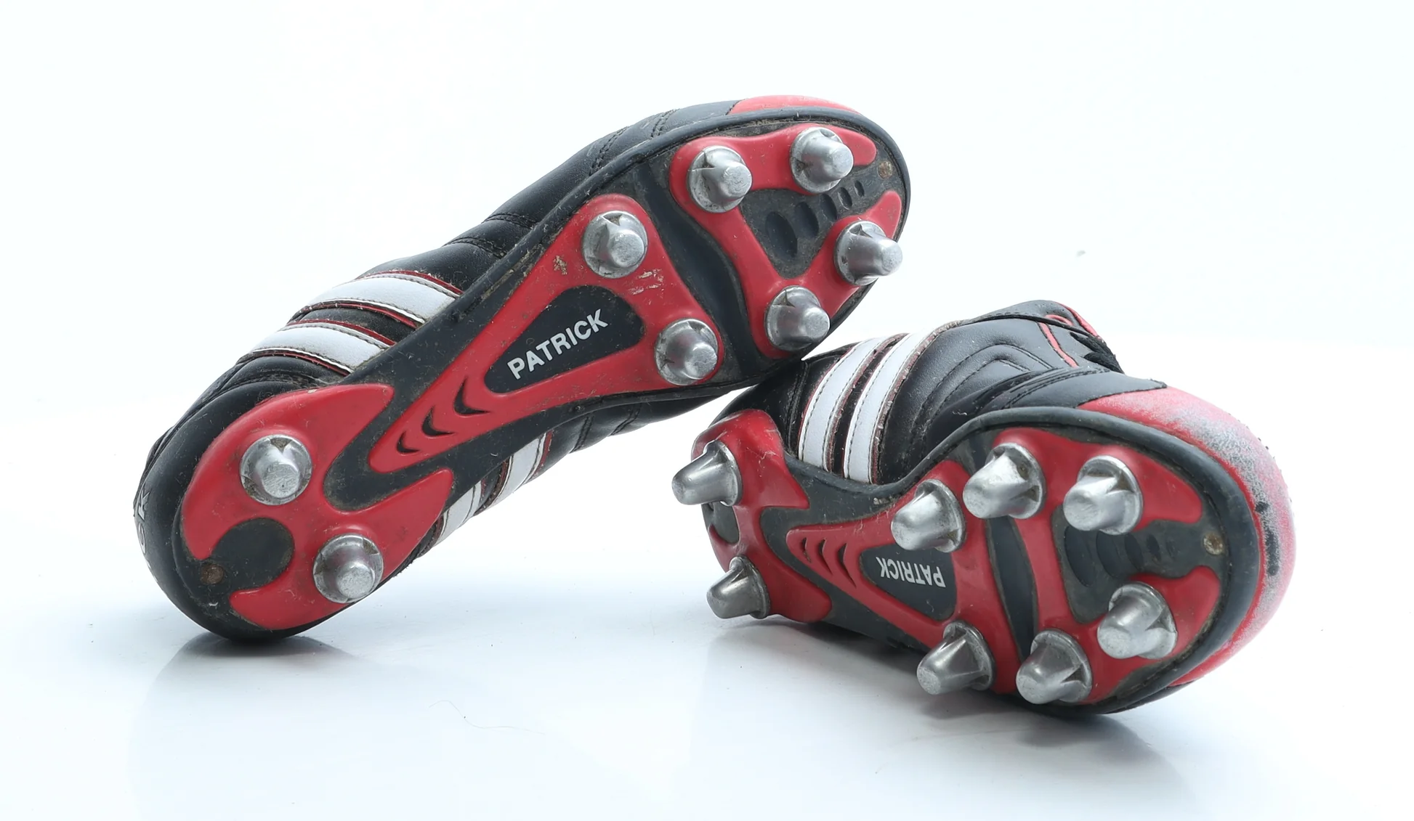


YES YES NO

Please be aware this a non-contact sport with rules and trained staff who are experienced to make these activities safe and enjoyable.

Please do not hesitate to reach out to me if you have any questions or concerns you may have.

Warm Regards

Mr Daniel McAlernon
Teacher of Physical Education and Year 10 Form Tutor

Article 23:- 'A child with a disability has the right to live a full and decent life with dignity and independence, and to play an active part in the community.'



