Meadow High School
Royal Lane, Hillingdon, Middlesex UB8 3QU

Telephone: (01895) 443310
Email: meadow@meadowhighschool.org
Website: www.meadowhighschool.org

Headteacher: Mr Graham Cunningham
Deputy Headteacher (Royal Lane): Miss Michelle Taylor
Deputy Headteacher (Northwood Road): Miss Amy Willis
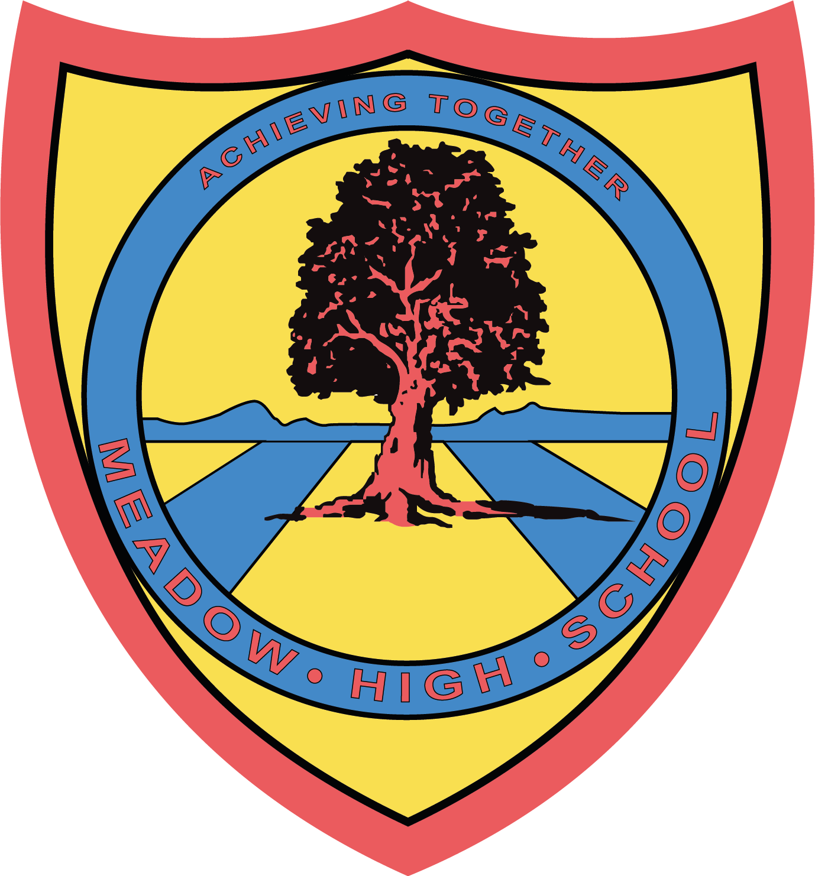



Celebrating 30 Years
Dear Parents / Carers,

Meadow High School will be taking part in Jeans for Genes day 2025 on Monday 22nd September to celebrate 30 years of Jeans for Genes Foundation.

1 in 25 children in the UK are living with a genetic condition, therefore we will be fundraising by hosting a Non-Uniform Day and encouraging everyone to dress top to toe in their best denim!

If you would like to support this fundraising event, you can donate directly via the Jeans for Genes website.
https://www.jeansforgenes.org/pay-in-your-money

Thank you for your support

Yours Sincerely,

Mrs A Mistry
AHT Workforce Development

Article 23:- 'A child with a disability has the right to live a full and decent life with dignity and independence, and to play an active part in the community.'



