Meadow High School
Royal Lane, Hillingdon, Middlesex UB8 3QU

Telephone: (01895) 443310
Email: meadow@meadowhighschool.org
Website: www.meadowhighschool.org

Headteacher: Mrs Jenny Rigby
Deputy Headteacher PW2/3: Ms Claire Caddell
Deputy Headteacher PW1: Miss Amy Willis
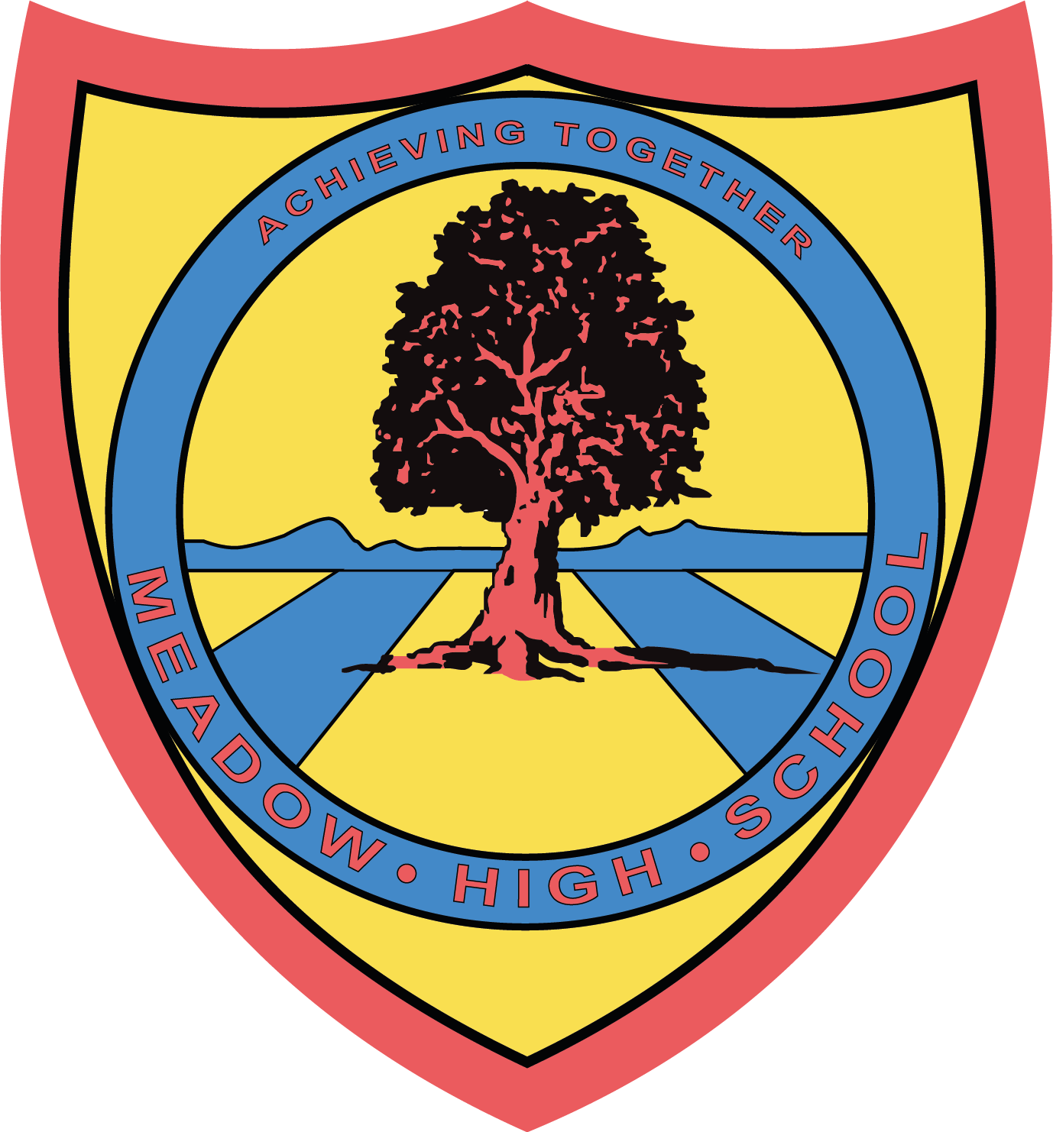

Tuesday 25th June 2024

Dear Parent/Carer,

As we approach the end of the school year, we kindly ask that you check at home for any school library books your child may have taken home throughout the year.

If you have any school library books at home, please send them back to school with your child so that they can be returned to Miss Gaafar, the school Librarian, before Thursday 18th July 2024.

If books are not returned by this date then we will assume they are lost, and you may be asked to contribute partial or full payment for us to replace these books. Please note that any extenuating circumstances will be taken into consideration before payment is requested.

If you have any questions or concerns, please contact Miss Gaafar via email on sgaafar@meadowhighschool.org.

Kind Regards,

Miss S Gaafar
Librarian (Supporting and Delivering Learning)

Article 23:- 'A child with a disability has the right to live a full and decent life with dignity and independence, and to play an active part in the community.'


