Meadow High School
Royal Lane, Hillingdon, Middlesex UB8 3QU

Telephone: (01895) 443310
Email: meadow@meadowhighschool.org
Website: www.meadowhighschool.org

Headteacher: Mrs Jenny Rigby
Deputy Headteacher PW2/3: Ms Claire Caddell
Deputy Headteacher PW1: Miss Amy Willis
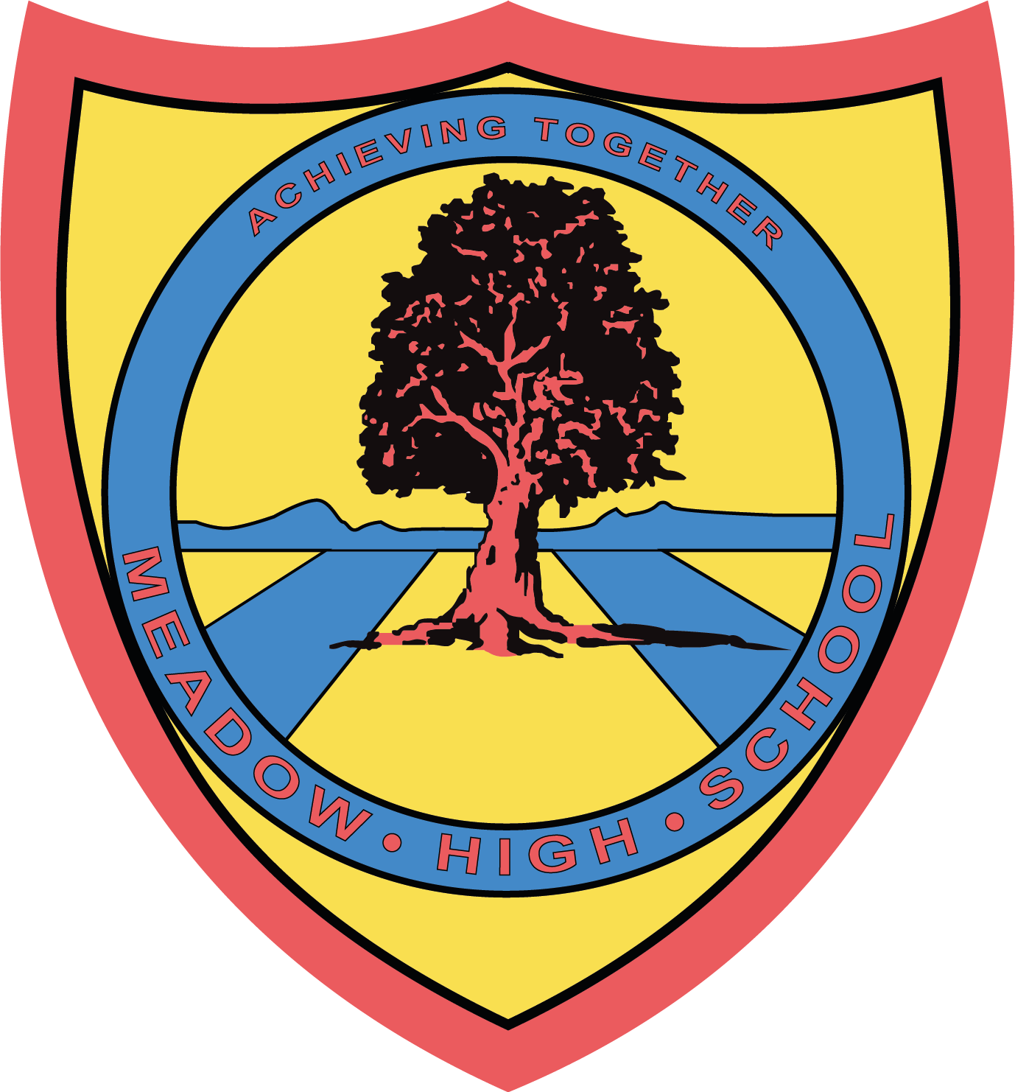

April 2024

Dear Parent/Carer,

In Food Technology, pupils will be focusing on a range of different cooked products. Pupils will be taking part in some theory lessons to further their understanding of Health and Safety in the kitchen and practical lessons where they will be building up their confidence towards everyday cooking.

Pupils will also take part in sensory evaluations of various foods, as well as cook their own meal. If you wish your child to take home the products that he/she prepares, the amount required for the practical and taste testing lessons will be £10.00.

In order to save administration time, we would like the cost of your child’s Technology practical work to be paid for all at once via Parent Pay.

If you require any assistance with your Parent Pay account, please contact the school reception for support.

Thank you in advance.

Mr G. Millard
Food Technology Teacher

Article 23:- 'A child with a disability has the right to live a full and decent life with dignity and independence, and to play an active part in the community.'


