Meadow High School
Royal Lane, Hillingdon, Middlesex UB8 3QU

Telephone: (01895) 443310
Email: meadow@meadowhighschool.org
Website: www.meadowhighschool.org

Headteacher: Mrs Jenny Rigby
Deputy Headteacher: Ms Claire Caddell
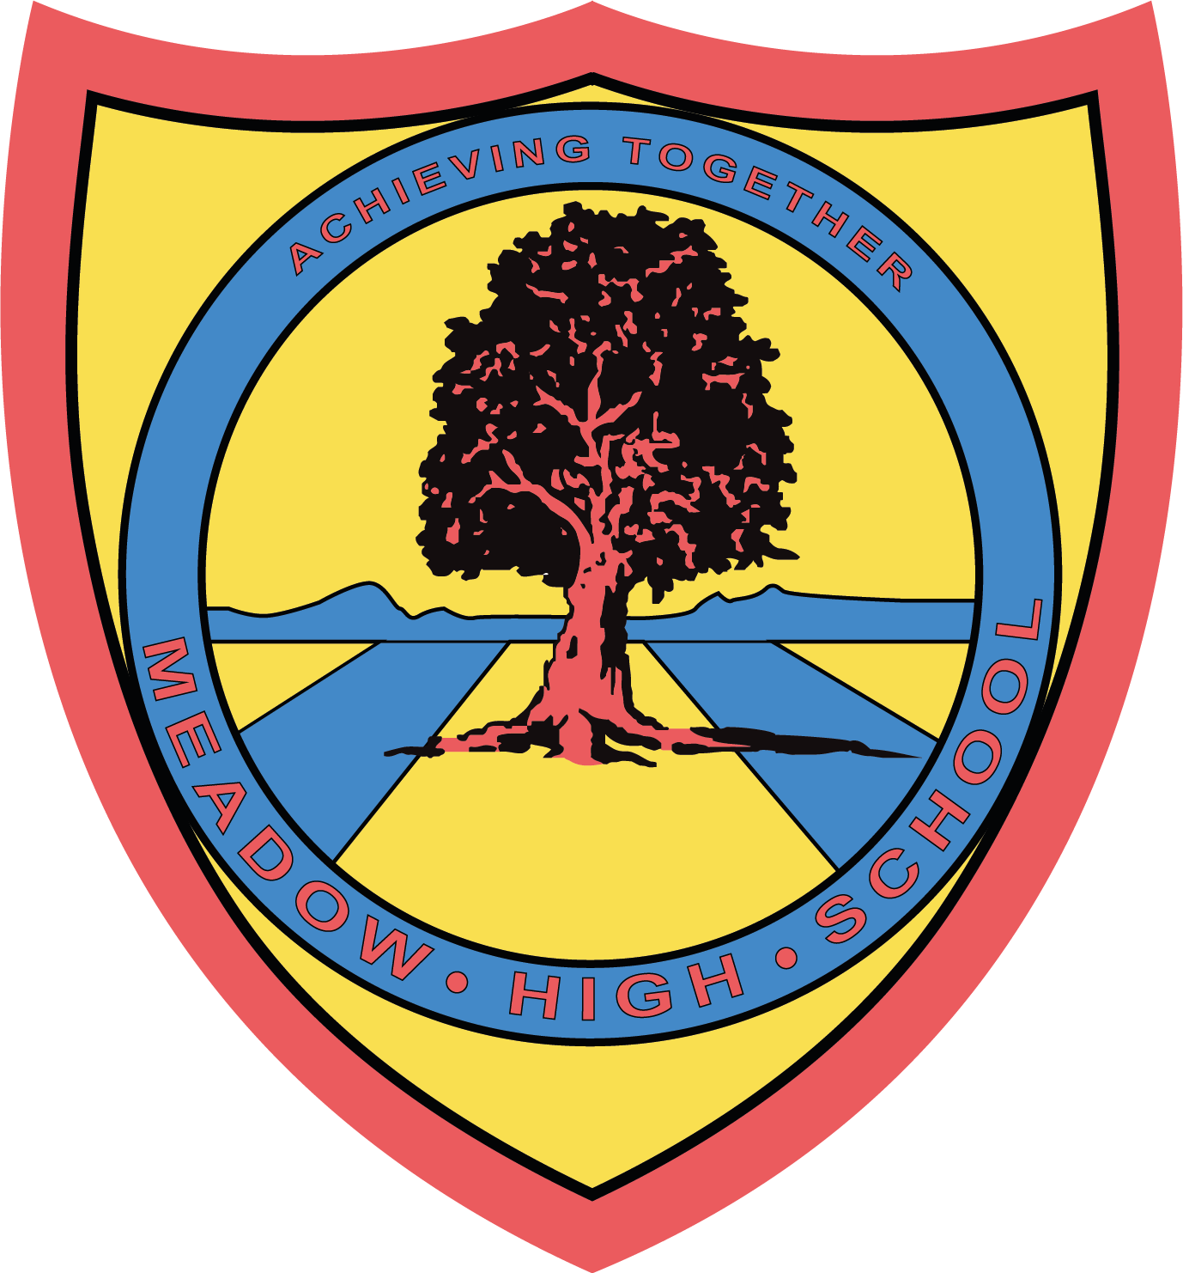

9th June 2023
Dear Parents / Carers,
London Youth Games

Your child has been selected to represent Meadow High School at the above event. The event will be taking place on Wednesday 14th June. For this event, please no studs / blade boots are allowed, so either astros or trainers must be worn and they must have shin pads (FA rules).

They will need to be at school for 7.45am for an 8.00am leave. They will require a healthy packed lunch, if your child is eligible for free school meals then one will be provided. We aim to be back to school in time for transport. If there are any delays, we will contact you on the number you leave below. Please indicate if your child is an independent traveller on the slip below.

Please complete and return the below reply slip as soon as possible.

Kind Regards,

Mr. Anstee
PE Faculty Lead

Article 23:- 'A child with a disability has the right to live a full and decent life with dignity and independence, and to play an active part in the community.'


REPLY SLIP: London Youth Games– please return to Mr. Anstee

I give permission for my child __________________________ to take part in the London Youth Games.
I acknowledge that my child must be at school for 7.45am.

My child is an independent traveller and will make their own way home after the event
I will provide my child with a healthy packed lunch
My child is entitled to a free school meal, please provide a packed lunch
Sandwich choice (please tick): Tuna Mayo ( ) Cheese ( ) Egg Mayo ( )

My emergency contact details are: _____________________________________

Signed: _______________________

