Meadow High School
Royal Lane, Hillingdon, Middlesex UB8 3QU

Telephone: (01895) 443310
Email: meadow@meadowhighschool.org
Website: www.meadowhighschool.org

Headteacher: Mrs Jenny Rigby
Deputy Headteacher (Royal Lane): Miss Michelle Taylor
Deputy Headteacher (Northwood Road): Miss Amy Willis
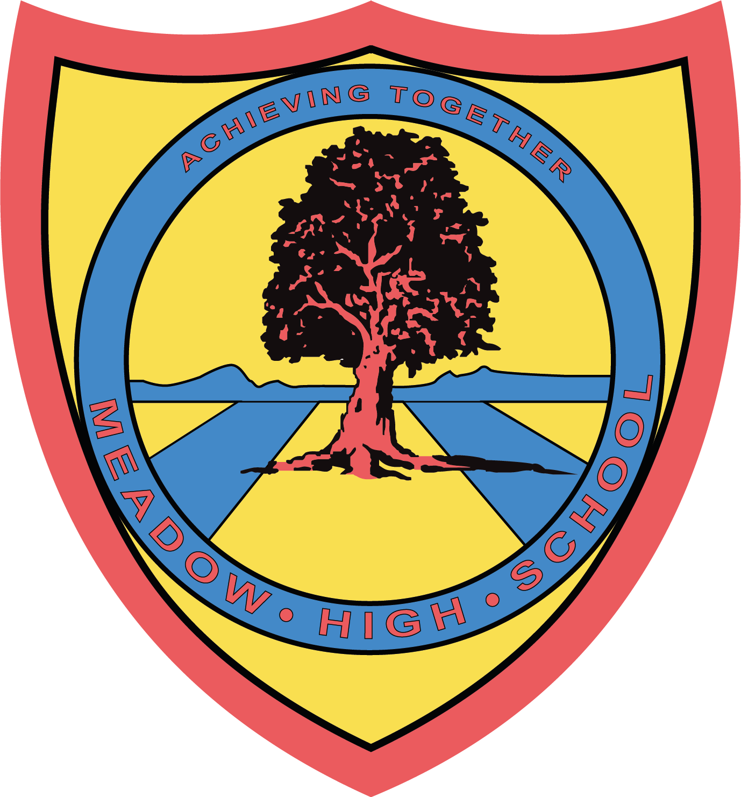

16th July 2025
Dear Parents/Carers,
Year 11 Trip to Thorpe Park

As a year group, we are going to visit Thorpe Park on Monday 21st July 2025. As we approach the end of Year 11, this trip is to recognise the hard work Year 11 has done throughout the year. We also hope it will make some happy memories before they prepare to move on to their next chapter.

As a reward trip, we will not be taking any pupil whose behaviour is likely to put others at risk. Everyone in Year 11 currently has a place, but pupils know their behaviour needs to be appropriate. If we do not feel confident that a pupil will follow instructions and keep themselves (and others safe) whilst off-site, they will not be allowed to go on the trip.

Students will be responsible for handling their own money and will be able to practise their social interaction skills with staff at Thorpe Park and each other.

We’ll be leaving school at 9.15am by minibus and we will arrive back at school before the end of the school day. There will be no cost to attend this trip.

If your child would like to buy lunch or snacks while we are out, please send a small amount of money in with them. Students are welcome to bring a packed lunch instead, if they prefer. If they are entitled to a free school lunch, please indicate below and we will make sure they have a packed lunch provided.

Many thanks,

Maxine Newman
Team Leader Years 9-11

Article 23:- 'A child with a disability has the right to live a full and decent life with dignity and independence, and to play an active part in the community.'


-------------------------------------------------------------------------------------------------------------------------------
REPLY SLIP: Year 11 Thorpe Park Trip - Please return to Mrs. M Newman

Student name: _____________________________________________

I will bring in a small amount of money

I will be bringing a packed lunch

I am entitled to a free school lunch and would like a lunch provided

Signed: ________________________________ Date: ______________

