Meadow High School
Royal Lane, Hillingdon, Middlesex UB8 3QU

Telephone: (01895) 443310
Email: meadow@meadowhighschool.org
Website: www.meadowhighschool.org

Headteacher: Mrs Jenny Rigby
Deputy Headteacher: Ms Claire Caddell
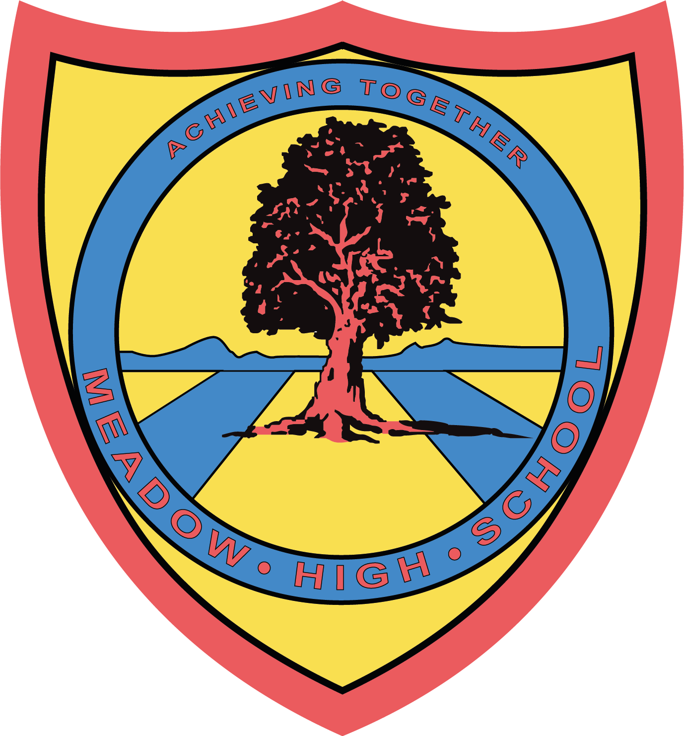

Dear Parents / Carers,

Year 10 REWARD – Airport Bowl

As a reward for all Year 10 students, we would like to go to the Airport Bowl and then come back to school and order pizza - as chosen by the pupils. As this is a reward, children with poor behaviour will not be allowed to go on the trip. In order for the trip to take place, we ask for a voluntary contribution of £5 per child. The children have an option to bring in some spending money for the arcades as well, however, no more than £5 spending money.

The event will take place on Tuesday 13th December during school hours. We will leave school at 11:00 and return at 12:40 – in time for lunch.

Please complete and return the reply slip as soon as possible. If there are any problems or questions then please contact me at school.

Kind Regards,

Mr. B Anstee and Miss. C Lepage
Form Tutors
@MeadowPE

Article 23:- 'A child with a disability has the right to live a full and decent life with dignity and independence, and to play an active part in the community.'


___________________________________________________________________________
REPLY SLIP: Year 10 REWARD – Airport Bowls – please return to Mr Anstee and Miss Lepage

Name of Child: ________________________________________

My child would like to take part in the bowling match and have enclosed £5.

My child has enclosed £_______ spending money – Maximum £5.

Signed: ___________________________________ Date______________________

