PSHCE Cycle 2 Spring 1 Different cultures and religions
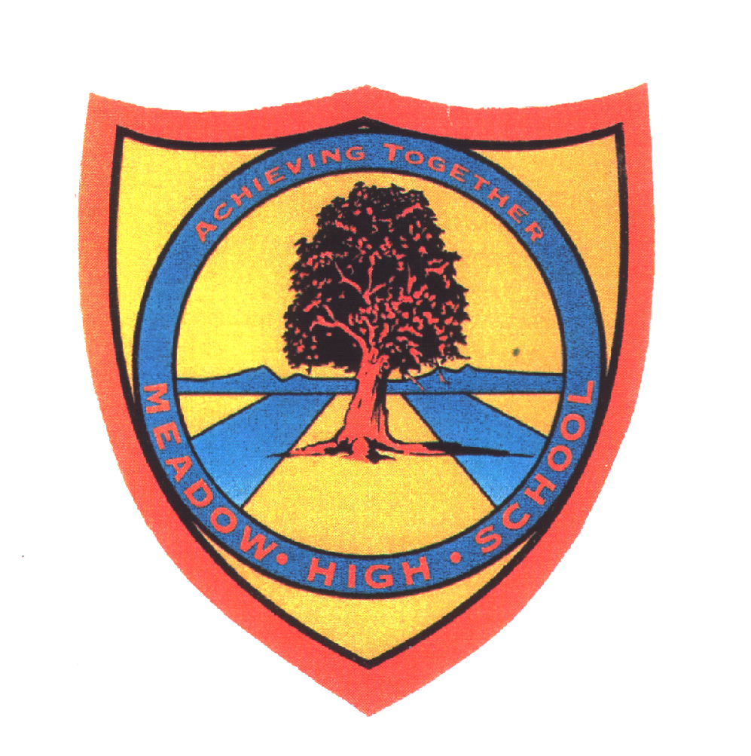 | Pathway 1 | KS5  PSHCE  Cycle 2 | Spring Term 1  Different cultures and religions
Learning Intention: Pupils will continue to develop their understanding and knowledge of the different world religions . Pupils will explore stories from different religions and develop their listening and questioning skills. Pupils will develop their ability to look for meaning in stories and consider how some people apply this in their daily lives.

By the end of this topic pupils will explore and become aware of a variety of religions and learn about the stories and beliefs associated with them. Pupils will also explore and learn about various festivals and celebrations form these various religions. Pupils will consider the religious and cultural links, this will include visits to various places of worship as well as making foods and items from different religions.

Key knowledge that should be learned during this SoW |  | All | Most | Some
Concept: |  | To be aware of a variety of religions and learn about the stories and beliefs associated with them. | Explore various festivals and celebrations form the main world religions | To be able to consider the religious and cultural links and what is the same across the world regions.
Knowledge: |  | To know own families beliefs and other beliefs in class. | To know some of the main world religions and be aware of key themes in these. | To know the main world religions and key stories and themes within them.
Key Skills: |  | Communication. | Peer work. Discussion. | Research.  Refection.
Language and/or communication skills: |  | Important  Special | Describe  Right  Wrong  Choice | Why
Curricular Links |  | Theme KS3and4. English KS3 and KS4.

