Meadow High School
Royal Lane, Hillingdon, Middlesex UB8 3QU

Telephone: (01895) 443310
Email: meadow@meadowhighschool.org
Website: www.meadowhighschool.org

Headteacher: Mrs Jenny Rigby
Deputy Headteacher PW2/3: Ms Claire Caddell
Deputy Headteacher PW1: Miss Amy Willis
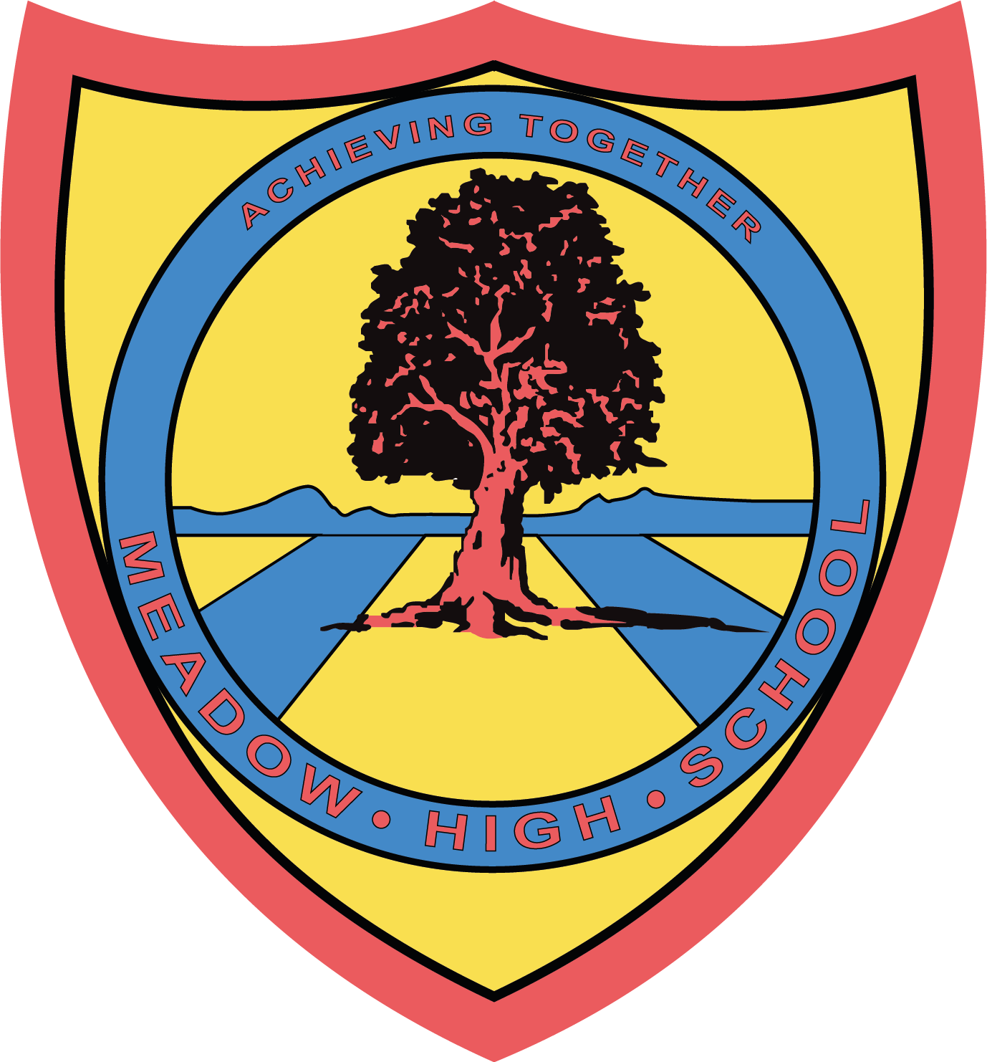

Tuesday 12th March 2024
Dear Parent/Carer

To support your child with their learning of ‘George’s Marvellous Medicine’ in English we have arranged a trip to the Roald Dahl Museum in Great Missenden on Monday 25th March.

We will be leaving school after registration at 9:15am and returning to school in time for transport at 3pm. Therefore, you will need to provide your child with a packed lunch and plenty of water. If your child is entitled to a free school meal then one can be provided for them; please indicate below if you would like one provided. We will travel on a coach and will be accompanied by First-Aid members of staff.

To cover the cost of the trip, we are asking for a voluntary contribution of £20. This includes a walking trail around the area, exploring the sights and sounds that inspired Roald Dahls’ stories and a self-guided tour of the museum. Please pay this via ParentPay.

If you would also like to provide your child with some money to buy a hot chocolate while we are out on our walk, or when they are visiting the museum shop, then please do so. No more than £5 please. This will need to be kept with your child on the day of the trip and it is their responsibility to look after their money.

Please complete the attached slip and return it as soon as possible. If you have any queries, please feel free to contact me.

Yours sincerely,
Mrs Ali

Article 23:- 'A child with a disability has the right to live a full and decent life with dignity and independence, and to play an active part in the community.'

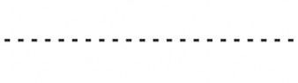
Reply-Slip: Roald Dahl Museum Trip. Monday 25th March 2024 – please return to Miss Ali

I acknowledge that my child …………………………………………………………………………………….. will take part in this educational trip.
( ) I will be providing my child with a packed lunch on that day.
( ) My child is entitled to a free lunch. Please provide one.
Sandwich choice: [ ] tuna mayo [ ] egg mayo [ ] cheese
( ) I have paid my contribution of £20 onto Parent Pay.

Signed (Parent/Carer) ……………………………………….………………………… Date ………………

