Meadow High School
Royal Lane, Hillingdon, Middlesex UB8 3QU

Telephone: (01895) 443310
Email: meadow@meadowhighschool.org
Website: www.meadowhighschool.org

Headteacher: Mrs Jenny Rigby
Deputy Headteacher PW2/3: Ms Claire Caddell
Deputy Headteacher PW1: Miss Amy Willis
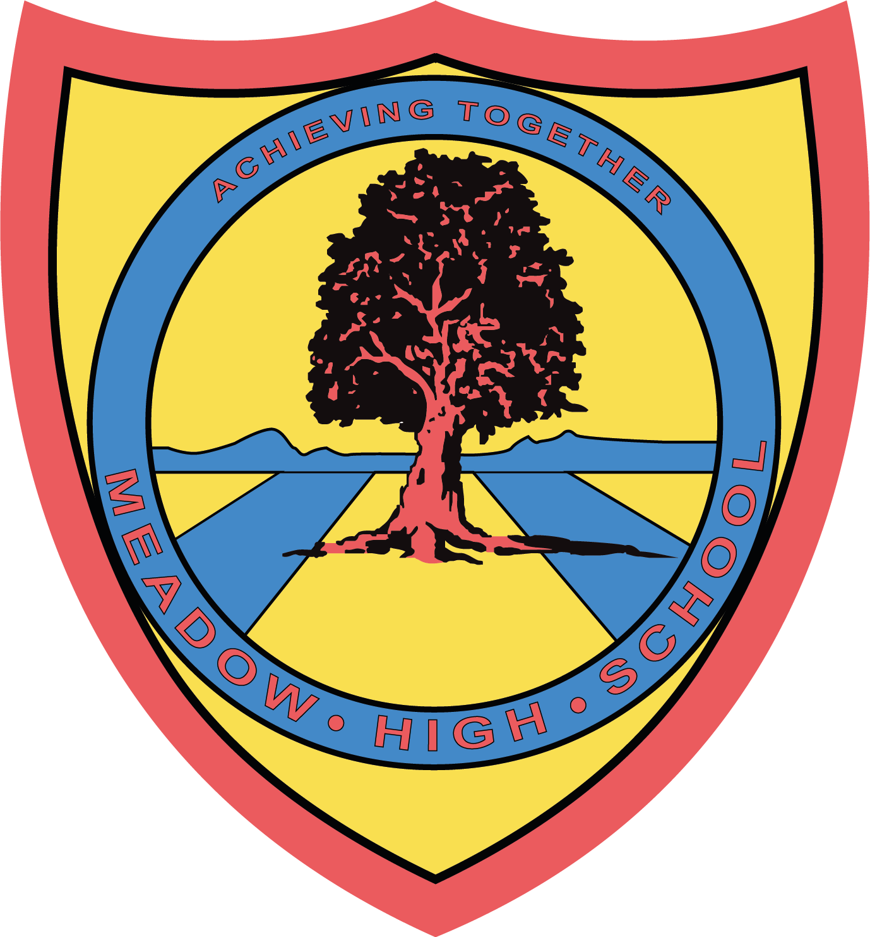

12th June 2024

Dear Parents/Carers,

I am writing to inform you that your child will be visiting the bicycle factory in Greenford on Thursday 20th June 2024 as part of the Career’s visit to a local employer.

The site address is -
Brompton Workshop
Unit 1 Greenford Park
Ockham Drive
Greenford
UB6 0FD

Students and school staff members will leave school around 9:15am on the school minibus and will be returning to school by 12:45pm. During the visit, students will have an opportunity to learn about the background of the company, tour the site, build knowledge of various job roles, meet with professionals and see the assembly line. Students might get an opportunity to participate in a practical task. This trip is free of charge and does not require any contribution.

Should you have any questions, please do not hesitate to email me on: skabhoo@meadowschool.co.uk or call school on 01895 443310 ext. 244
Yours Sincerely,

Mrs Kabhoo
Trip Organiser
Article 23:- 'A child with a disability has the right to live a full and decent life with dignity and independence, and to play an active part in the community.'

____________________________________________________________________________________
Brompton Photo Permission Slip – please return to Mrs Kabhoo
Please sign and return this slip if you give permission for the photo to be taken by the hosting organisation for their internal and external publication purposes.

Child name: _______________________________________ Class: ____________

Parent name: ______________________________________

Signature of parent: _________________________________ Date - ______________

