KS3 - Performing Arts - Cycle 2
Spring Term 1
Growing

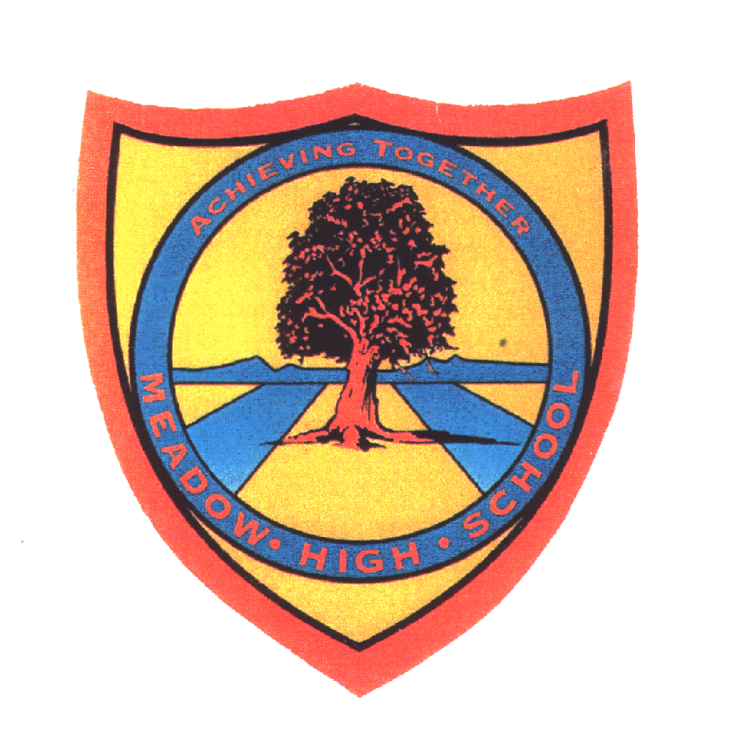 | Pathway 1 | KS3  Performing Arts  Cycle 2 | Spring Term 1  Growing
Learning Intention: Dance based unit, pupils will have explored different ways of moving their bodies. Pupils will have looked at the growth of plants and reenacted this using their bodies. Pupils will have considered how baby and adult animals move and performed these movements.
Key knowledge that should be learned during this SoW |  | All | Most | Some
Concept: |  | I can move my arms and legs. I know that plants and animals grow. | I can move my arms and legs in different directions. I know that plants and animals grow in different ways. | I can describe the directions I am moving my arms and legs in. I can describe the different ways plants and animals move as they grow.
Knowledge: |  | Identify arms and legs. Match animals and their babies | Identify directions up, down, left and right. Order the stages of plants growing | Identify the directions forwards and backwards. Describe movements seen in videos of animals moving and suggest movements for different stages of growth for plants
Key Skills: |  | Move arms and legs as independently as physical limitations allow, in a controlled manner. Copy simple movements demonstrated by staff. Take part in a simple warm up | Record a simple sequence of movements using images/drawings. Repeat a short sequence of movements. | Describe directions they are moving their arms and legs in and record this in simple sentences. Sequence a short chain of movements. Mimic animal movements seen in videos
Language and/or communication skills: |  | arms  leg  move  up  down  growing  plant  seed  movements  deer  chicken  egg  frog  Use of signalong and widgit symbols to support access to and learning of new language | direction  left  right  shoots  roots  stem  leaves  flowering  fawn  chick  frogspawn  tadpole  froglet  Use of ELKLAN sequencing diagrams to support creating/structuring movement sequences.  Use of Mindmaps to explore themes | forwards  backwards  germination  describe  hatching  Use of Colourful Semantics to support construction of sentences
Curricular Links |  | Maths  Ma1/3.3a describe position, directions and movements, including whole, half, quarter and three-quarter turns.  PE  PE1/1.1a master basic movements including running, jumping, throwing and catching, as well as developing balance, agility and coordination, and begin to apply these in a range of activities  PE1/1.1c perform dances using simple movement patterns.  RSE  Body awareness - knowing that everyone’s body is different  Science  Sc1/2.1a identify and name a variety of common wild and garden plants, including deciduous and evergreen trees  Sc1/2.1b identify and describe the basic structure of a variety of common flowering plants, including trees  Sc1/2.2a identify and name a variety of common animals including, fish, amphibians, reptiles, birds and mammals  Sc1/2.2c describe and compare the structure of a variety of common animals (fish, amphibians, reptiles, birds and mammals including pets)

