Meadow High School
Royal Lane, Hillingdon, Middlesex UB8 3QU

Telephone: (01895) 443310
Email: meadow@meadowhighschool.org
Website: www.meadowhighschool.org

Headteacher: Mr Graham Cunningham
Deputy Headteacher (Royal Lane): Miss Michelle Taylor
Deputy Headteacher (Northwood Road): Miss Amy Willis
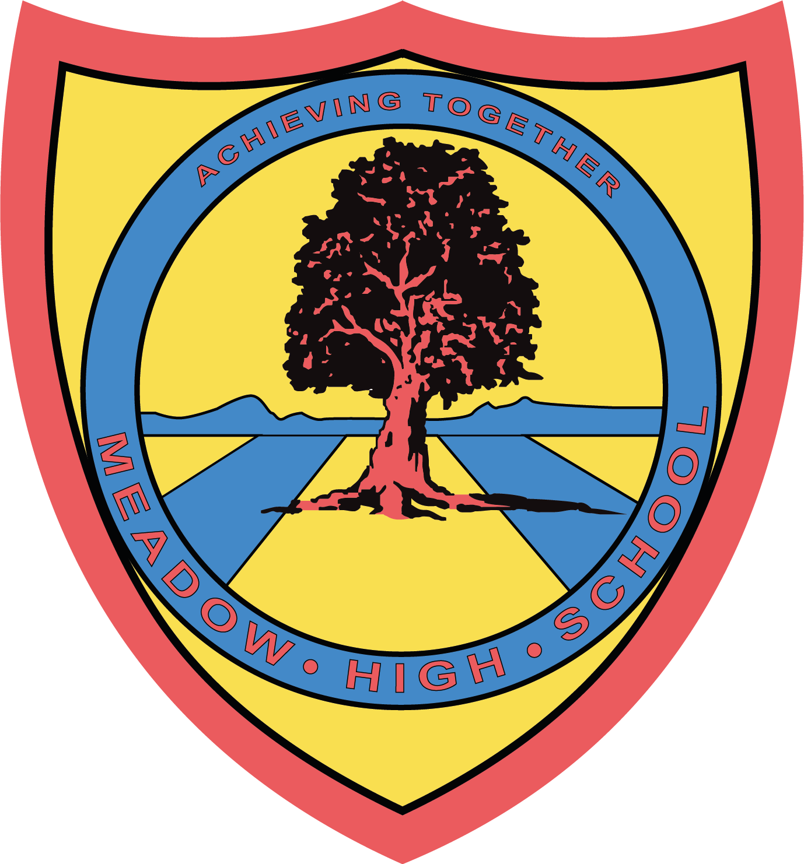

11th September 2025

Dear Parents/Carers,
Dance Lessons

Your child is taking Dance this term as part of the Performing Arts carousal. It will be every Wednesday.

For this lesson, they will require a dance kit they will need to bring each week to take part.

We would suggest suitable clothing would be their PE kit or similar such as:
- Jogging bottoms or leggings
- T-shirt (plain)
- Trainers
- Water bottle

Students will have time to change in and out of their kit within lessons.

Thank you for your support,
Yours sincerely,

Miss Kalia
Dance Lead

Article 23:- 'A child with a disability has the right to live a full and decent life with dignity and independence, and to play an active part in the community.'



