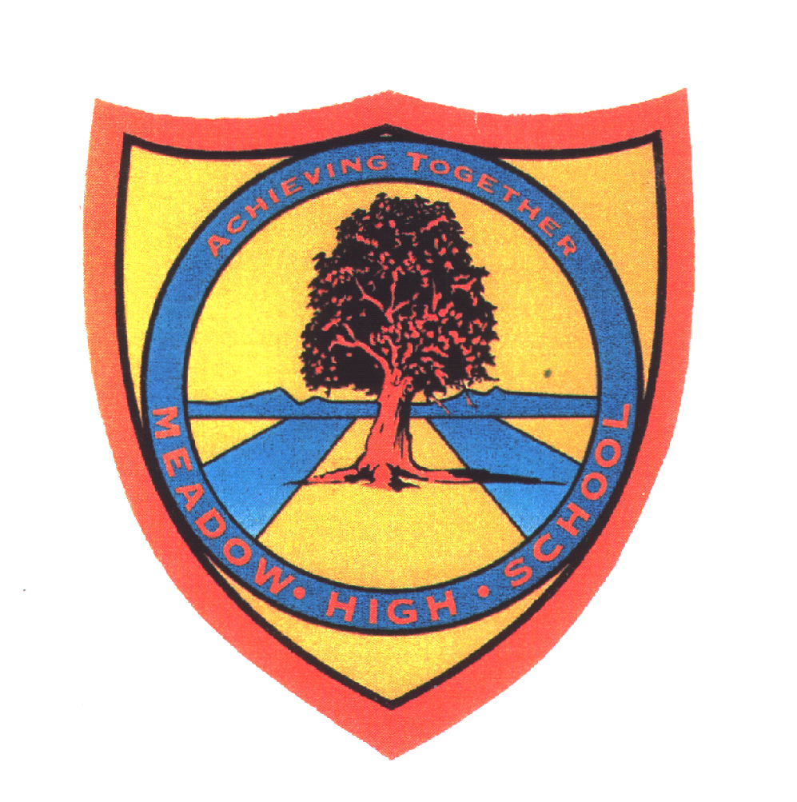 | Pathway 1 | Key Stage 3 Cycle 1 | Summer 1  Topic: Identifying & Classifying Living Things
Learning Intention: Pupils will be able to identify and then classify living things. Learning and developing their awareness of the world around them and
Key knowledge that should be learned during this SoW |  | All | Most | Some
Concept: |  | Pupils will be able to distinguish different features between key groups of animals. Pupils will learn and develop language to describe them. Pupils will explore habitats to which they are suited and describe how different habitats provide for the basic needs of different kinds of animals and plants. They will begin to recognise the importance of the environment to the survival of living things and know what choices they can make to improve the quality of the environment in their own local area.
Knowledge: |  | To identify and name a variety of common animals including fish, birds, reptiles, amphibians and mammals.  To understand that plants and animals can be found in many different places. | To describe and compare a variety of common animals.  To know that the place where plants and animals live are called habitats. | To identify and classify animals according to set criteria.  To know the seven characteristics of all living things.  To know that different plants and animals have adaptations to live in certain habitats.
Key Skills: |  | Identifying. | Describing.  Comparing. | Classify.  Explain/reason.  Consider.
Language and/or communication skills: |  | Plants  Animals | Habitats  Alive  Move  Fish  Birds  Reptiles  Amphibians  Mammals | Environment  Adaptation  Extinct  Endangered
Curricular Links |  | Geog, history, PSHCE,

