Meadow High School
Royal Lane, Hillingdon, Middlesex UB8 3QU

Telephone: (01895) 443310
Email: meadow@meadowhighschool.org
Website: www.meadowhighschool.org

Headteacher: Mrs Jenny Rigby
Deputy Headteacher (Royal Lane): Miss Michelle Taylor
Deputy Headteacher (Northwood Road): Miss Amy Willis
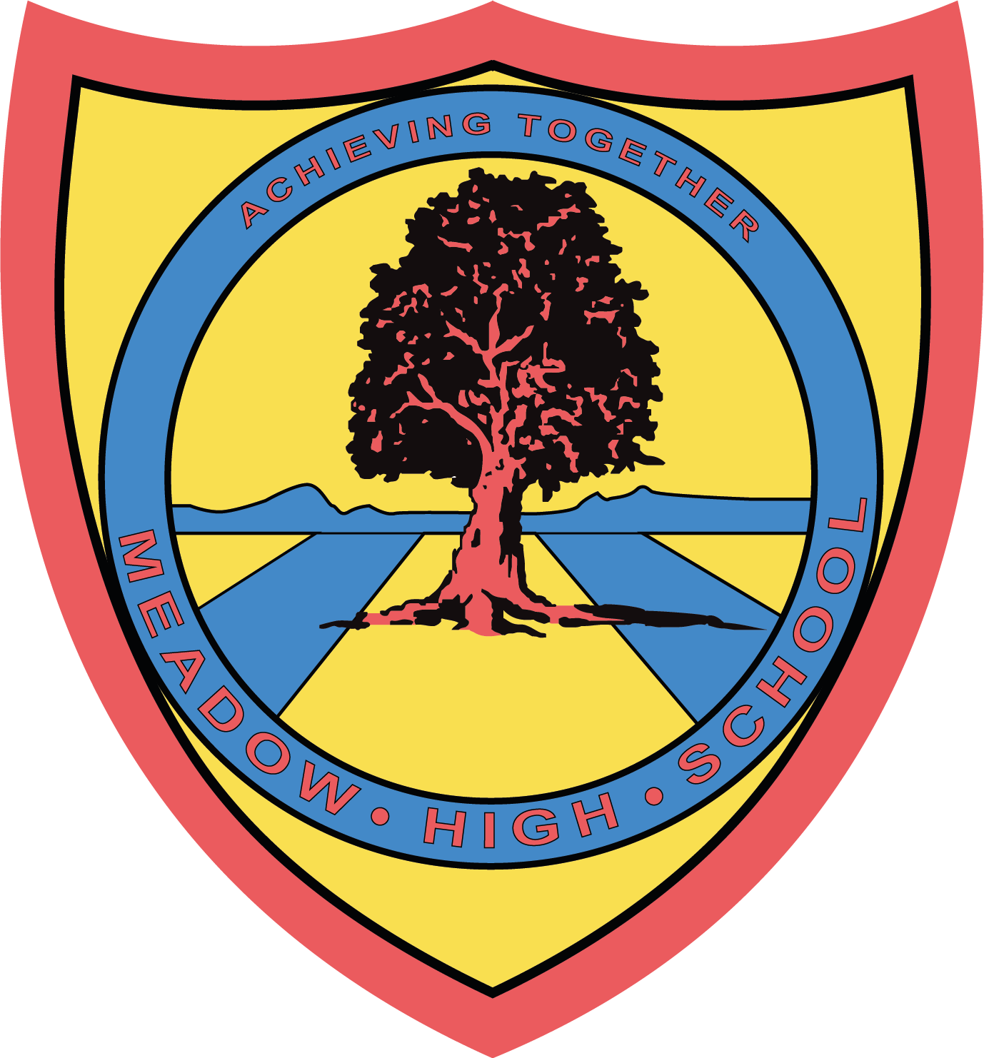

Wednesday 12th March 2025

Dear Parent/Carer,

To support your child with their learning of ‘Environments’ in Geography we have arranged a trip to Cotswold Wildlife Park on Tuesday 18th March 2025.

We will be leaving school after registration at 9:10am and returning to school in time for transport at 3pm. Therefore, you will need to provide your child with a healthy packed lunch and plenty of water. If your child is entitled to a free school meal then one can be provided for them. We will travel on a coach and will be accompanied by First-Aid members of staff.

The cost of the trip will be covered by the school. We will not be visiting the gift shop, so your child will require no money on the day.

Please complete the attached slip and return it as soon as possible. If you have any queries, please feel free to contact me.

Yours sincerely,

Mrs Rottmann

Article 23:- 'A child with a disability has the right to live a full and decent life with dignity and independence, and to play an active part in the community.'

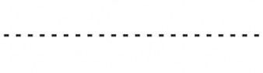
REPLY-SLIP: Cotswold Wildlife Park. Tuesday 18th March 2025

I acknowledge that my child ………………………………………………………………………………………………….. will take part in this educational trip.
( ) I will be providing my child with a healthy packed lunch on that day.
( ) My child is entitled to a free lunch. Please provide one for him/her.
Sandwich choice: Cheese ( ) Tuna Mayo ( ) Egg Mayo ( )

Signed …………………………………………………………… Date ……………………………………………………………………
(Parent/Carer)

