Meadow High School
Royal Lane, Hillingdon, Middlesex UB8 3QU

Telephone: (01895) 443310
Email: meadow@meadowhighschool.org
Website: www.meadowhighschool.org

Headteacher: Mr Graham Cunningham
Deputy Headteacher (Royal Lane): Miss Michelle Taylor
Deputy Headteacher (Northwood Road): Miss Amy Willis
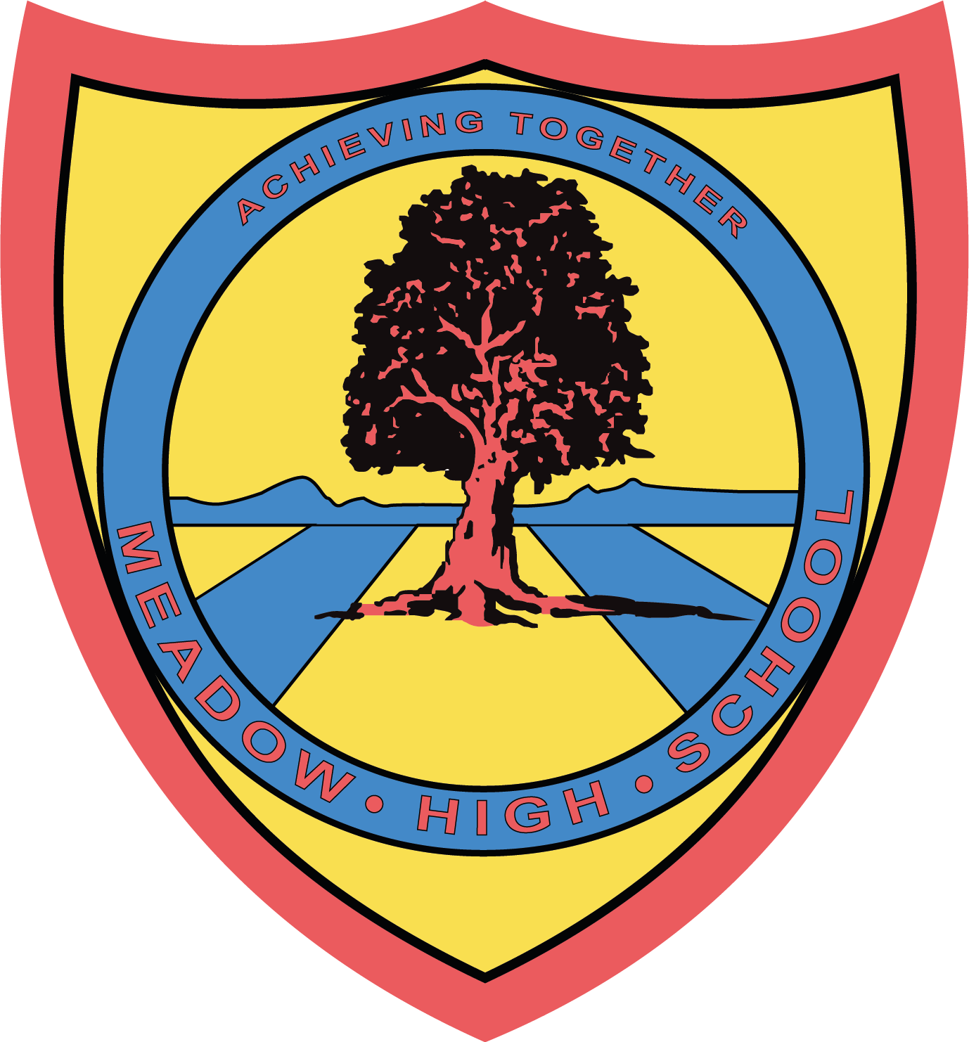

23 October 2025

Dear Parent/Carer,

As part of our Technology curriculum, all students will take part in practical Food Technology lessons for half of the year, during which they will develop essential life skills, creativity, and confidence through hands-on cooking and food preparation.

For the remainder of the year, students will focus on Computing.

To support these Food Technology lessons, the school provides many of the ingredients and resources needed. While the true cost of these materials is significantly higher, we have heavily subsidised them to keep the contribution required from families as low as possible.

We kindly ask for a contribution of £10.00 per half term, or alternatively a one-off payment of £30.00 for the half the year. All payments should be made via ParentPay.

Your support enables us to continue offering high-quality, practical experiences for every pupil in Food Technology.

Thank you for your continued cooperation.

Yours sincerely,
Mrs Shukla
Science and Technology Faculty Lead

Article 23:- 'A child with a disability has the right to live a full and decent life with dignity and independence, and to play an active part in the community.'



