Meadow High School
Royal Lane, Hillingdon, Middlesex UB8 3QU

Telephone: (01895) 443310
Email: meadow@meadowhighschool.org
Website: www.meadowhighschool.org

Headteacher: Mrs Jenny Rigby
Deputy Headteacher: Ms Claire Caddell


Dear Parent /Carer,

On Wednesday 19th October 2022, 12JS and 10BA have been given the opportunity to attend a fishing experience organised by Middlesex Trout and Salmon Fishing Charity.

The charity has accommodated the school with this facility yearly and we are excited to give the students the chance to experience something different whilst bonding with their newly formed tutor group. This experience will take place at Halliford MereTrout Fishery, Chertsey Rd, Shepperton TW17 9NN.

Halliford Mere is a complex consisting of four spring-fed
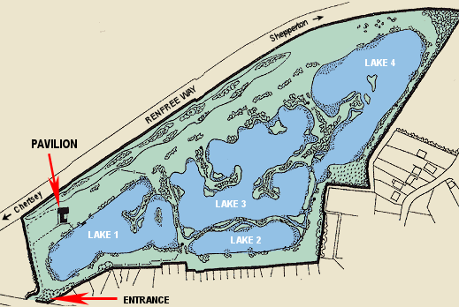
lakes totaling 15 acres of water. The fly-fishing trout lakes are highly stocked with top quality Rainbow trout ranging from 2-10lbs. The lakes are well established, supporting prolific natural aquatic life.

Middlesex Trout and Salmon Fishing Charity have a full Risk Assessment Policy in place, with an up-to-date Certificate of Employers Liability Insurance Policy. They maintain very strict Health and safety guidelines as well as issuing Health and Safety Instructions to all Teachers and careers who attend. The casters (students) also have to watch a Health and Safety Video before the commencement of each event.

For more information please see Website: http://www.hallifordmere.co.uk/default.asp

Students will need to dress appropriately for the weather conditions, casual but comfortable. If they own a pair of wellies we would suggest they bring them (if not a suitable pair of trainers).

Food will be provided for the students, however if students have dietary requirements we would advise they bring their own healthy packed lunch.

Students attending the trip will need to arrive at school at 9am sharp. They are to head straight to their designated tutor groups where they will be registered for attendance. Following this, we will be traveling by the school’s minibus to our destination where we expect to arrive between 10am-10.15am.

We will leave Halliford MereTrout Fishery at 2pm and arrive back before the end of the school day.
Yours sincerely,
Jeanette St John, form tutor 12JS
Ben Astee, form tutor 10BA

Please return reply-slip to school by Monday 10th October 2022.
Child’s Name: ………………………………….…………. Class: ……………………..

I give permission for my child to attend the trip to Halliford MereTrout Fishery on the 19th October 2022.

Signed………………………………………….. (Parent/Carer)

