Meadow High School
Royal Lane, Hillingdon, Middlesex UB8 3QU

Telephone: (01895) 443310
Email: meadow@meadowhighschool.org
Website: www.meadowhighschool.org

Headteacher: Mrs Jenny Rigby
Deputy Headteacher: Ms Claire Caddell
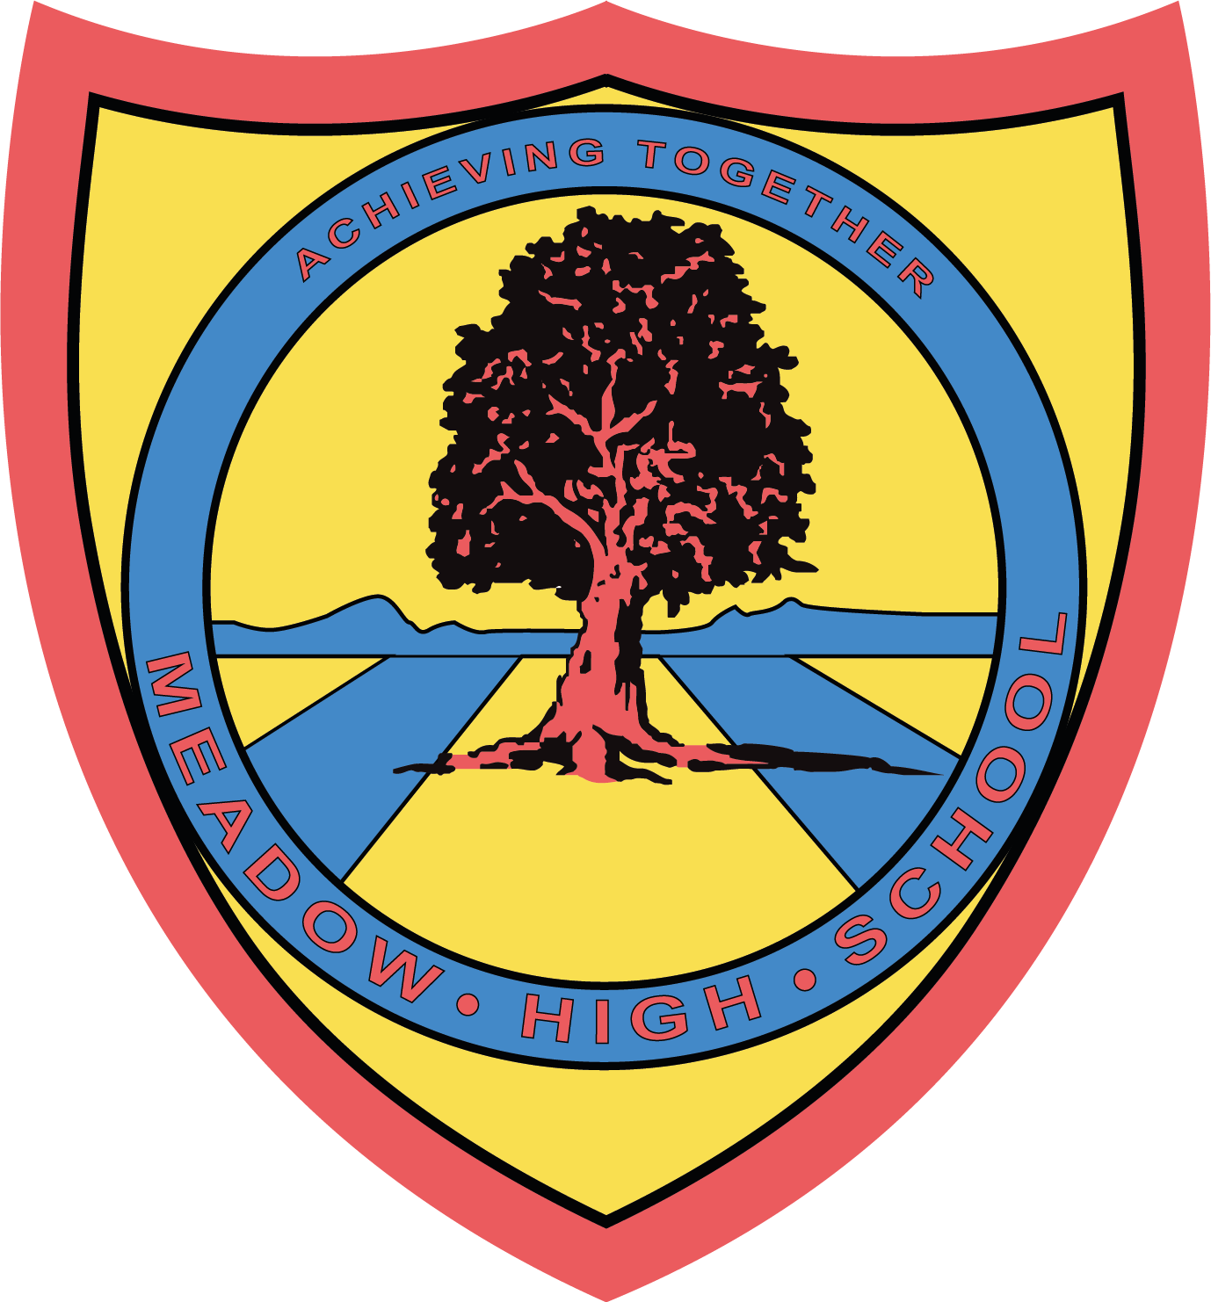

February 2023

Dear Parents/Carers,
6VL Bowling Trip
As a class, 6VL are going to Airport Bowl on Wednesday 8th February 2023. This trip is an educational opportunity for the class’ hard work over the last term, but also a chance to practise our teamwork skills and social interaction.
1 game of bowling is £3 per person.
We will be leaving at lunchtime and travelling on the school mini bus. Students can bring either a packed lunch or a small amount of money to eat at McDonalds. If your child is entitled to a free school lunch, please indicate below and we will make sure they have a lunch to bring along from school.
Yours sincerely,

Mrs Lazarevic
6th Form Tutor

Article 23:- 'A child with a disability has the right to live a full and decent life with dignity and independence, and to play an active part in the community.'


----------------------------------------------------------------------------------------------------------------------------------------------------------------------------------------------
REPLY SLIP: 6VL Airport Bowl Trip – Please return to Mrs Lazarevic

Name: …………………………………………..

Is entitled to a free school lunch and would like a lunch provided

Will bring in a packed lunch or money for lunch

Will bring in £3 for bowling

Parent/Carer signature: ……………………………………………………

