KS5 Cycle 1 Autumn Term PSHCE Hygiene

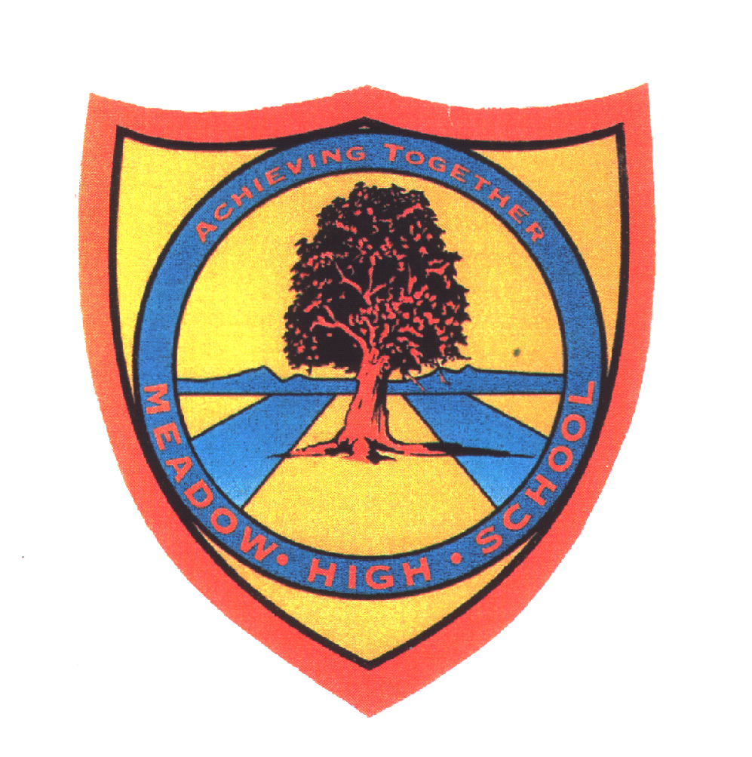 | Pathway 1 | KS5  PSHCE  Cycle 1 | Autumn Term  Hygiene
Learning Intention: Pupils in Pathway 1 KS5 have previously covered personal hygiene lower down the school but the focus in KS5 now is for the pupils to be able to take care of as much for themselves as possible. Pupils will learn about the importance of personal hygiene and practise the various skills needed in order to maintain good personal hygiene.
Key knowledge that should be learned during this SoW |  | All | Most | Some
Concept: |  | Practise basics of personal hygiene and can complete some independently (or by asking for relevant help) | To understand the importance of good personal hygiene and to gain skills in completing these effectively and frequently. | That they are young adults that have a responsibility to maintain good personal hygiene to keep themselves healthy and to ensure they make and maintain positive peer relationships.
Knowledge: |  | To know that we need to do some things to keep ourselves clean.  To know what we use to keep ourselves clean. | Know about germs and how bad ones can affect people's bodies and what can be done to minimise them.  Know what we need to do to ourselves daily, weekly, monthly to keep ourselves clean and healthy. | To know the impact of having good and bad personal hygiene and understand the importance in own lives of maintaining good hygiene.  To know how keeping clean makes us feel
Key Skills: |  | Wash hands effectively.  Brush own teeth  Brush own hair.  Wash own face over sink.  Practice fine motor skills to build and maintain strength for these tasks. | Ability to follow sequences and to learn, practise and then complete with increasing independence.  Bathe or shower independently (at home but supported from school). | To be able to use a sequence chart to prompt what is needed to complete set tasks related to hygiene. Pupils to be able to complete most basic personal hygiene tasks with use of prompts alone.  Wash own hair
Language and/or communication skills: |  | Pupils will be able to ask for specific help in relation to personal hygiene.  Pupils will have the vocabulary to ask for what they need if they cannot locate it themselves. Pupils will learn words, signs and symbols for products and tools related to hyeigee (soap, shampoo, hairbrush toothbrush) | Pupils will be able to use alague and communicate their needs and the essential to maintain good personal hygiene. Pupils will be able to idientlgyt he name of products used when maintaining good personal hygiene and then explain their uses. | Pupils will have the language to be able to locate items needed in a shop and to be able to go into a shop and buy what they need related to their personal hygiene. Pupils will be able to order and sequence what they need to do when washing their hair, washing their hands.
Curricular Links |  | Science, Maths,  KS5 PSHCE Cycle 1 Summer Term Keeping myself healthy  KS3-4 Theme Learning

