Meadow High School
Royal Lane, Hillingdon, Middlesex UB8 3QU

Telephone: (01895) 443310
Email: meadow@meadowhighschool.org
Website: www.meadowhighschool.org

Headteacher: Mrs Jenny Rigby
Deputy Headteacher: Ms Claire Caddell
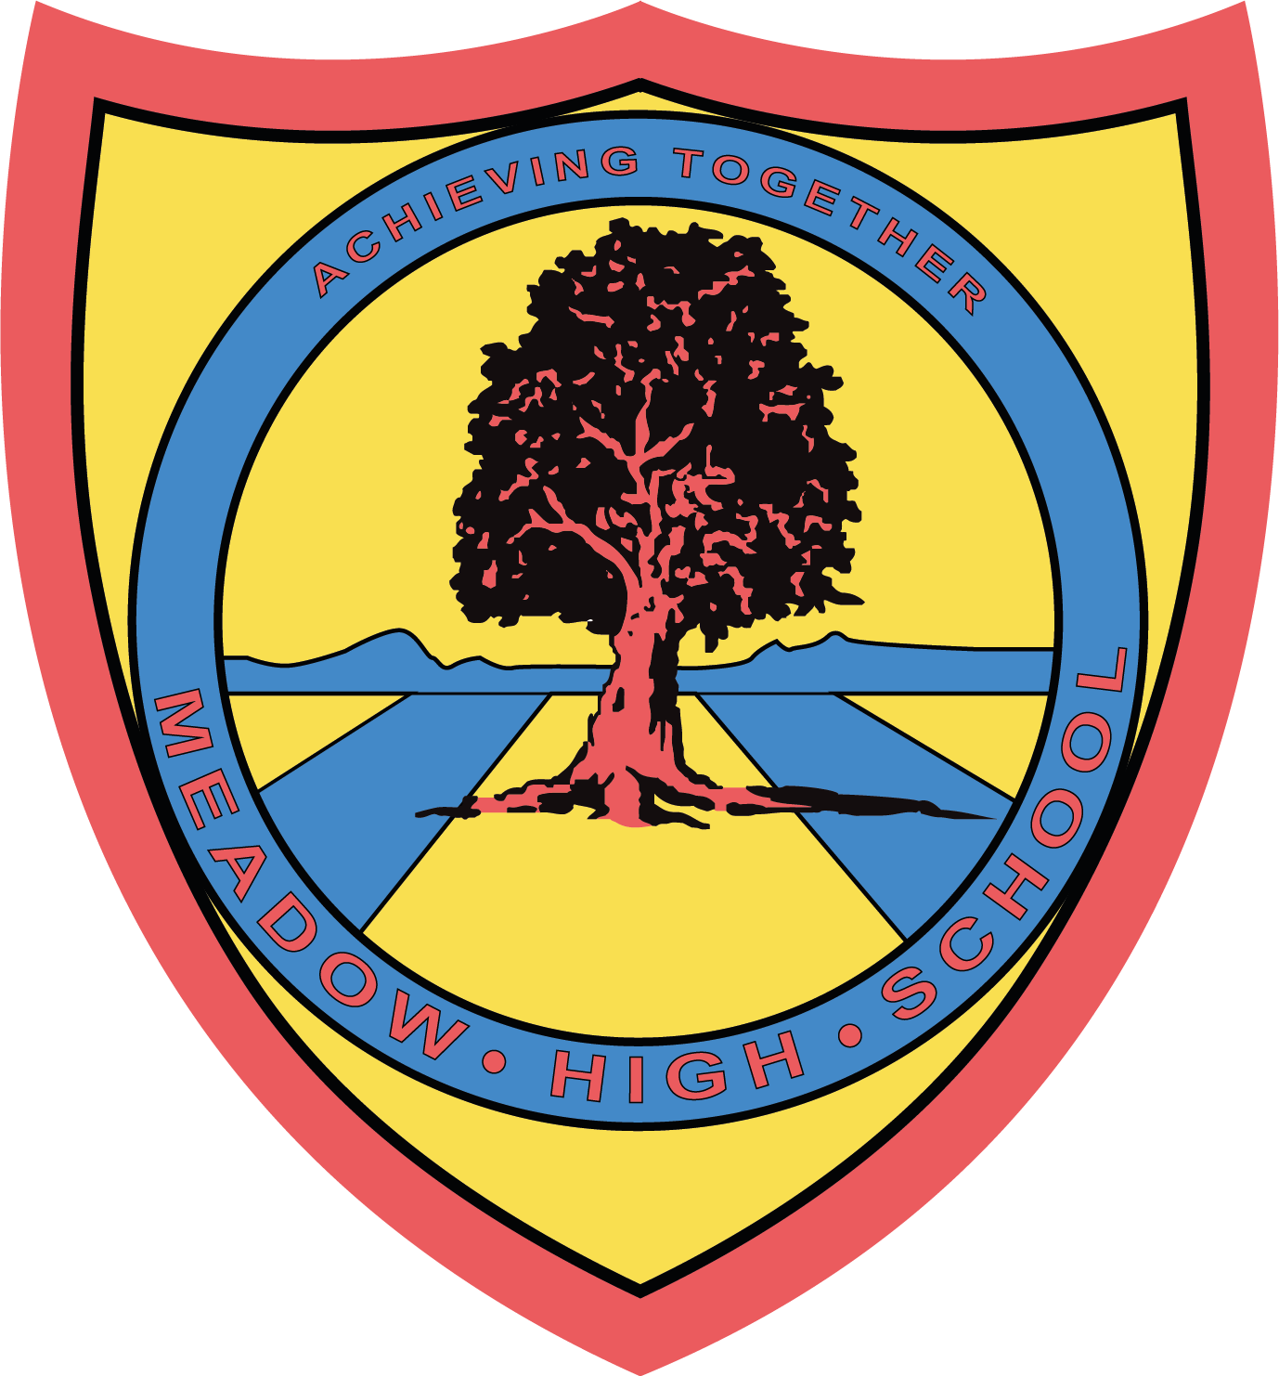

February 2023

Dear Parents/Carers,

Trip to Gooey Waffle - 1st March 2023

As a result of winning the class prize draw for completing the Flair Survey, we will be taking the students to Gooey Waffle on 1st March 2023, where they will be able to choose a dessert from the menu.
We will be travelling to Uxbridge on the mini-bus after lunch and returning to school in time for transport.
Yours sincerely,

Mrs Lazarevic
6th Form Tutor

Article 23:- 'A child with a disability has the right to live a full and decent life with dignity and independence, and to play an active part in the community.'



--------------------------------------------------------------------------------------------------------------------------------REPLY SLIP: 6VL Gooey Waffle Trip – Please return to Mrs Lazarevic
Name: …………………………………………..

• I give permission for my son to go to Gooey Waffle

Parent/Carer signature: ……………………………………………………

