Meadow High School
Royal Lane, Hillingdon, Middlesex UB8 3QU

Telephone: (01895) 443310
Email: meadow@meadowhighschool.org
Website: www.meadowhighschool.org

Headteacher: Mrs Jenny Rigby
Deputy Headteacher: Ms Claire Caddell
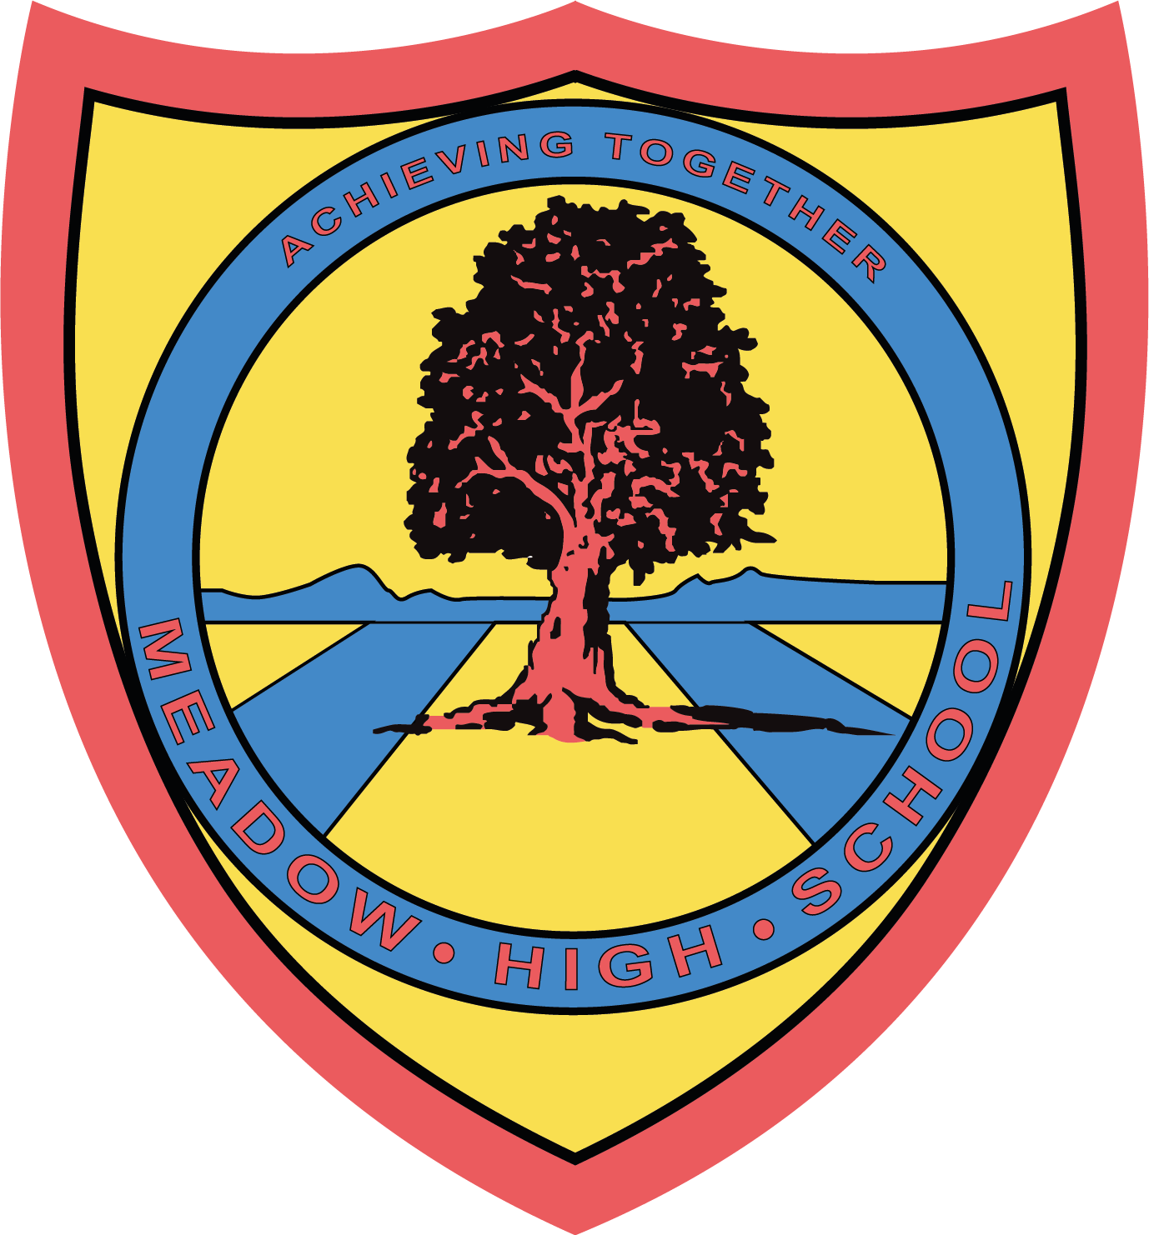

12th July 2023

Dear Parent/Carer,

Next Thursday, 20th July 2023, we are planning a class trip to the Urban Farm in Hounslow. Tickets are £6 each and we are seeking voluntary contributions from families to support the cost of the trip. This can be paid via Parent Pay.


We will visit during normal school hours. Pupils should be wearing school uniforms. We will be traveling by school minibus, which will be driven by MIDAS (qualified) trained drivers.

Pupils will require a healthy packed lunch on the day, however, if your child is entitled to a free school meal we can provide a packed lunch for them if you wish (please indicate a sandwich choice on slip below).

Please complete the permission slip below. If you have any questions, please do not hesitate to contact myself at ssewell@meadowhighschool.org.
Yours faithfully,
Miss Sewell - Class teacher - Pathway 1

Article 23:- 'A child with a disability has the right to live a full and decent life with dignity and independence, and to play an active part in the community.'


-------------------------------------------------------------------------------------------------------------------------------
REPLY-SLIP: Class SS trip to Hounslow Urban Farm - please return to Miss Sewell (ASAP please)
Name of Child: ……………………………………………………………….
( ) I would like my child to attend.
( ) I will pay the voluntary donation of £6.00 to cover my child's ticket (paid via Parent Pay)
( ) I will be providing my son/daughter with a healthy packed lunch
( ) My child is entitled to a free school lunch, please provide one Please specify the sandwich filling ( ) Egg Mayonnaise ( ) Tuna Mayonnaise ( ) Cheese
Signed: ……………………………………………………. Date: …………….

